HSB Option 3 for new hired employee:

Note:System compare Deduction Pay Date with current date time stamp.
Verified below scenario:
A] If Deduction Pay Date:2/10/2016(Retro date)
1]New hired with Effective date 01/01/2016
Deduct A 1 Time Amount From My Profit Sharing, Commission Or Bonus Check field: Disabled.
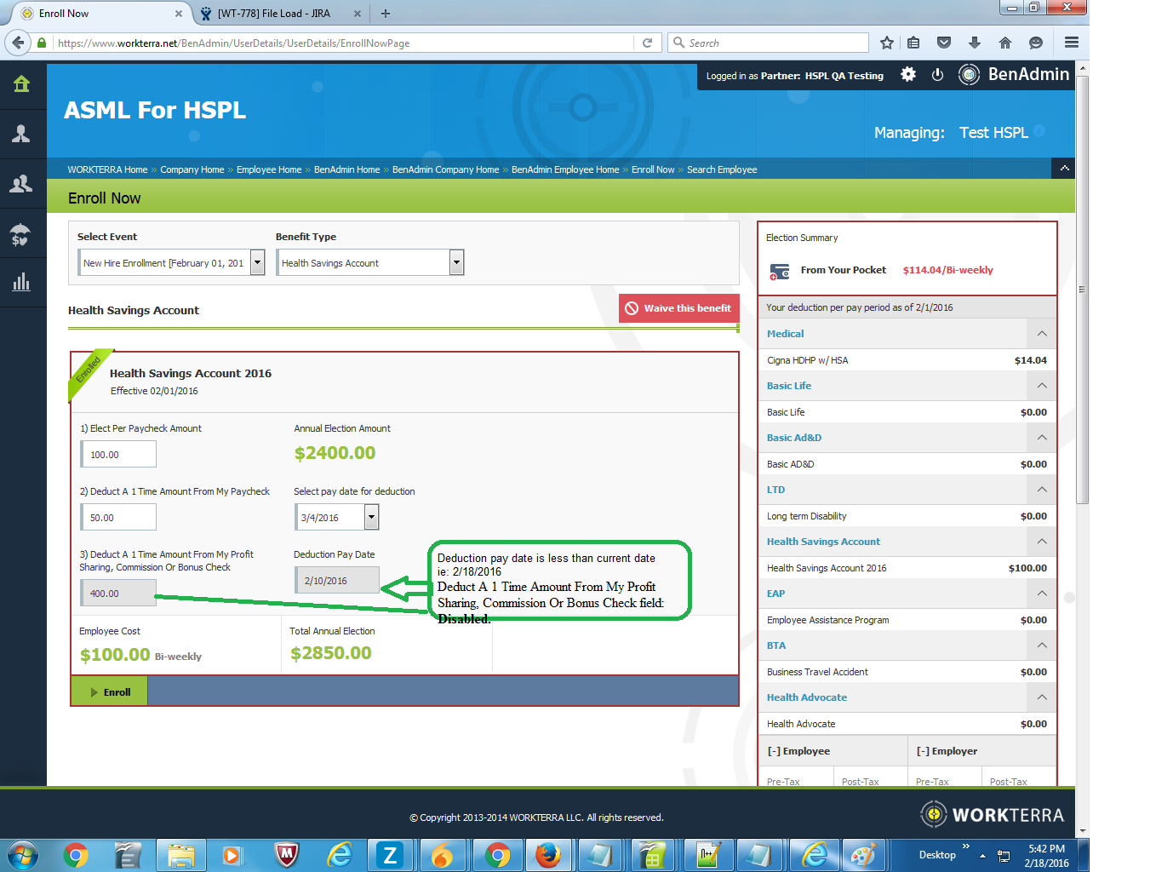

B] If Deduction Pay Date:2/18/2016 (Current date)
1]New hired with Effective date 02/01/2016
Deduct A 1 Time Amount From My Profit Sharing, Commission Or Bonus Check field: Enabled
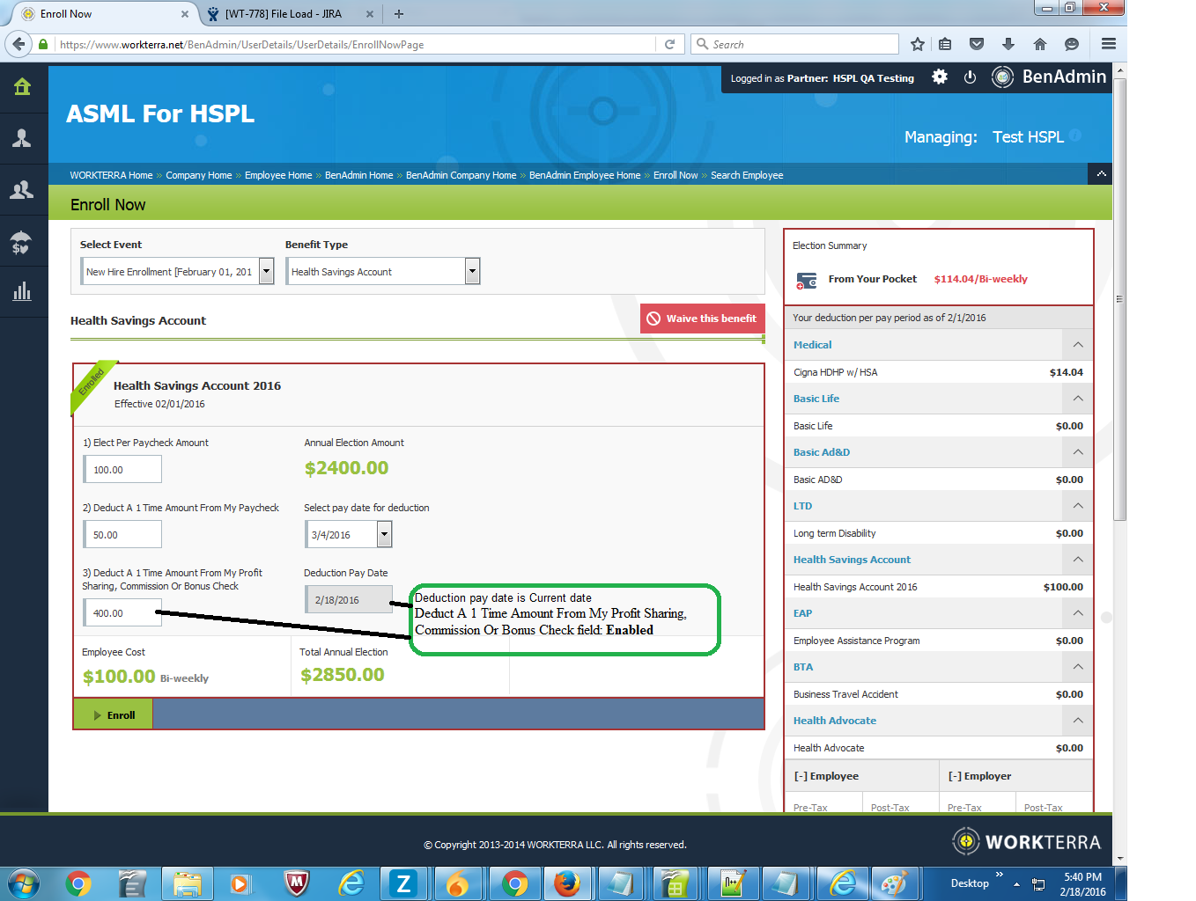

C] If Deduction Pay Date:2/18/2016(Current date)
1]New hired with Effective date 02/25/2016
Deduct A 1 Time Amount From My Profit Sharing, Commission Or Bonus Check field: Enabled
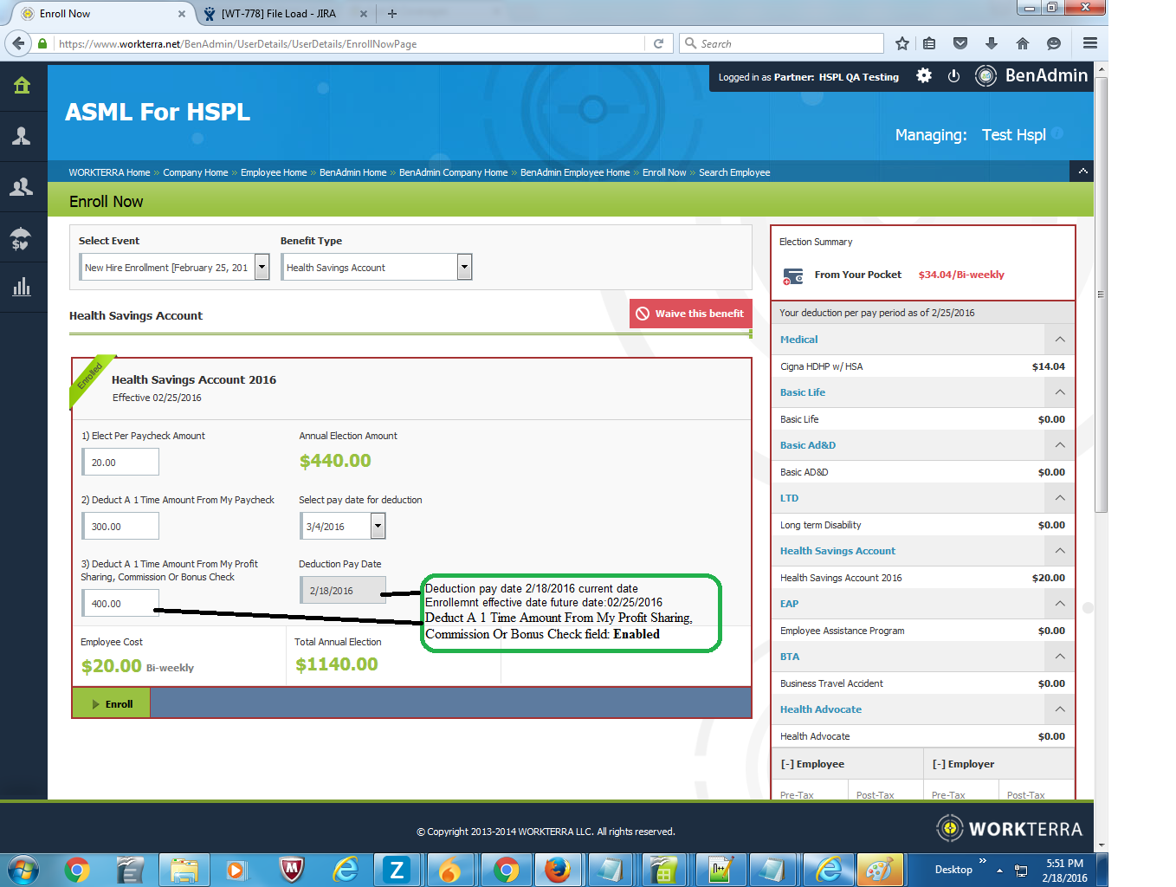

HSB Option 3 for Qualifying Event employee:
Imp Note: System compare Deduction Pay Date with current date time stamp.
Verified below scenario:
A] If Deduction Pay Date:2/10/2016(Retro date)
1]QE with Effective date 01/01/2016
Deduct A 1 Time Amount From My Profit Sharing, Commission Or Bonus Check field: Disabled.
2]1]QE with Effective date 02/17/2016
Deduct A 1 Time Amount From My Profit Sharing, Commission Or Bonus Check field: Disabled.
3]QE with Effective date 02/19/2016
Deduct A 1 Time Amount From My Profit Sharing, Commission Or Bonus Check field: Disabled.
B] If Deduction Pay Date:2/17/2016 (Current date)
1]QE with Effective date 01/01/2016
Deduct A 1 Time Amount From My Profit Sharing, Commission Or Bonus Check field : Enabled
2]1]QE with Effective date 02/17/2016
Deduct A 1 Time Amount From My Profit Sharing, Commission Or Bonus Check field: Enabled
3]QE with Effective date 02/29/2016
Deduct A 1 Time Amount From My Profit Sharing, Commission Or Bonus Check field: Enabled
C] If Deduction Pay Date:2/19/2016(Future date)
1]QE with Effective date 01/01/2016
Deduct A 1 Time Amount From My Profit Sharing, Commission Or Bonus Check field: Enabled
2]1]QE with Effective date 02/17/2016
Deduct A 1 Time Amount From My Profit Sharing, Commission Or Bonus Check field: Enabled
3]QE with Effective date 02/29/2016
Deduct A 1 Time Amount From My Profit Sharing, Commission Or Bonus Check field: Enabled
Working Fine as expected.

