I updated my cases and made the plans minimum value and re-ran the reports. I am no longer seeing the 1F code but I am noticing that line 16 for some cases is coming up blank. I also added the other open items at the end of the email.

RCPS Examples (report finalized on 3/30/2016):
11 people show a blank in line 16 and are showing a 1G in line 14
First Name | Last Name
Kay | Alley
Sonya | Clark
Andrea | Edwards
Sarah | Gill Anthony
Monica | Hubbard
Charlita | Ingram
Jo | Lonker
Donna | McCaleb
Alice | Mitchell
Shane | Pendleton
Caroline | Thielecke

Kaeser Examples (report finalized on 3/30/2016):
Frank Mueller – Line 16 blank, Line 14 1E. He waived medical on 12/19/2013, eff 1/1/2014. I do not see anything for 2015 listed in the EE history. Is that why Line 16 it’s blank?

Denton Examples (report finalized on 3/30/2016):
30 people showing a blank in line 16 and showing either 1G or 1H in line 14
First Name | Last Name | Line 14 Code | Line 16 Code
Ronda | Barnes | 1H
Danella | Bunselmeyer | 1H
Denise | Burke | 1H
Christen | Calhoun | 1H
Jamie | Carter | 1H
Jeffrey | Carter | 1G
Marlene | Cordell | 1H
Elliot | Edmonds | 1H
Lara | Elio | 1H
Caroline | Finley | 1G
Kathryn | Folger | 1H
Austin | Hammond | 1H
Kenneth | Hedges | 1G
Sophie | Huemer | 1H
Melissa | Jimenez-Bolin | 1H
Melanie | Johnston | 1H
Randee | Klingele | 1G
Elva | Maldonado | 1H
Denise | Marquez | 1H
Casey | McBride | 1H
Brittany | McCarty | 1H
Brandon | McGary | 1G
Calvin | McGary III | 1H
Chassidy | Miles | 1H
Jasmine | Pope | 1H
Trisha | Rinck | 1H
Katrina | Schroeder | 1H
William | Sterling | 1H
Mayela | Vasquez | 1H
Janna | White | 1H

Other Open Items
Yami Question on Kaeser:
1094C Should there be something selected in section 22 of the form?

Questions from Kaeser on the reporting:
Also, this employee has been full time since he’s been with us, why is this column showing as no (for everyone, not just him)? Yami - Is there something we need to update in the site for this?

**********************************************
PPO is still visible in the waiting period (though the minimum cost has changed from the 221 to zero): Yami – After I removed the Lowest EE Cost the cost for the EE below went away however the report is still picking up the plan name, is that correct?
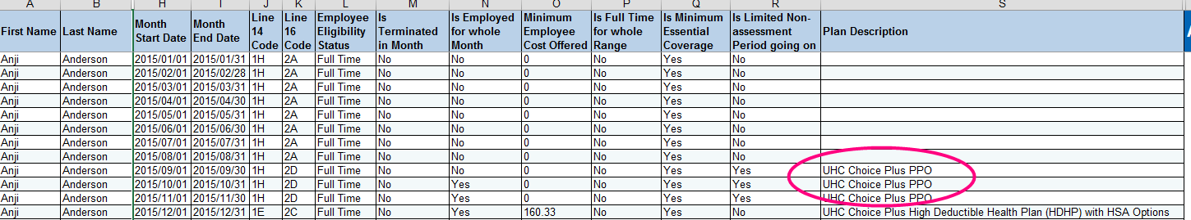

*************************************************
I realize this is not what the employee sees on the 1095, but this labeling here is confusing. Because it is not possible to be both Part Time and NOT EMPLOYED in the same time frame for the same employer. Perhaps a better label should be used. Yami – Feedback from the client regarding the report. Also, Why is the EE showing Part Time? The EE was terminated eff 1/22/2015. The client does not use a part time status. The EE has a terminated status in the site.

