STEP1: Create Approver Group

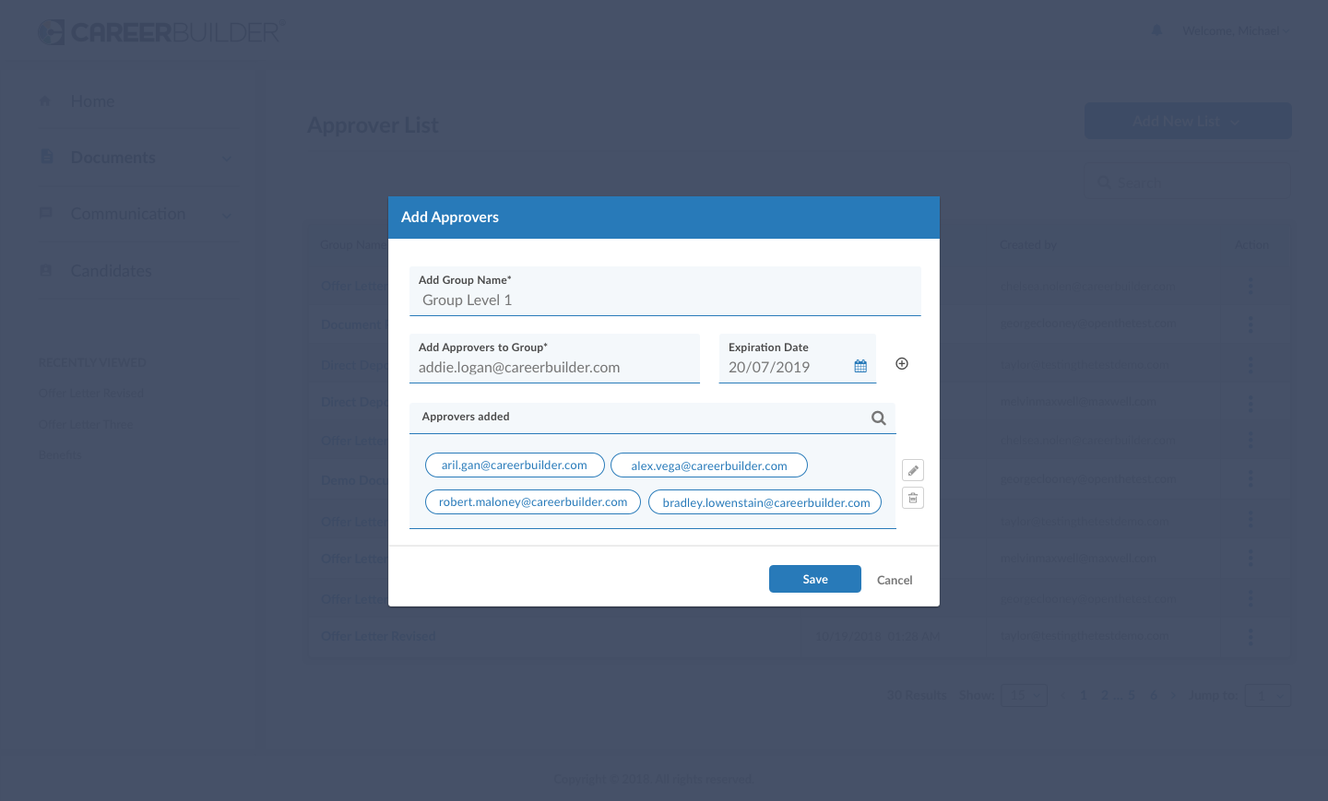
Note:
- Signers for the group should be stored on DMS.
- Approval sequence needs to be maintained.

SETP2: Send document to candidate by selecting approver group

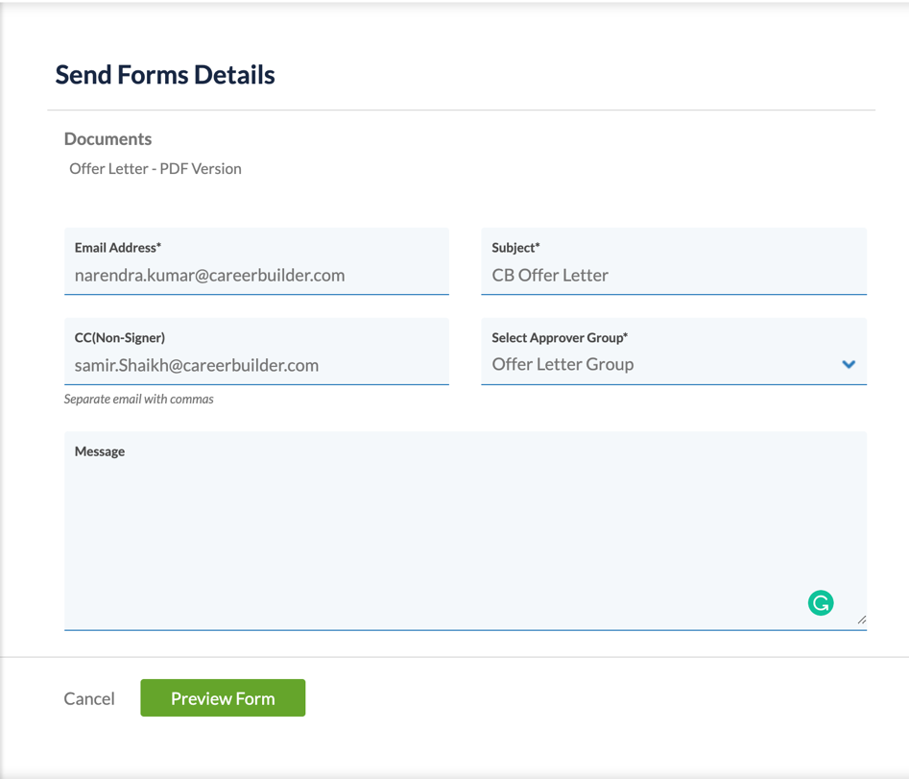

STEP3: Email Shoot to the approver based on hierarchy

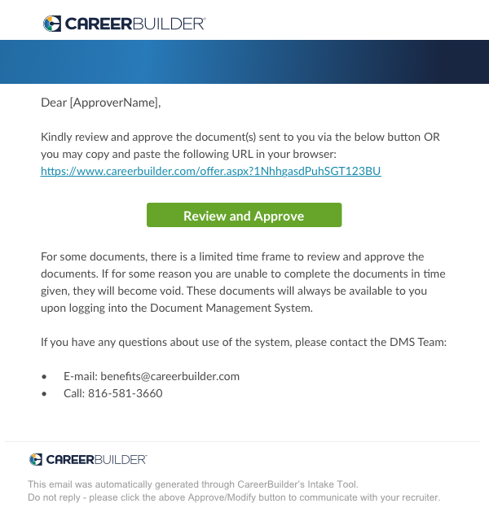

STEP4: Approver Open document and take action for Approve/ Reject/ Skip

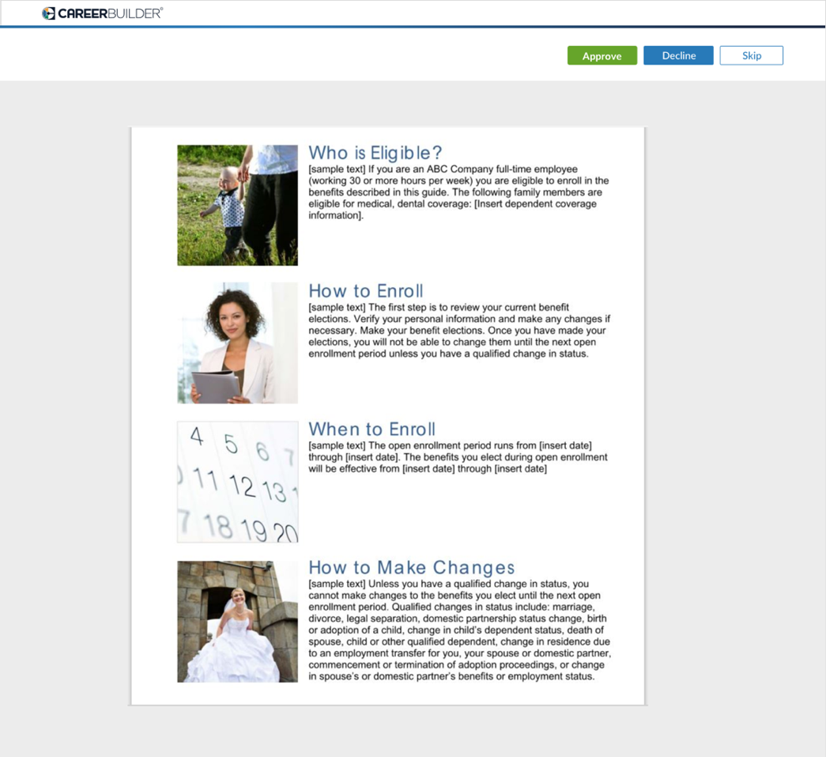
During Approve/ Decline process, approver can also put the comments.
*Storing signature by document (Multiple signer)

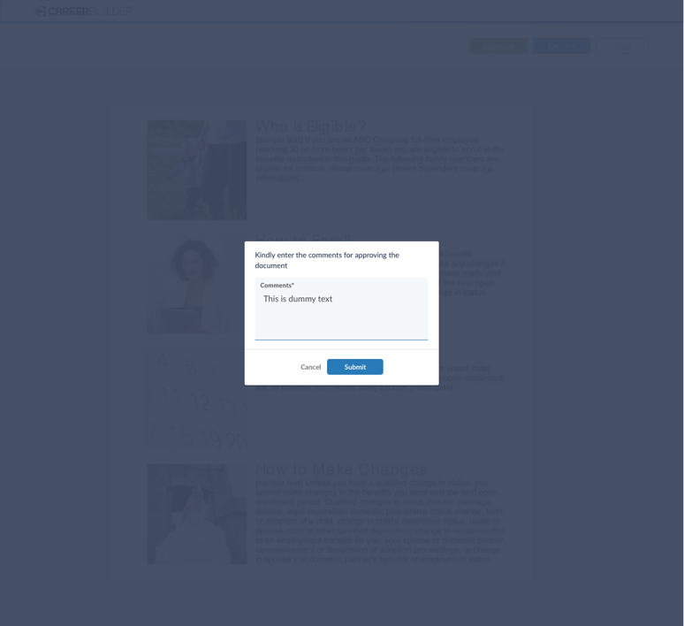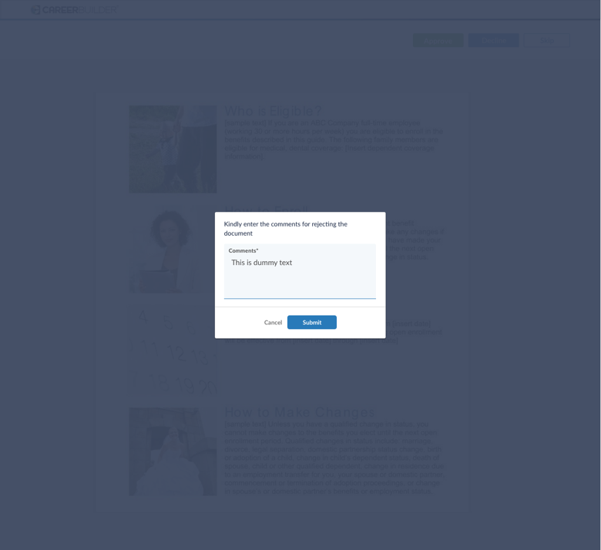

STEP5: Once all approvals done, document will be sent to the candidate. In case of decline document will be sent to originator with comments.

