Step 7 Change Notes 05.13.16
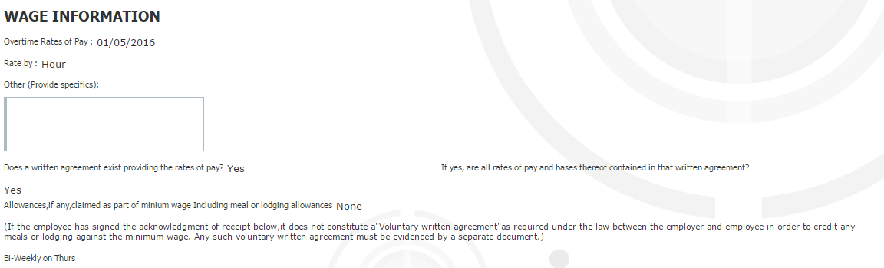
Overtime Rate of pay should not be a date. Should reflect information from Payroll page in BenAdmin.
Overtime Rate - If Overtime rate = 1.5
Show either “1.5 x regular hourly rate” or change verbiage on Step 7 Notice to Employee, Wage Information to “Overtime Calculator:” 1.5
Move response next to question.
___________________________________________________________________________________
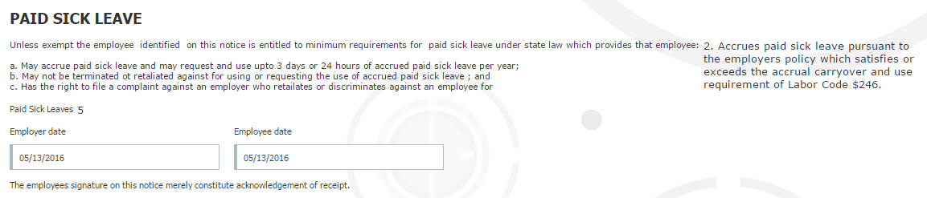
Now that the answer (ex 2. Accrues paid sick leave…) populates, remove a, b, c, bullet points and format pre-populated response to fall under top line.
Example
PAID SICK LEAVE
Unless exempt, the employee identified on this notice..
Accrues paid sick leave pursuant to…

