2016

Guide to Access OnBoard Forms
Table of Contents
1 Introduction 3
1.1 Purpose 3
1.2 Overview 3
2 System Configurations to Make Forms Available After Tunnel Completion 3
3 Steps for Admin to Retrieve Completed Forms 10
4 Steps for Employee to Access Completed Forms 14

Introduction

Purpose

The purpose of the document is to describe the steps using which forms completed during onboarding process will be made accessible to administrator and employee after the process is completed.

Overview

In the OnBoard module of WORKTERRA application employee completes some forms as a part of onboarding process. Currently these forms are not available to administrator and employee once the onboarding process is completed. However WORKTERRA application offers customizations using which such forms can be made available to employees and administrator. The customizations required for this are described in Chapter 2. Once the customizations are done the steps by which administrator and employees can access the forms are described in chapters 3 and 4 respectively.

System Configurations to Make Forms Available After Tunnel Completion

This chapter describes the configuration an administrator is required to do, so that the forms completed during onboarding stage are available to employees and administrator after the onboarding process is completed. Please note the forms to which these configurations are applied would also be visible to employee in the enrollment workflow. The steps are described below.
- Login to the WORKTERRA platform using administrator credentials. The company dashboard will be displayed.

- Click on the ‘Customizer Icon’ shown on the left menu bar. Please refer Figure 1 to see the icon.

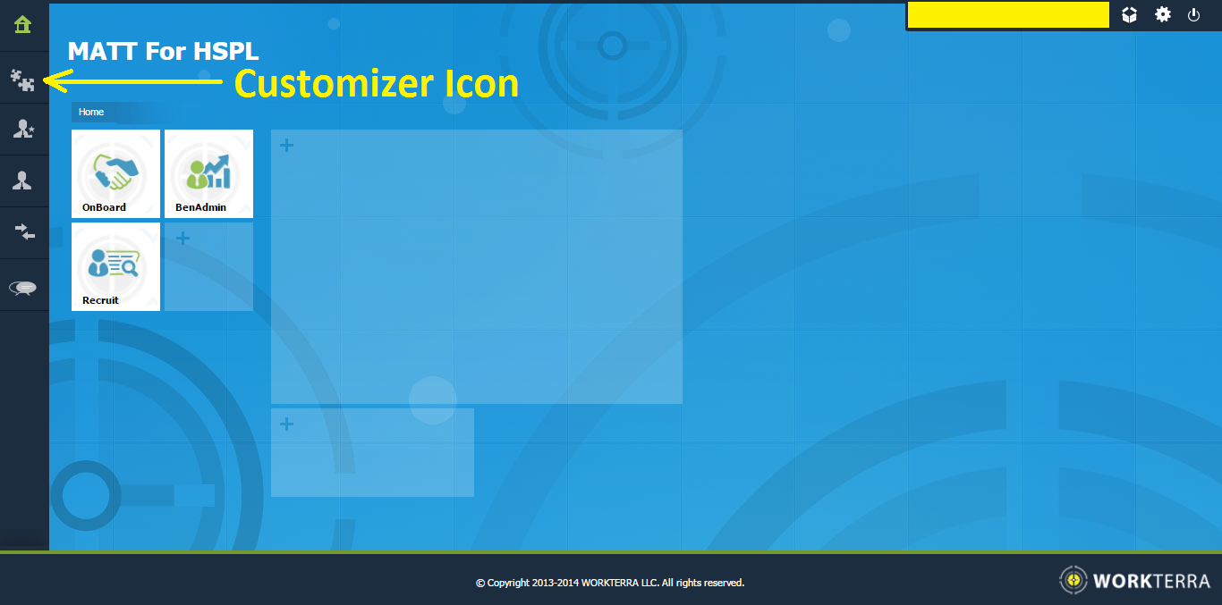
Figure 1: Company Dashboard - Customizer Icon
- On clicking the ‘customizer icon’ the left menu will open and the options as displayed in Figure 2 will be displayed. Click on the option ‘Employee Screen Configurations’

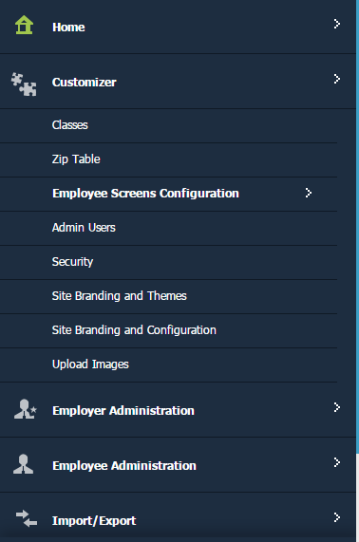
Figure 2: Customizer Menu Expanded
- On clicking the option ‘Employee Screen Configurations’ the menu would expand further and various options as shown in Figure 3 will be displayed. Click on the option ‘Form Builder’.
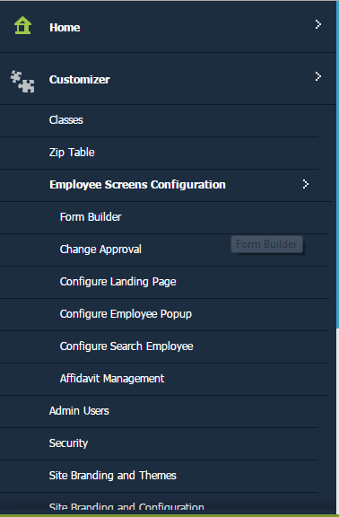
Figure 3: Employee Screens Configurations Expanded Menu
- On clicking the option ‘Form Builder’ the ‘Form Builder’ page similar to the one shown in Figure 4 will be displayed. The page would have list of different forms.

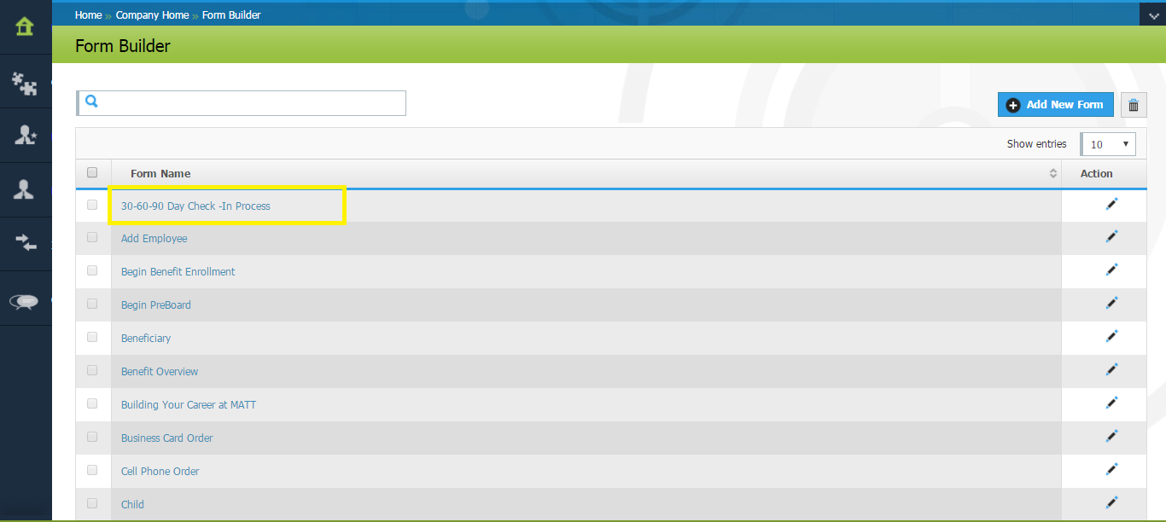
Figure 4: Form Builder Page
- Select the form which needs to configure so that it is available to employee and admin after completion of OnBoarding process. In our case we select the form ‘30-60-90 Day Check-In-Process’.

- On selecting the form the detailed configuration page similar to the one shown in Figure 5 will be displayed. By default the tab ‘Add Details’ will be loaded.

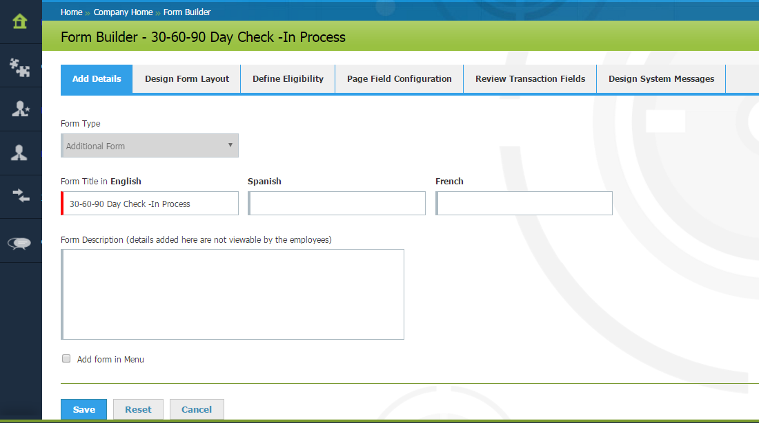
Figure 5: Details Configuration Page of a Form

- In the ‘Add Details’ tab select the checkbox ‘Add Form in Menu’. Once done click on the ‘Save’ button.

- A popup (Figure 6) indicating the successful update of form information will be shown. Click on ‘OK’ button to dismiss the popup.

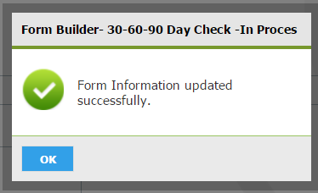
Figure 6: Popup Shown on Successfully Updating Form Information
- Now navigate back to company dashboard.

- Click on the ‘Employer Administrator’ icon shown on the left menu bar. Please refer Figure 7 to see the icon.
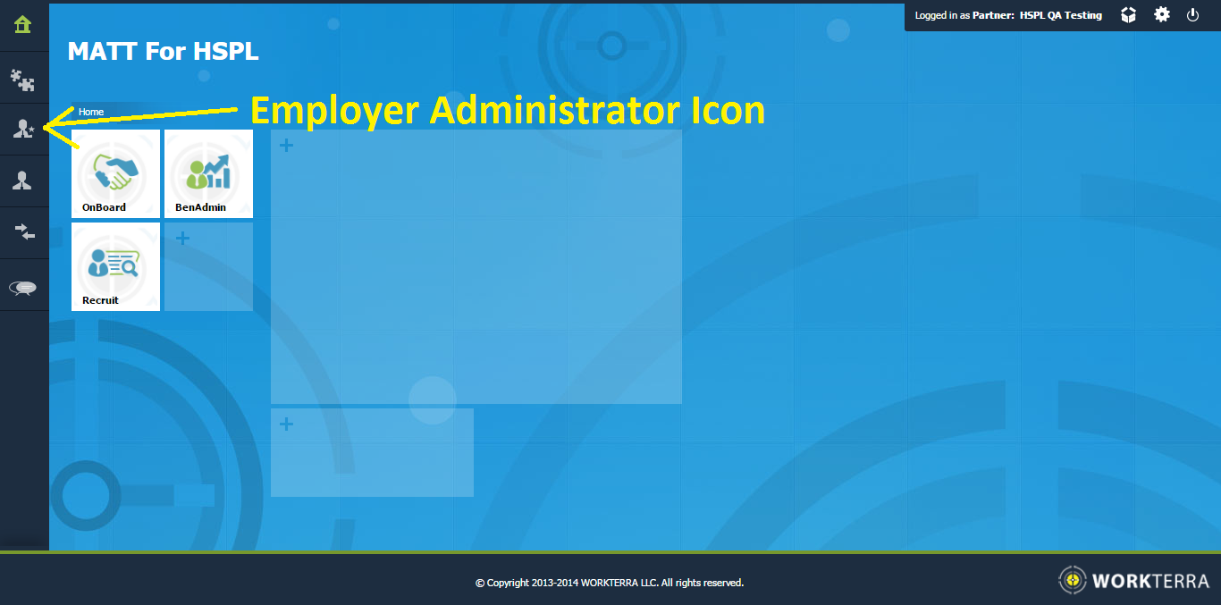
Figure 7: Company Dashboard - Employer Administrator Icon
- On clicking the ‘Employer Administrator’ icon the left menu will open and the options as shown in Figure 8 will be shown. Click on the option ‘Company Information’.

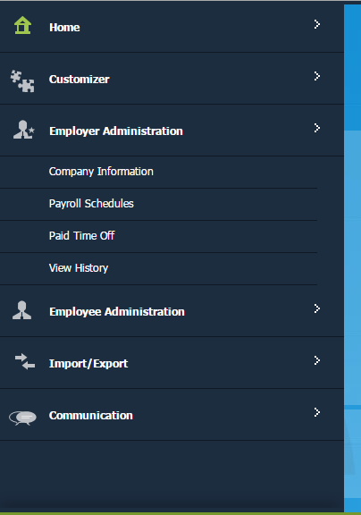
Figure 8: Employer Administrator Menu Expanded
- On clicking the option ‘Company Information’ the company Information page as shown in Figure 9 will be displayed.

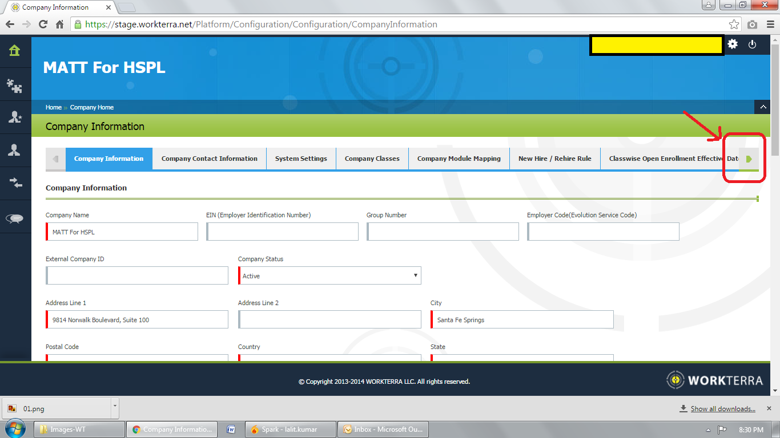
Figure 9: Company Information Page
- The company information consists of multiple tabs. Using the ‘Right Arrow’ icon highlighted in Figure 9 view more tabs and select the tab ‘Employee Data Screens’.

- On selecting the ‘Employee Data Screens’ tab the page shown in Figure 10 will be displayed.
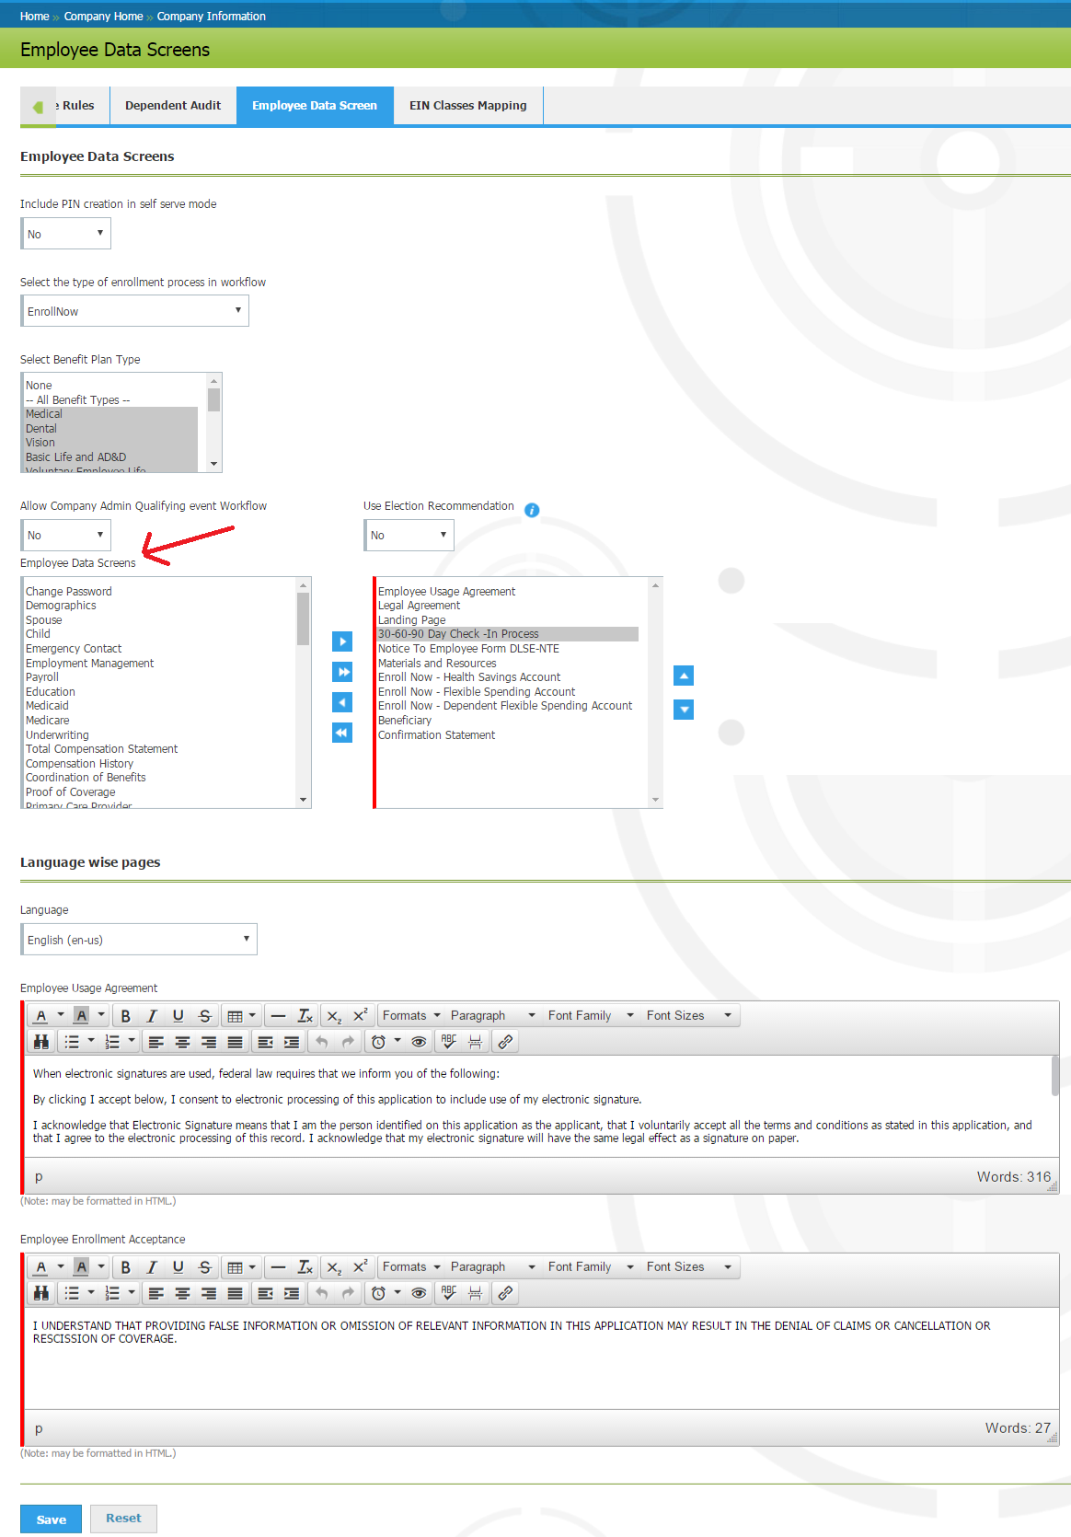
Figure 10: Employee Data Screen Page
- On the page ‘Employee Data Screens’ there is a field ‘Employee Data Screen’ having two list boxes as shown in Figure 10. The listbox on the left has the complete list of forms. The listbox on the right has the forms that are accessible to employees.

- From the listbox shown on left, select the form(s) that should made accessible to employee and move those page to the listbox on right by using the right arrow button.

- Once the forms are in the right hand side listbox you may order the sequence in which they appear using the up and down arrow button. Please note we have moved the form ‘30-60-90 Day Check-in Process’ to the listbox on right side.

- Once done click on the ‘Save’ button. A popup (Figure 11) indicating the successful update of ‘Employee Data Screens’ will be displayed.

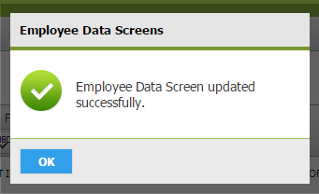
Figure 11: Popup Shown on Successfully Updating Employee Data Screens Page

Steps for Admin to Retrieve Completed Forms

This chapter described the steps using which admin can access forms of the employees. The steps are described below.

- Login to the WORKTERRA platform using administrator credentials. The company dashboard will be displayed.

- Click on the ‘Employee Administration’ icon shown on the left menu bar. Please refer Figure 12 to see the icon.

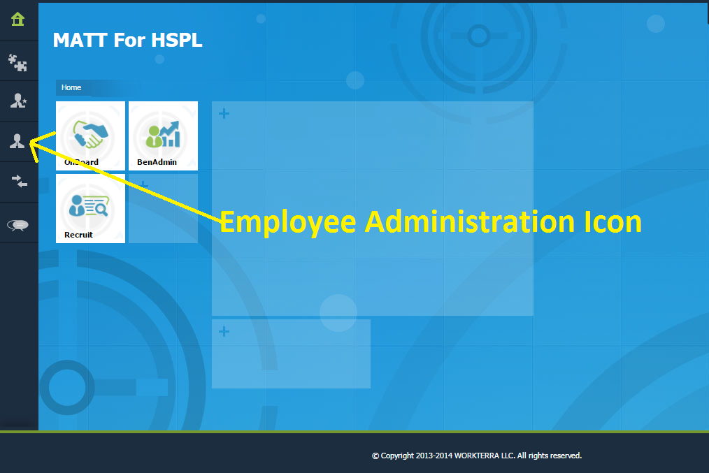
Figure 12: Employee Administration Icon
- On clicking the ‘Employee Administrator’ icon the menu will open and the options as shown in Figure 13 will be displayed. Click on the option ‘Search Employee’.

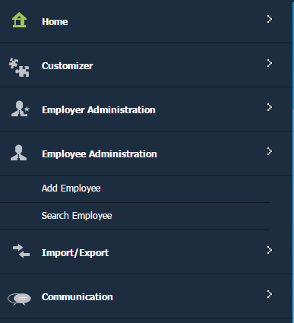
Figure 13: Employee Administration Menu Expanded
- On clicking the ‘Search Employee’ option the list of employee as shown in Figure 14 will be displayed.
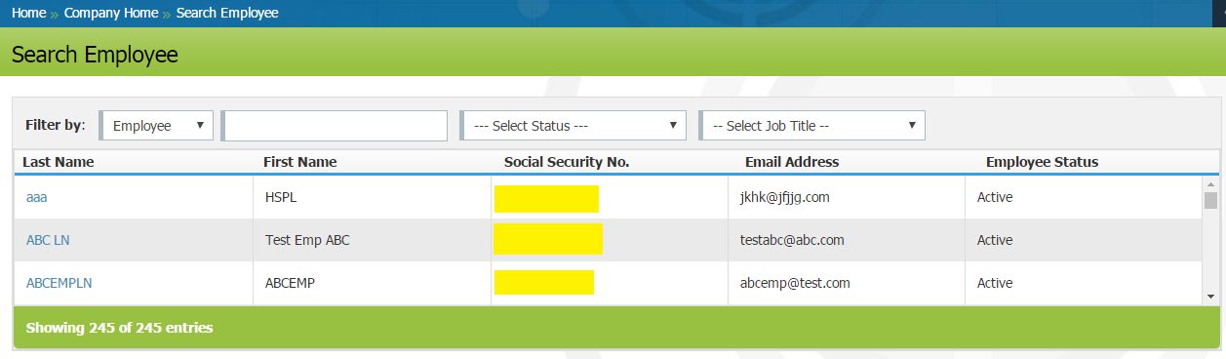

Figure 14: Search Employee Page
- From the list select the employee for whom the forms are to be viewed

- Once the employee is selected the dashboard for managing the employee similar to the one shown in Figure 15 will be displayed. Click on the ‘Employee Icon’.

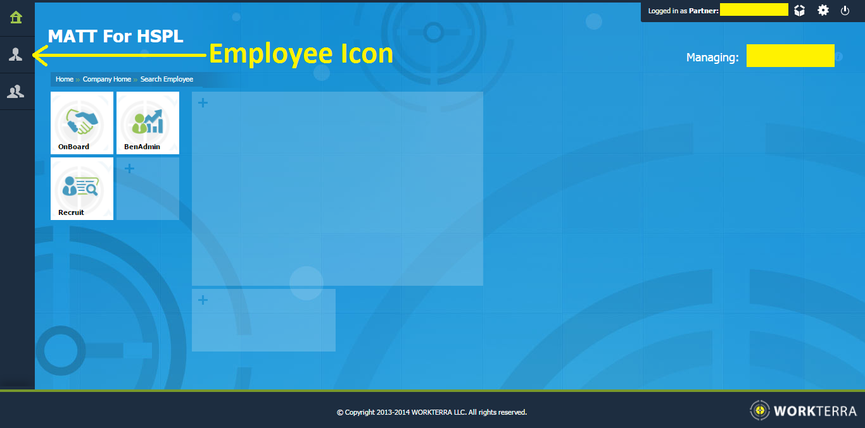

Figure 15: Admin View of Managing Employee
- On clicking the ‘Employee Icon’ the menu will expand and the various options as shown in Figure 16 will be displayed.
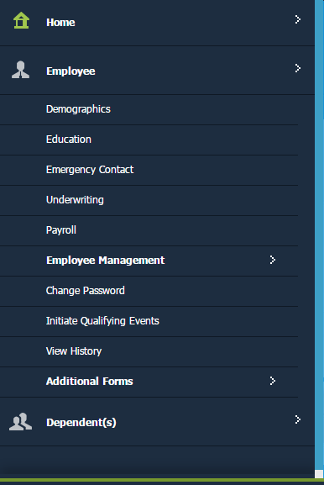

Figure 16: Employee Menu Expanded
- To view the list of forms for the employee click on the employee ‘Additional Forms’. The menu will expand the various forms for the employee will be shown.

- Figure 17 shows the list of additional forms. Click on a form to view it. The form ’30-60-90 Day Check-In Process’ added earlier is now available to the administrator.

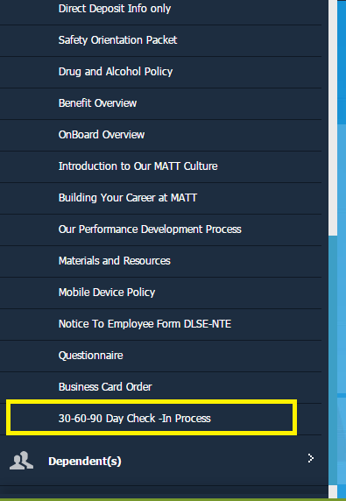

Figure 17: Additional Forms for Employee

Steps for Employee to Access Completed Forms

This chapter describes the steps using which employee can view the forms. The steps are described below.
- Login to the WORKTERRA platform using the employee credentials. The company dashboard.

- Click on the ‘Employee Profile Icon’ on the left menu bar. Please refer Figure 18 to view the icon.

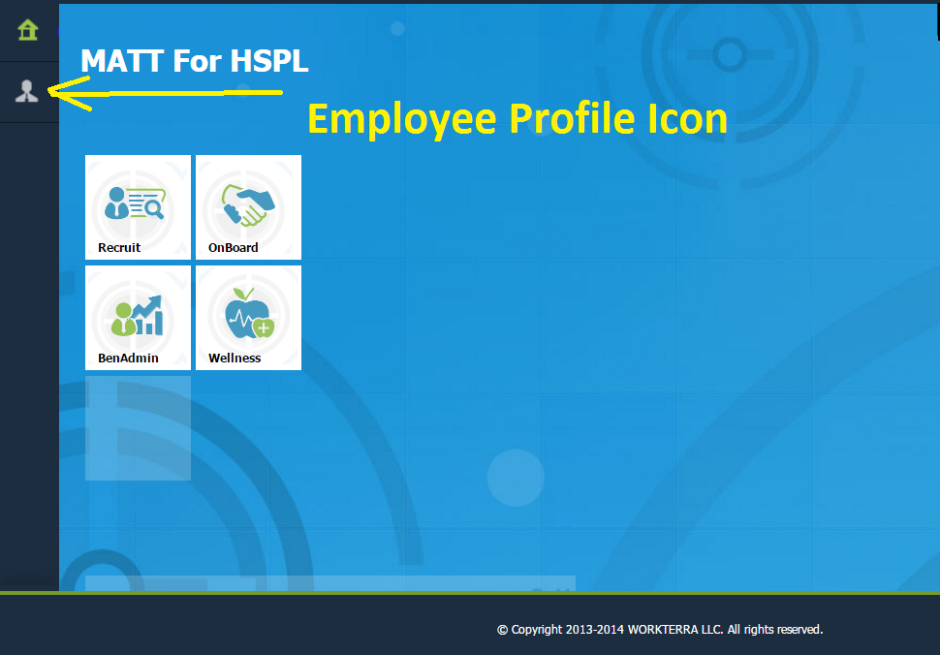
Figure 18: Employee Profile Icon
- On clicking the ‘Employee Profile Icon’ the menu will expand and the various options as shown in Figure 19 will be displayed.

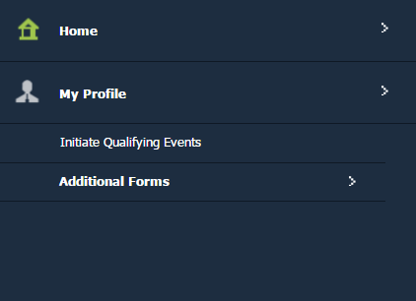
Figure 19: My Profile (Employee Profile) Menu Expanded
- To view the forms click on the option ‘Additional Forms’. The menu will expand the various forms accessible to the employee will be shown. Figure 20 shows an example of additional forms accessible to employee. The form ’30-60-90 Day Check-in Process’ can also be seen in the list.
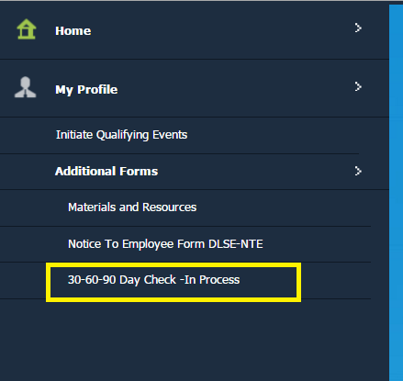
Figure 20: Additional Forms Accessible to Employee
- Click on the form to view it.

