quo
2016

New Hire Guide for Employers
Table of Contents
1 Introduction 3
1.1 Purpose 3
1.2 Overview 3
2 Adding Employee 4
3 Taking Tour 6
4 I9 Form Completion and Submission 6
4.1 Form Completion 7
4.2 Form Submission 9
5 Approve Changes 12
6 Review Documents 16

Introduction

Purpose

The purpose of this document is to serve as an end-to-end guide for employers for adding and onboarding a new hire.

Overview
WORKTERRA application comes with an onboard module, using which module employer can create preboard and onboard tour for the new hires. These tours allow seamless transition of a new hire into the organization. Once a new hire logs into the system he/she is asked to take the preboard tour and once it’s completed the new hire proceeds to the onboard tour. As soon as onboard tour is completed the employee is asked to complete the new hire enrollment. The employer on the other hands needs to complete and submit the I-9 form for the new hire and approve the documents and information provided by the new hire. The process is summarized in Figure 1
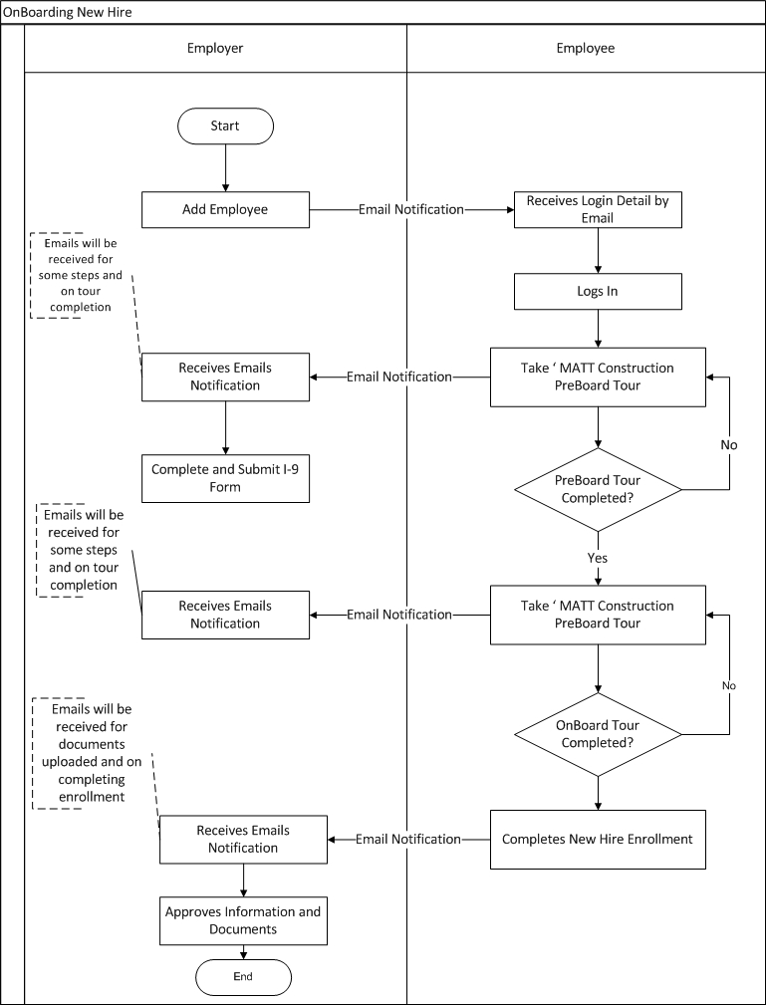
Figure 1: Onboarding a New Hire Process
During the new hire process the system sends email notifications to the employee (new hire) and employer for different events such as tour completion. However emails will only be sent if the settings are configured for them. The different settings are listed as footnote t different places in the document.

Adding Employee

In this section the process to add an employee (new hire) is described. Please follow the below points.

- Navigate to the company homepage. Click on the ‘Employee Administrator’ icon on the left menu bar. Please refer Figure 2 to see the icon.

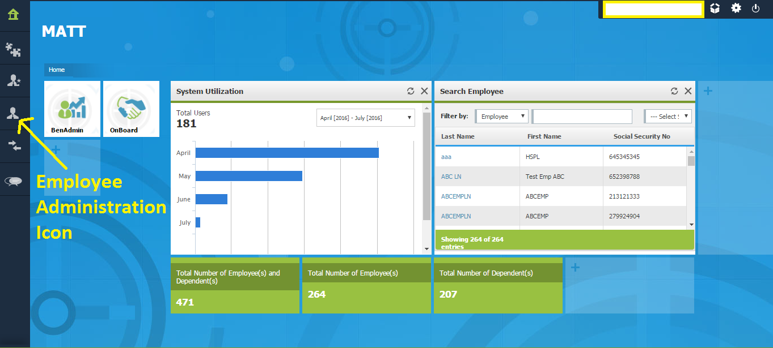

Figure 2: Employee Administrator Icon Marked
- On clicking the ‘Employee Administrator’ icon the left menu bar will expand and various options as shown in Figure 3 will be displayed.

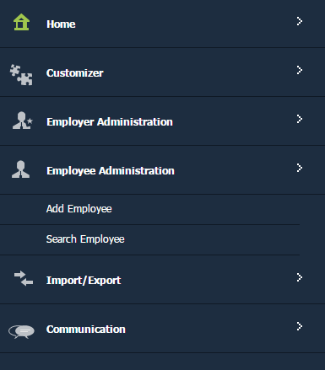
Figure 3: Employee Administrator Menu expanded
- Click on the option ‘Add Employee’. The page shown in Figure 4 to enter employee information will be displayed.
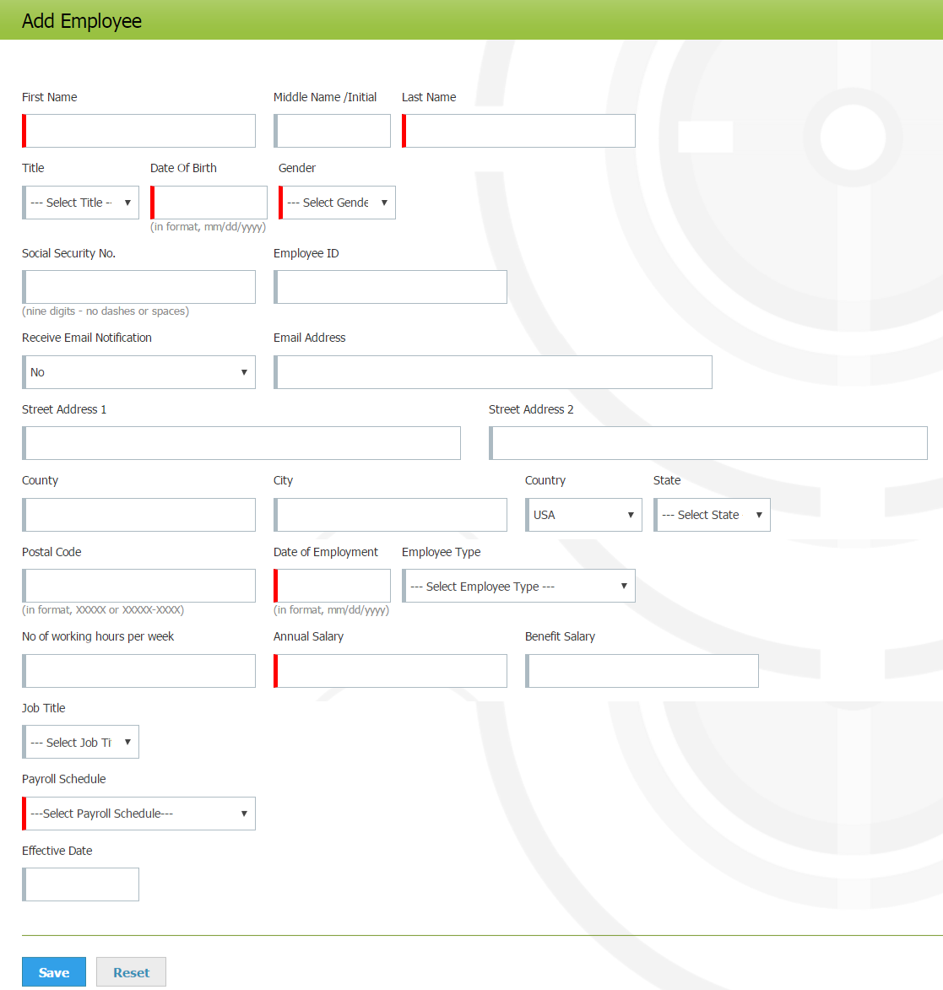

Figure 4: Form to Enter Information of an Employee to be added
- Fill the details of the employee to be added in the form shown in Figure 4. The details for the fields in the form are given below.

  - First Name, Middle Name / Initial, Last Name: In these fields enter the first name, middle name and last name of the employee respectively.
  - Title: In this dropdown select the title of the employee.
  - Date of Birth: In this field enter the date of birth of the employee.
  - Gender: In this dropdown select the gender of the employee.
  - Social Security Number: In this field enter the SSN of the employee
  - Employee ID: In this field enter the employee ID of the employee.
  - Receive Email Notification: In this dropdown select ‘Yes’ if the employee should receive notifications by email, else select ‘No’.
  - Email Address: In this field enter the email address for the employee
  - Street Address1 and Street Address2: In these fields enter address for the employee.
  - County: In this field enter the county for the employee address.
  - City: In this field enter the city for the employee address.
  - Country: In this dropdown select the country for the employee address.
  - State: In this dropdown select the state for the employee address.
  - Postal Code: In this field enter the postal code for the employee address.
  - Date of Employment: In this field enter the date of employment of the employee.
  - Employee Type: In this dropdown select the type of employee.
  - Number of working hours per week: In this field enter the working hours for the employee per week.
  - Annual Salary: In this field enter the annual salary of the employee.
  - Benefit Salary: In this field enter the benefit salary of the employee.
  - Job Title: In this dropdown select the job title of the employee.
  - Payroll Schedule: In this dropdown select the payroll schedule of the employee.
  - Effective Date:

- Once all the details are filled, click on the ‘Save’ button shown at the end of the form.
- A popup (Figure 5) indicating successful creation of employee will be shown.

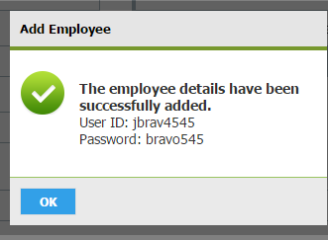

Figure 5: Popup Shown on Successfully Adding Employee
- The employee would receive an email having the username and password. Using these credentials employee can login to the platform.

Taking Tour

MATT Construction has 2 tours for the new hires. These tours are – ‘MATT Construction PreBoard’ and ‘MATT Construction OnBoard Tour’. The new hire would be first asked to take the ‘MATT Construction PreBoard’ tour .The steps in this tour are listed here.

- Welcome To MATT
- Begin PreBoard
- Demographics
- Questionnaire
- I-9 Verification: The form in this step must be completed by the employee no later than the first day of employment.
- W4
- Notice To Employee from DLSE-NTE
- Direct Deposit Info Only
- Safety Packet Orientation
- Drug and Alcohol Policy
- Mobile Device Policy
- Cell Phone Order
- Business Card Order
- Benefits Overview
- PreBoard Complete

Once this tour is completed, the employee will be asked to take the ‘MATT Construction OnBoard Tour’. The steps in this tour are listed here.

- OnBoard Overview
- Introduction to Our MATT Culture
- MATT Culture Video
- MATT Video Debrief
- Building Your Career at MATT
- What To Expect
- 30-60-90 Day Check-In-Process
- Our Performance Development Process
- Training and Development
- Materials and Resources
- Thank You

Among the steps listed for the tours, in some of these employee just needs to view the information provided (e.g. Welcome To MATT, OnBoard Overview) whereas in other steps employee is required to enter information (e.g. Demographics, W-4, and Safety Packet Orientation) to complete the step.

For steps in which employee is required to input information the employer would receive an email notification once the step is completed by the employee. The list of such steps for each tour is given below.

MATT Construction PreBoard Tour: Demographics, Questionnaire,W-4, I-9 Verification, Notice To Employee from DLSE-NTE, Safety Packet Orientation, Drug and Alcohol Policy, Mobile Device Policy, Cell Phone Order and Business Card Order.

MATT OnBoard PreBoard Tour: No Such step exists

Additionally employer would receive an email notification on the completion of each tour by the employee.

I9 Form Completion and Submission

Employers or their authorized representatives are required to complete and submit section 2 of the I-9 form within 3 business days of the employee’s first day of employment. The process for this is described in section 4.1 and 4.2.

Form Completion

Please follow the below steps to complete section 2 of the I-9 form.
- Select the employee from the employee list. A home page for managing the employee similar to the one shown in Figure 6 will be displayed.

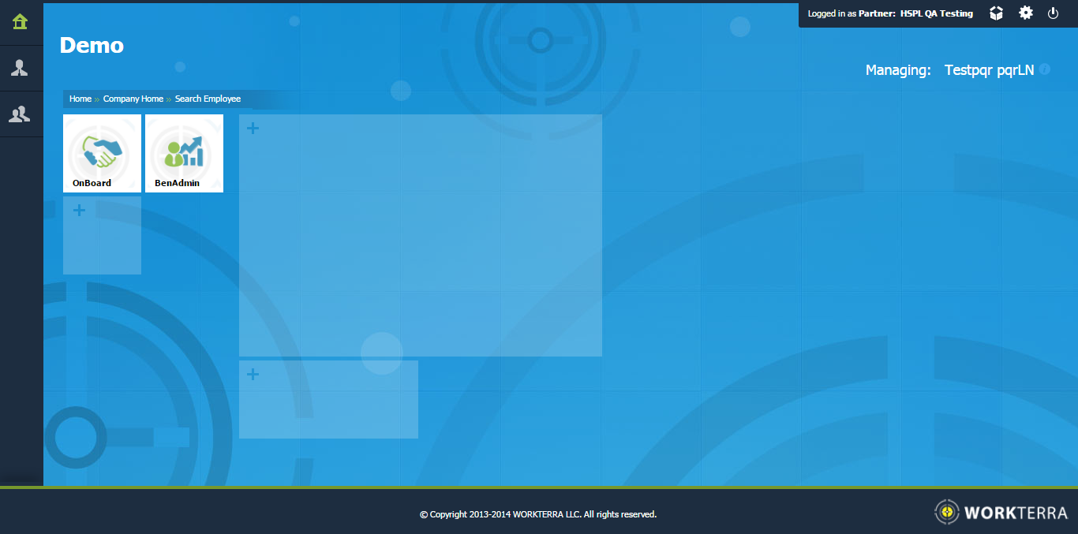
Figure 6: Home page for Managing Employee
- Click on the tile ‘OnBoard’. The onboard dashboard will be shown.
- Click on the employee icon on the left menu. The left menu will expand and various options as shown in will be displayed.

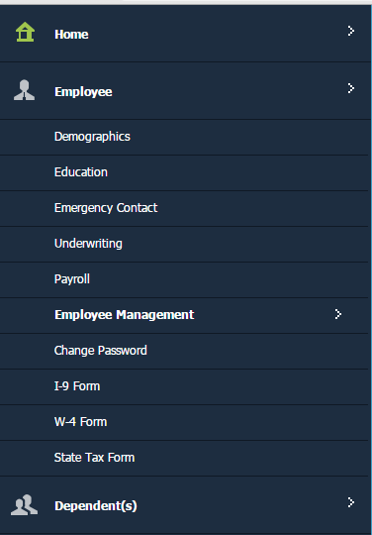
Figure 7: Employee Menu Expanded on OnBoard Homepage
- Click on the option ‘I-9 Form’. A page having the section 1 and section 2 of the form I-9 as shown in Figure 8 will be displayed.

  - The section 1 contains information as entered by the employee. Employer may edit the information if required.
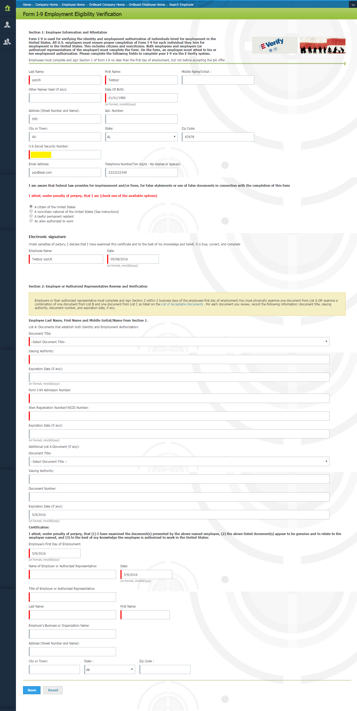

Figure 8: Employer View of Form I-9

- Complete the section 2 of form I-9 shown in Figure 8. Once all the information is entered click on the ‘Save’ button to save the form.
- Now submit the form by following the instruction given in section 4.2.

Form Submission

- Navigate to the I-9 Approval status page by either clicking ‘I-9 Approval Status’ tile on dashboard or navigating through menu (Employee Administration >I-9 Approval Status)
- The list of employees as shown in Figure 9 will be displayed.

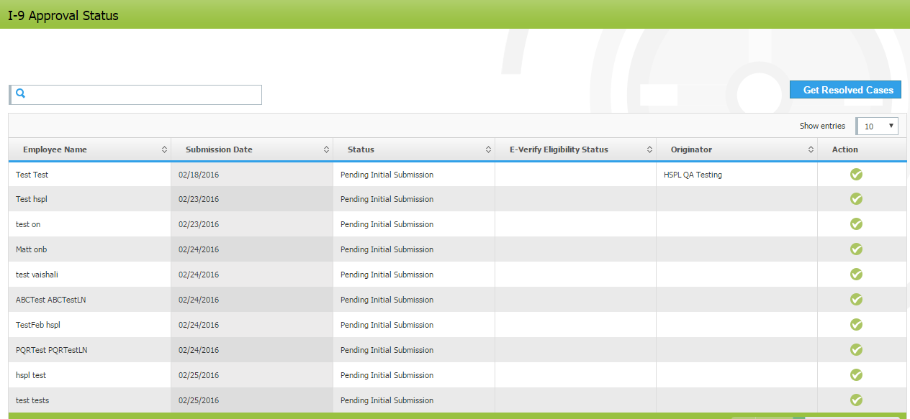
Figure 9: I-9 Approval Status Page
- In the list search the employee for whom I-9 information is to be submitted and click on the corresponding icon show in the column ‘Action’.
- A popup similar to the one shown in Figure 10 would be shown. The popup would have the information of the employee. Verify the information and click on the ‘Approve’ button.

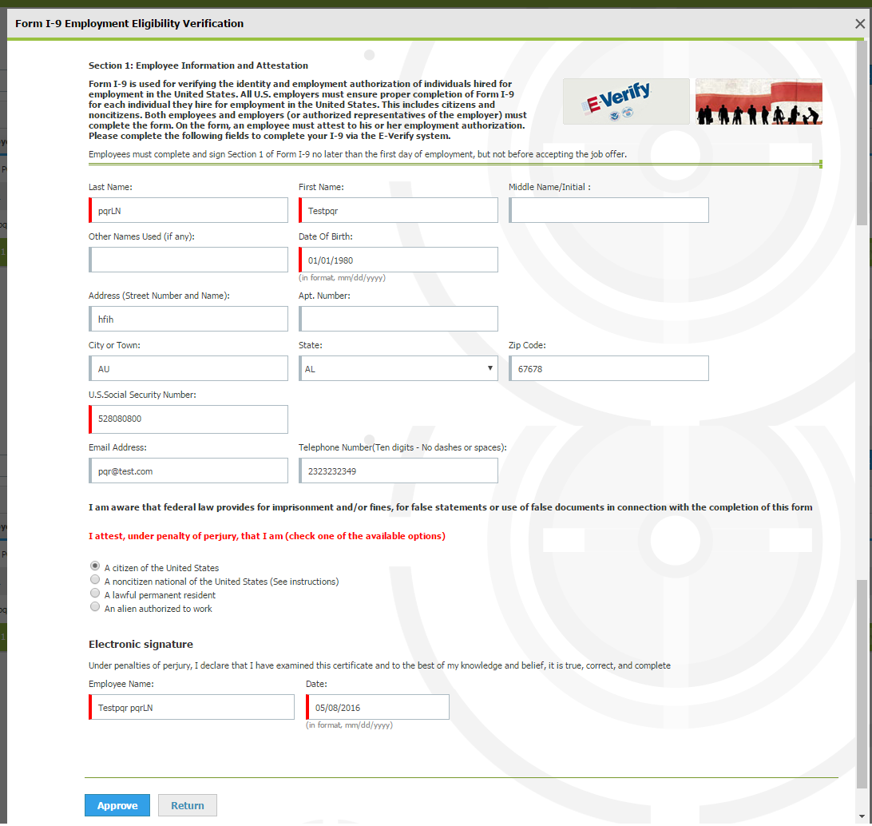

Figure 10: Popup Showing Information to be Approved for Submission
- On clicking the ‘Approve’ a popup similar to the one shown in Figure 11 will be displayed. If the information is correct click ‘OK’ else click ‘Cancel’

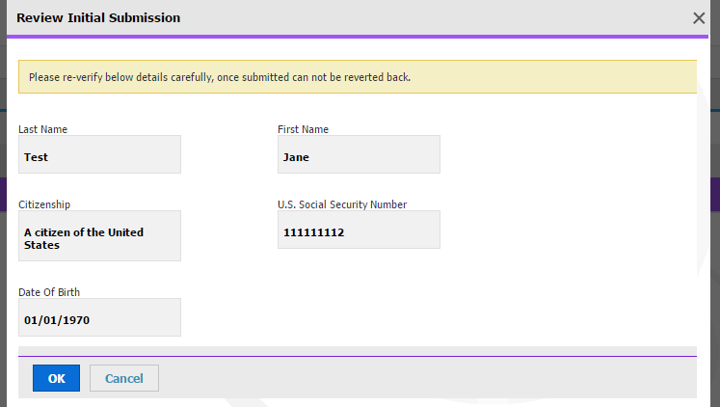
Figure 11: Popup to Review Approved Information
- Once the ‘OK’ button is clicked, another popup similar to the one shown in Figure 12 will be shown.

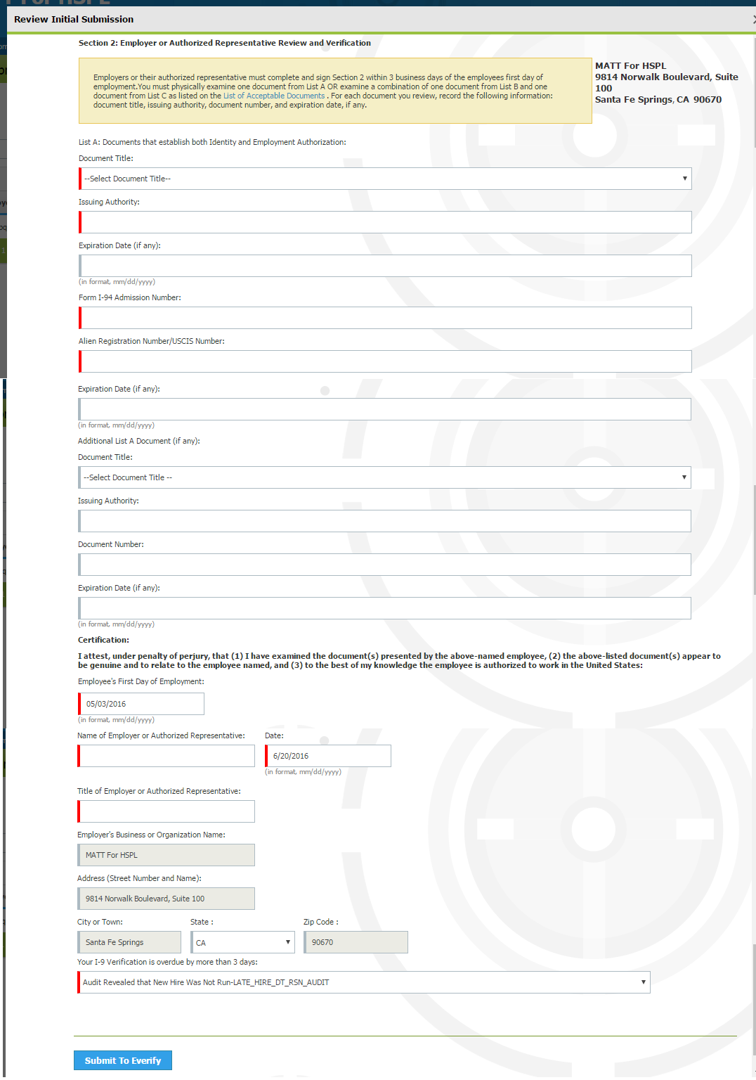
Figure 12: Popup to Submit Information to E-Verify

- Verify the information and if the information is correct, click on the button ‘Submit to E-Verify.’ The information will be submitted to the E-Verify service in the background. Please note the following points about the submission.

  - The submission to E-verify on stage won’t work for all employees.
  - On stage it only works for those set of employees whose data that is provided by E-verify for testing purpose.
  - The service would work on production for all employees.

- To view the resolved cases click on the ‘Get Resolved Cases’ button on the I9 Approval Status page.

Approve Changes

Once a new hire completes the new hire enrollment, the employer will receive an email indicating the same. During the new hire enrollment, the new hire would have added different details that need to be approved by the employer. Please follow the below steps to review and approve the information provided.
- Navigate to the ‘BenAdmin’ homepage by clicking on the tile ‘BenAdmin’ shown on the company homepage.

- Click on the icon ‘Employee Administration’ shown on the left menu bar, the menu will expand and the various options as shown in Figure 13 will be displayed.

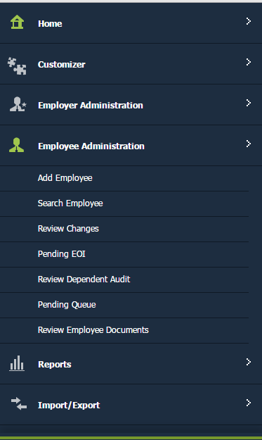

Figure 13: Employee Administration Menu Expanded on BenAdmin Homepage

- Click on the option ‘Pending Queue’, a page similar to the one shown in Figure 14 will be displayed. This page is used to show request pending for approval.

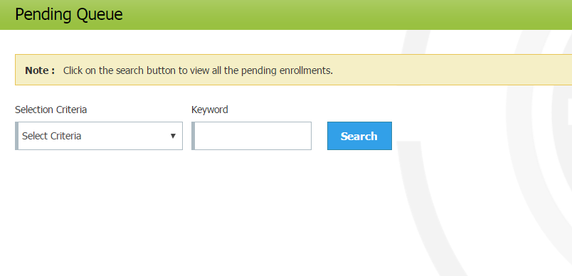

Figure 14: Pending Queue Page on Loading
- In the dropdown ‘Selection Criteria’ select the criteria by which you want to search requests pending for approval. The options available are – Employee First Name, Employee Last Name, Employee SSN, Job Title, Payroll Schedule and Employee ID.

- In the field ‘Keyword’ enter the text to searched using the criteria selected and click on the ‘Search’ button.

- The page would update and the different requests pending for approval will be displayed on the page. While displaying, the requests are grouped into different tables where each table is used to show a specific type of requests. In case no request exists of a particular type then the message ‘There is no data available’ will be shown in the corresponding table. The different tables (pending requests) and methods to approve them are summarized below.

  - Initiate Qualifying Events: In this table the change done to initiate qualifying events are listed for approval. A sample table is shown in Figure 15.

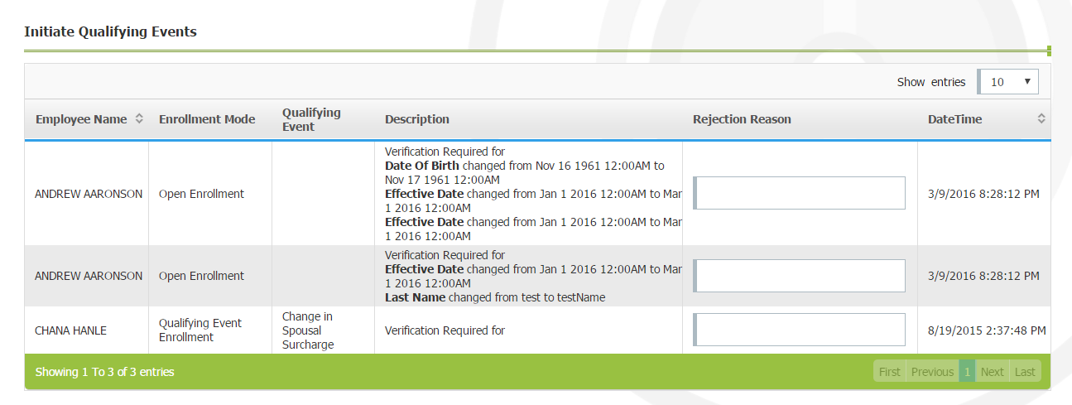

Figure 15: Sample Tables of Initiate Qualifying Events on Pending Queue Page

    - To review the request, move the mouse pointer on top of the employee name. A small band as shown in Figure 16 will be displayed. In case there are documents to be verified with the request click on ‘Verify Document’. A popup showing the list of uploaded documents will be shown. Click on a document to view it.

    - To accept the request click on the option ‘Accept’. A popup (Figure 17) indicating the successful completion of update will be shown.

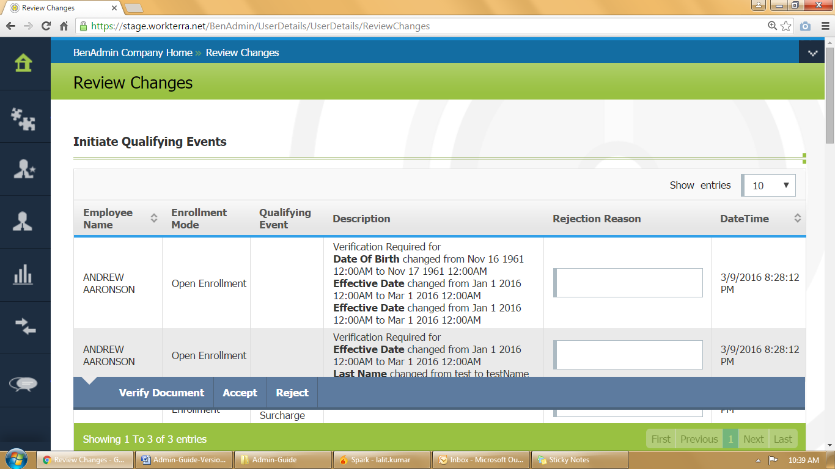
Figure 16: Options to Review Pending Item
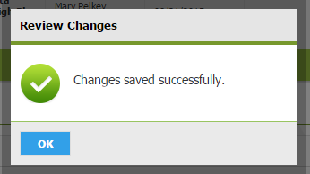

Figure 17: Popup Shown on Successfully Reviewing a Change Request

    - To reject the request enter the reason for rejecting the request in the field shown in the column ‘Rejection Reason’. Now move the mouse on top of the employee name and click on the option ‘Reject’. A popup (Figure 17) indicating the successful rejection of change will be shown.

  - Review Transaction Fields: In this table any changes done to fields marked as transaction field are listed for approval. A sample table is shown in Figure 18.

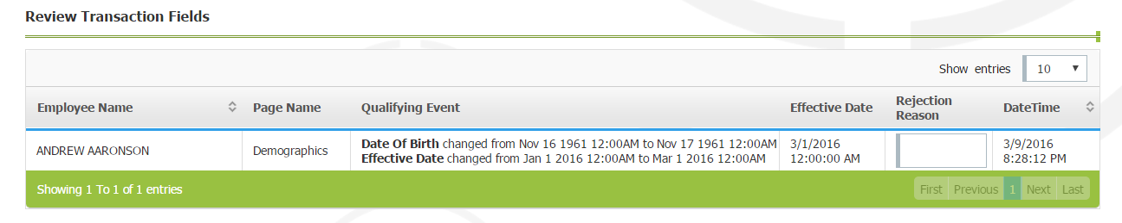

Figure 18: Sample Tables of Review Transaction Fields on Pending Queue Page
    - To approve these change requests follows the steps described for approving changes in Initiate Qualifying Events.

  - Review Child/Spouse Types: In this table any changes done to spouse and child information are listed for approval. A sample table is shown in Figure 19.

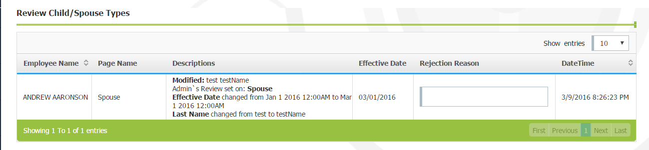

Figure 19: Sample Table of Review Child/Spouse Types on Pending Queue Page
    - To approve these change requests follows the steps described for approving changes in Initiate Qualifying Events.

  - Approval Pending Elections: In this table the elections which require approval are listed. A sample table is shown in Figure 20.

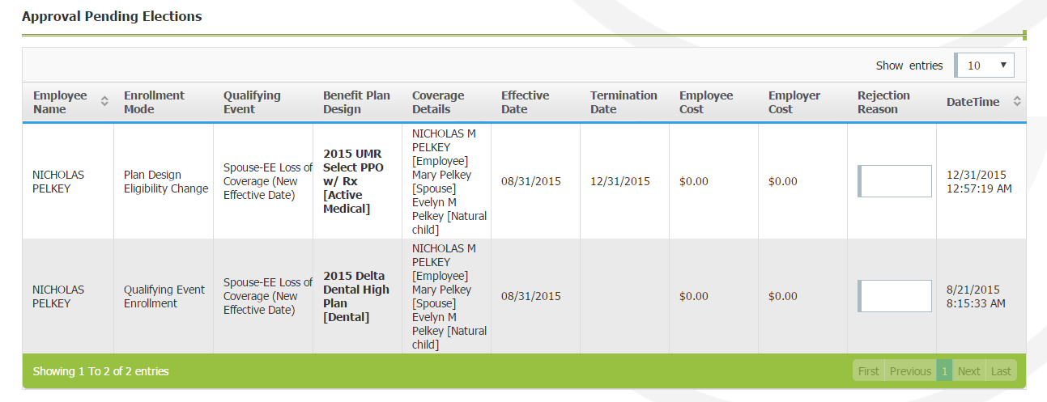

Figure 20: Sample Table of Approval Pending Election on Pending Queue Page
    - To approve these change requests follows the steps described for approving changes in Initiate Qualifying Events.

  - Approval Pending for Waived Elections: In this table any elections that are waived by an employee are listed for approval. A sample table is shown in Figure 21.

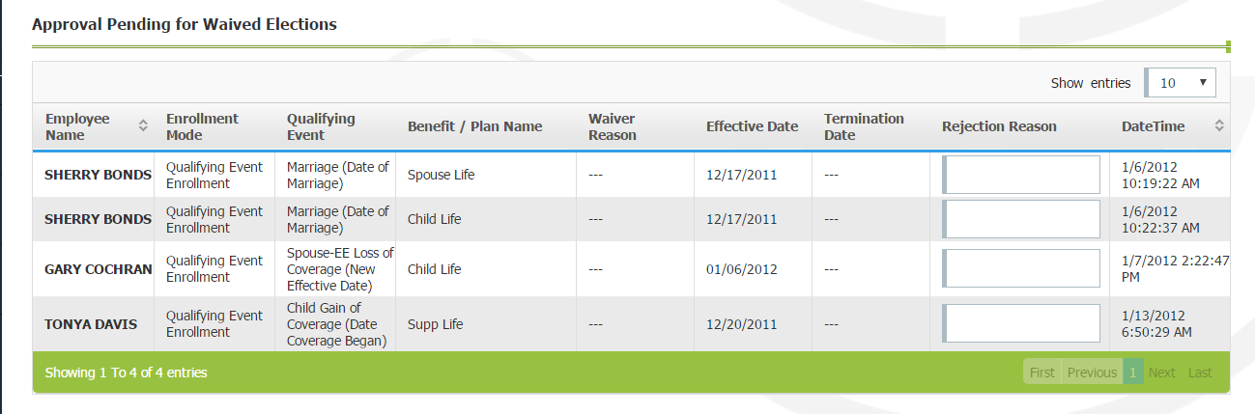

Figure 21: Sample Tables of Approval Pending for Waived Election on Pending Queue Page
    - To approve these change requests follows the steps described for approving changes in Initiate Qualifying Events.

  - Pending EOI: In this table the evidence of insurability provided by the employee are listed for approval. A sample table shown in Figure 22.

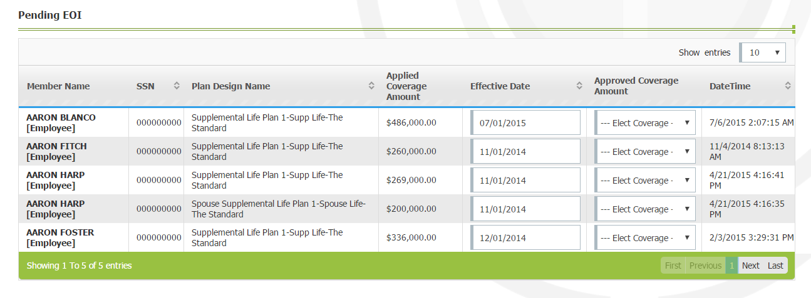

Figure 22: Sample Tables of Pending EOI on Pending Queue Page
    - To update an EOI request select the approved coverage amount using the dropdown shown in the column ‘Approved Coverage Amount’.

    - Once done, move the mouse pointer on top of the employee name. A small band as shown in Figure 23 will be displayed. To approve the EOI, click on the option ‘Update’ and to reject the EOI click on ‘Reject’.
Figure 23: Options Shown for a Pending EOI Entry
    - In case of ‘Update’, a popup (Figure 24) indicating the successful completion of the update will be shown.
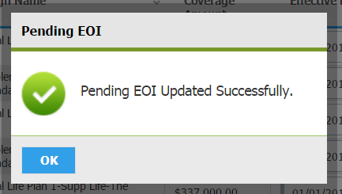
Figure 24: Popup Shown on Successfully Updating EOI
    - In case of ‘Reject’, a popup (Figure 25) indicating the successful rejection of EOI will be shown.
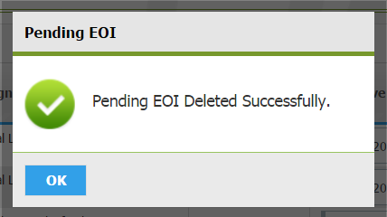
Figure 25: Popup Shown on Successfully Rejecting EOI
  - Review Dependent Audit: In this table the list of dependents (if any) whose information has been audited are listed in the table. A sample table is shown in Figure 26.
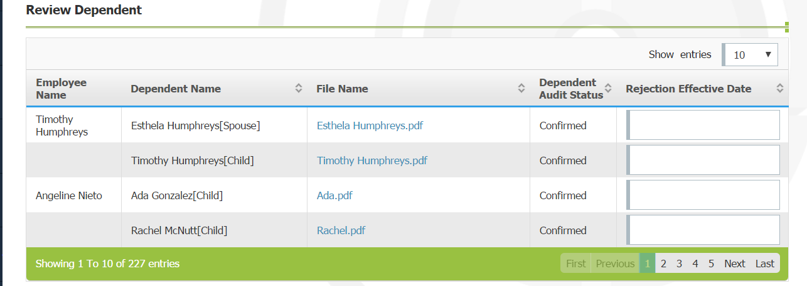

Figure 26: Sample Table of Dependent Audits Listed on Pending Queue Page
    - To review the request, move the mouse pointer on top of the employee name. A small band as shown in Figure 16 will be displayed. In case there are documents to be verified with the request click on ‘Verify Document’. A popup showing the list of uploaded documents will be shown. Click on a document to view it.

    - To accept the request click on the option ‘Accept’. A popup (Figure 17) indicating the successful completion of update will be shown.

    - To reject the request, enter the effective date of rejection and move the mouse over the employee name and click ‘Reject’.

- For every request that is approved or rejected by the employer the employee will receive an email notification.

Review Documents

During the new hire enrollment, the employee (new hire) may have uploaded documents that need to be verified and approved by the employer. For the each document uploaded by employee, the employer would have received an email notification. Please follow the below steps to review the documents.
- Navigate to the ‘BenAdmin’ homepage by clicking on the tile ‘BenAdmin’ shown on the company homepage.
- Click on the icon ‘Employee Administration’ shown on the left menu bar, the menu will expand and the various options as shown in Figure 13 will be displayed.
- Click on the option ‘Review Employee Documents’. A page ‘Review Employee Document’ similar to the one shown in Figure 27 will be displayed.

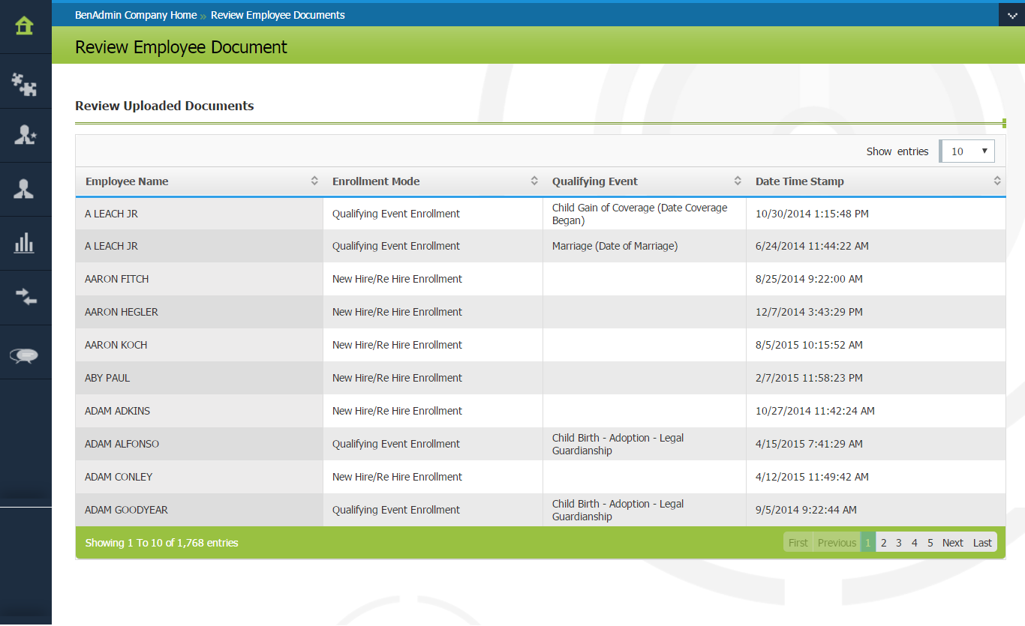

Figure 27: List Documents Uploaded by Employees for Review
- To verify these documents, move the mouse pointer on to the name of the employee shown in the first column. A small band having different options as shown in Figure 28 will be displayed.

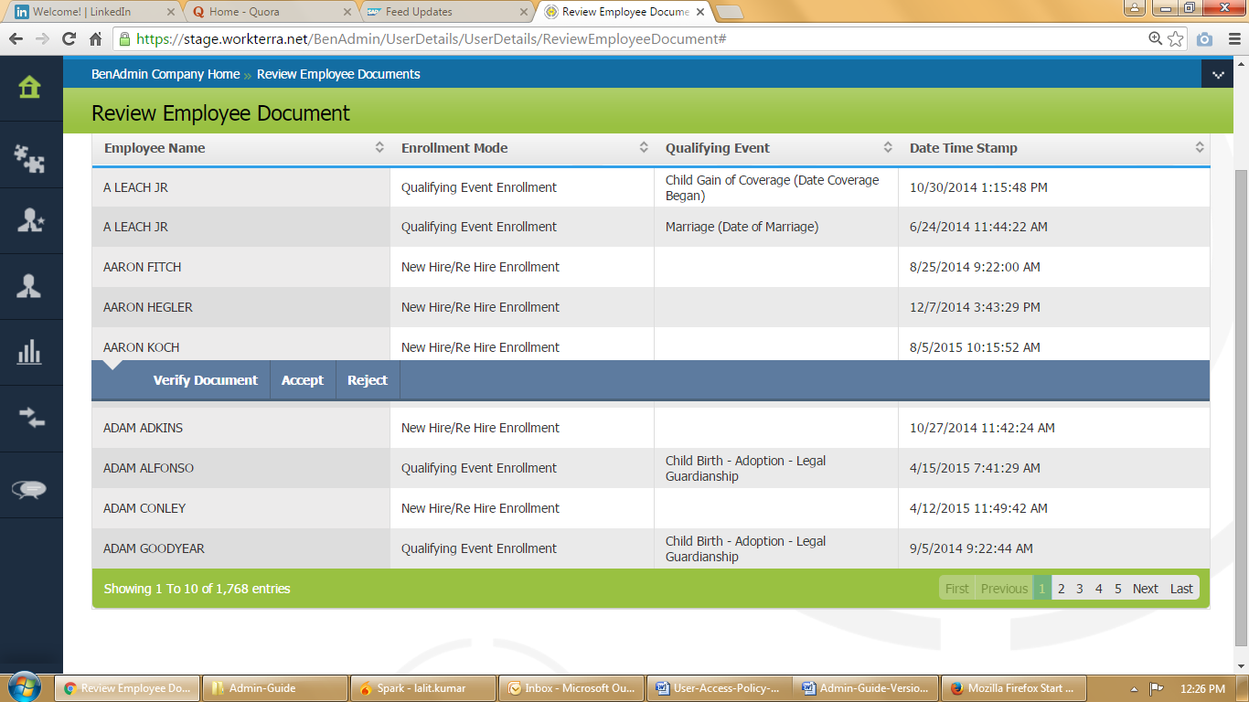

Figure 28: Options Shown to Verify Document Uploaded by Employee
- Click on the option ‘Verify Document’. A popup similar to the one shown in Figure 29 having the list of uploaded documents will be shown.
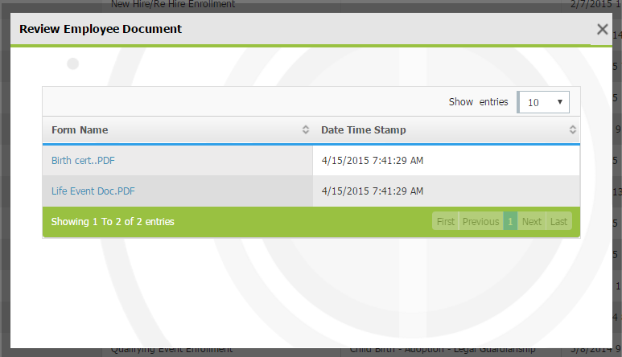

Figure 29: List of Documents Uploaded to Verify
- Click on a document to download and review it. Once all the documents are reviewed close the popup.

- After reviewing, the employer may either be accept or reject the documents.

  - To reject, move the mouse pointer on top of the employee name and click on the option ‘Reject’. A popup (Figure 30) indicating the successful completion of the update will be shown. Click on the ‘OK’ button to dismiss the popup.

Figure 30: Popup Shown on Successfully Reviewing Documents
  - To accept, move the mouse pointer on top of the employee name and click on the option ‘Accept’. A popup (Figure 30)) indicating the successful completion of the update will be shown. Click on the ‘OK’ button to dismiss the popup.

- The employee will receive an email notification about the acceptance or rejection of the uploaded documents.

Email will be sent only if: 1) ‘Receive Email Notification’ setting is set to Yes on Company Setting and Employee Page. 2) Email Address is provided for employee on Employee page. 3) ‘Email Message Format Status’ is enabled for ‘Add Employee’ in ‘E-mail Message Format Setting
Email will be sent only if: 1) ‘Receive Email Notification’ setting is set to Yes on Company Setting page. 2) ‘Email Message Format Status’ is enabled for ‘Additional Form Change Notification Employee’ in ‘E-mail Message Format Setting
Sending Email notification for this step is under development. Ticket for it is 1788
Email will be sent only if: 1) ‘Receive Email Notification’ setting is set to Yes on Company Setting page. 2) ‘Email Message Format Status’ is enabled for ‘Election Confirmation Notification’ in ‘E-mail Message Format Setting
Email will be sent only if: 1) ‘Receive Email Notification’ setting is set to Yes on Company Setting page. 2) ‘Email Message Format Status’ is enabled for ‘Upload Document Indicator’ in ‘E-mail Message Format Setting

