- Provide example of email to employee once loaded into WT
- Add in receive email explanation from WT – Possible explanation on page
  - Can it be defaulted to yes?
- MATT - Checking to see if Employer notice with Wage information form will be used as it does not connect to the demographic to fill in spaces correctly. Valerie will notify me.
- Change the below to just dashes
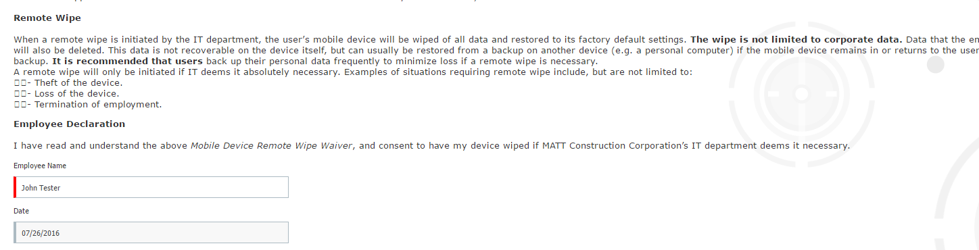
- Ben admin tunnel
  - First page with Materials and Resources to be removed
    - This is page #4 on the Ben Admin Employee tunnel
  - Can this Materials and Resources be replaced with the forms library?
- Is there a way to see their employee home page before completing the Ben Admin/new hire tunnel?
  - Would like to have a link to their home page before completion.
    - MATT will provide language to add to Ben Admin welcome until we have a firm answer on the above request
KS – send dev new benefit guide for 2016 beginning 7/1 to ensure will be loaded in OnBoard tunnel Included in today
- When eVerify approves and sends form back – goes back to Valerie with approval?
  - How do they login to eVerify? Amit – I have my answer that this is an SSO
  - Or is this an SSO? Are all of their admins included in the SSO? Amit – I have my answer that this is an SSO
- Will MATT be able to go back into eVerify to view the forms? Will they need to create their own account with eVerify to review forms at a later date?

- Where is the information on the phone number, survey, business card, etc. being housed in WT or is that just emailed to them?

- If they add interns as a class – can they have access to just preboard and nothing else?

