- Provide example of email to employee once loaded into WT
Harb Reply:
Please find instructions below-
Log-In with Partner/Admin credentials
Go to company home page
On left side menu click on Communications-Email Message Format
Select Category and you will find desired template.

-Add in receive email explanation from WT – Possible explanation on page
  - Can it be defaulted to yes?
- Harb Reply:
Yes this can be achvied for each new EE, this needs Dave’s approval.
- MATT - Checking to see if Employer notice with Wage information form will be used as it does not connect to the demographic to fill in spaces correctly. Valerie will notify me.
On-Hold-Waiting for inputs
- Change the below to just dashes
- Harb Reply:

We need to add dashes to Theft of the devices, Loss of the device, Termination of Employment, please confirm.
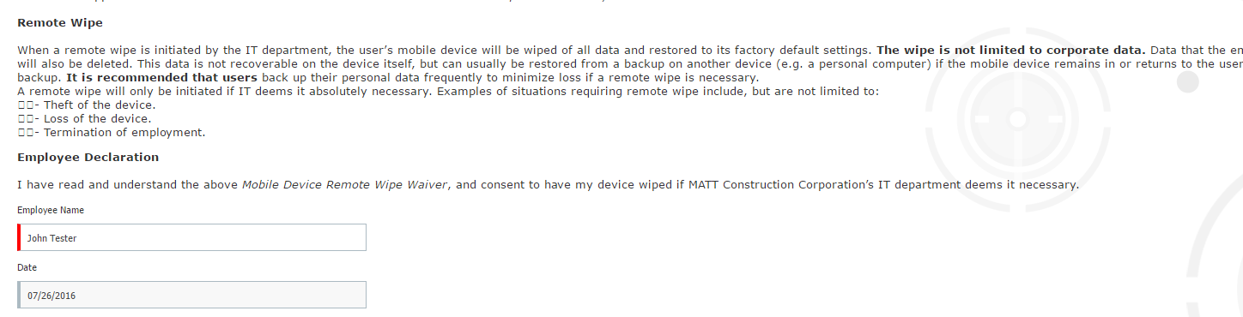
- Ben admin tunnel
  - First page with Materials and Resources to be removed
    - This is page #4 on the Ben Admin Employee tunnel
- Harb Reply:
This can be done but then,it will not be available in menu, i.e. this will not be available to EE at EE home page menu.
  - Can this Materials and Resources be replaced with the forms library?—Query
- Harb Reply:
Please elaborate on forms library? Is it the EE menu or actual Forms Library Page?
If it is a Forms Library then this is possible for .doc and .pdf.
Is there a way to see their employee home page before completing the Ben Admin/new hire tunnel?
Harb Reply: No

Would like to have a link to their home page before completion.- Harb Reply: No

    - MATT will provide language to add to Ben Admin welcome until we have a firm answer on the above request
KS – send dev new benefit guide for 2016 beginning 7/1 to ensure will be loaded in OnBoard tunnel Included in today Harb Reply: Received

- When eVerify approves and sends form back – goes back to Valerie with approval?
- Harb Reply: No this is not yet implemented.

  - How do they login to eVerify? Amit – I have my answer that this is an SSO
- Harb Reply: They need not have to log in, they will able to see all EE I9 information in WT along with Status.
  - Or is this an SSO? Are all of their admins included in the SSO? Amit – I have my answer that this is an SSO
- Harb Reply: No this is not a SSO.

- Will MATT be able to go back into eVerify to view the forms? Will they need to create their own account with eVerify to review forms at a later date?
- Harb Reply: They need not have to log in, they will able to see all EE I9 information in WT along with Status.
- Where is the information on the phone number, survey, business card, etc. being housed in WT or is that just emailed to them?
Harb Reply: This information is stored in WT, and is available in respective forms. This is not emailed to EE.

- If they add interns as a class – can they have access to just preboard and nothing else?
Harb Reply: Yes. Eligibility criteria can be set on tour for particular class.

