Provide example of email to employee once loaded into WT - COMPLETE
- Log-In with Partner/Admin credentials
- Go to company home page
- On left side menu click on Communications-Email Message Format
- Select Category and you will find desired template.

Add in receive email explanation from WT – Possible explanation on page
  - Can it be defaulted to yes?
    - Yes, this can be done. We will get approval and move forward
- MATT - Checking to see if Employer notice with Wage information form will be used as it does not connect to the demographic to fill in spaces correctly. Valerie will notify me. Will you be removing this page at this time?
  - Please let KS know if you would like this page removed for now
  - Development will continue to test to see if possibility of salary update in this page and notify if we can add back in
- Change the below to just dashes
  - Will be completed next week -
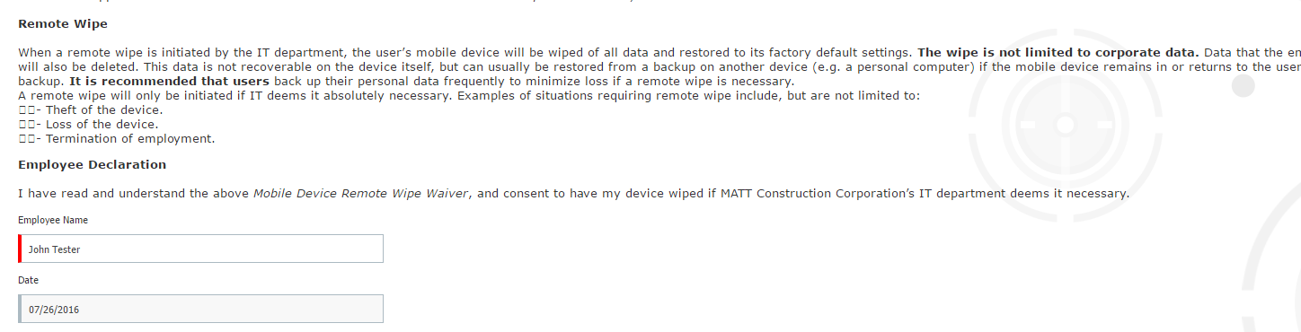
- Ben admin tunnel
  - First page with Materials and Resources to be removed
    - This is page #4 on the Ben Admin Employee tunnel
  - Can this Materials and Resources be replaced with the forms library?
- Is there a way to see their employee home page before completing the Ben Admin/new hire tunnel? This is not a possibility
  - Would like to have a link to their home page before completion.
    - MATT will provide language to add to Ben Admin welcome until we have a firm answer on the above request
      - Please provide KS language to add to the Ben Admin welcome page. Have not received language to date. Please provide updated language ASAP.
KS – send dev new benefit guide for 2016 beginning 7/1 to ensure will be loaded in OnBoard tunnel
- When eVerify approves and sends form back – goes back to Valerie with approval?
  - How do they login to eVerify?
  - Or is this an SSO? Are all of their admins included in the SSO?

- Will MATT be able to go back into eVerify to view the forms? Will they need to create their own account with eVerify to review forms at a later date? No, eVerify will send an email to the admin with approval. This set up is in progress.

- Where is the information on the phone number, survey, business card, etc. being housed in WT or is that just emailed to them? Awaiting response from Development.

- If they add interns as a class – can they have access to just preboard and nothing else?

  - Yes, this can be set up

FYI- New Harassment policy has been created on Matt main company on stage and is added in preboard tour before the safety agreement.

