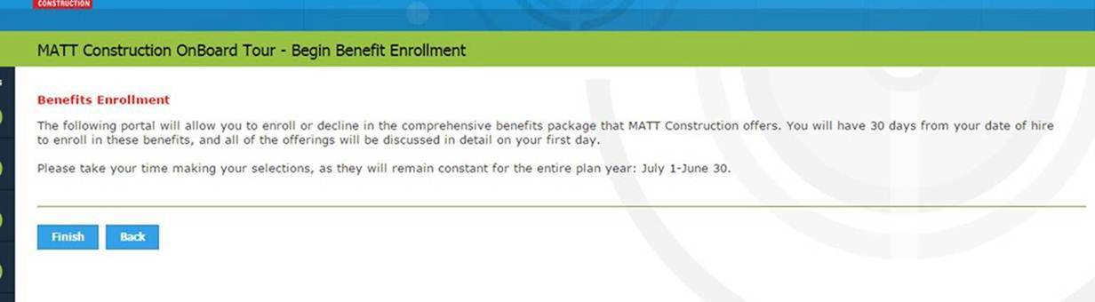

After “on your first day” please add:

It is mandatory to complete the following portal in order to reference previous materials. Please make the selections that you feel are appropriate for your circumstances, however these selections can be changed after you are able to ask any questions you may have.

Also after “July 1-June 30” please add:

once finalized.

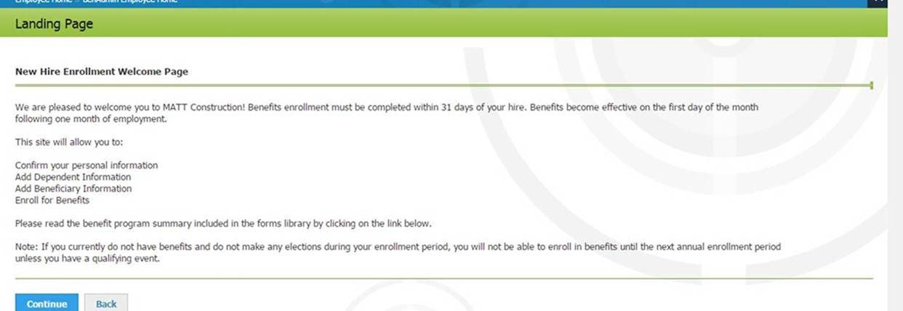
Please change the first line to “completed within 30 days of your hire” also change the second sentence to “Benefits become effective on the first day of the month following your date of hire”

Please add after the first line:
It is mandatory to complete this portal in order to reference previous materials. Please make the selections that you feel are appropriate for your circumstances, however these selections can be changed after you are able to ask any questions you may have.

