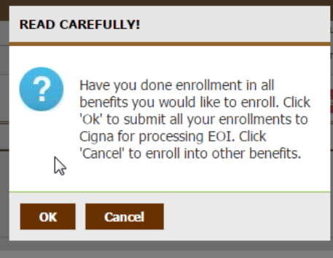
For the 1st pop up box, it would be great if the system could assume the employee wants to cancel to continue to continue to enroll in the additional benefits.
If you cannot do that, update the wording to show:
If you have enrolled in all benefits for life and disability that may require EOI you can click submit/OK. If you want to enroll in additional life and disability benefits that may require EOI click on Continue Enrolling/Cancel.

If the employee clicked on the Continue Enrolling/Cancel this box appears. Is there a way to NOT show this box?
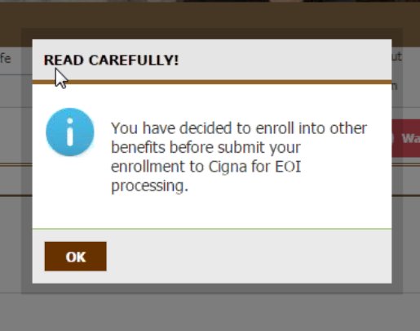

NOTE: The risk is if the employee chooses to Continue Enrolling/Cancel in other benefits but does not have any other EOI enrollments, EOI does not get to CIGNA. This is an issue that needs to be discussed/addressed.

For the Tunnel Flow, the benefits that require EOI must be grouped together for this flow to work.

Can DEV work on the flow so that the system can assume they want to Continue Enrolling/Cancel and then after the benefits with EOI rules if any EOI pending the system would come up with EOI submit page. Is that possible? Something like you have enrolled in all benefits that could require Evidence of Insurability (EOI); click on Continue to EOI submit to CIGN

