Upload I9 supporting documents

Requirement: New (static) form of "Upload I9 supporting documents"
- Features on form:
- Reflection of their selection from Form 1 –Need clarification
Sorry please ignore this. This is more for I9 Section 2 review, not I9 Section 1 input.
- 3 dropdown list of List A, List B and List C documents.
- Upload function (ability to upload multiple)
- Popup to show the list of accepted documents for I9
- Show the following below the Upload function "Supported Formats: doc, docx, ppt, pptx, pdf, jpeg, gif, png, bmp. Upload limit 4069 KB per file"
- Rules:
- When List A is selected, List B and List C should be non-clickable.
- When List B or List C is selected, List A should be non-clickable and it is mandatory they also select List B or List C
- Date and Time of upload should be logged and show up within "View History"
- Respect the accepted file format and file size–Need clarification
This is referring to validation of supported file format and size when uploading the document e.g. reject any .exe file or file size exceeding 4069KB
- When saving file, replace name with "I9 Supporting Doc" and the type e.g. I9 Supporting Doc - US Passport
Referencing query 6, instead of replacing the filename, we can have this as document category.

Approach:
- On new page, there will be 3 dropdown lists for List A, B, C.
- We will display the message on this page that “You should upload documents those you are mentioning on i9 form.”
- As per the citizenship type selected on I9 form, we will restrict user to upload those documents only. E.g. If user has selected “US Citizen”, from List A , he will see US passport or passport card only.
In view of the backlog, I recommend for this phase we don’t cross check and limit the document type based on profile first. It is no doubt a good feature and we will add it to backlog.
- Upload file controls will be there under each of the category.
- At the bottom, save button will be there. On click of which, database record will be inserted for each document uploaded.
- Employee can be searched and we will let the employee know. We will maintain history for these uploads. It will be shown under Employee View history page for each employee.

Queries:
- Should we allow employee to upload multiple documents with same category if the already uploaded document expires or employee is rehired?
Yes we should not limit and we should not overwrite either. We can decide on purging rule (if any) for supporting document subsequently.
- Should uploaded documents be approved by admin? Provide approval button for admin approvals?
Nope. The section 2 verification will have to be physical copies, not online upload.

I already have a backlog task down the road so companies can see the uploaded document in Section 2 review step (in case they upload one but hand over another document).
- If yes, Should we freeze deletion / updating of documents once they are approved?
I don’t think there is any deletion of uploaded document anyway. Where are you seeing this?
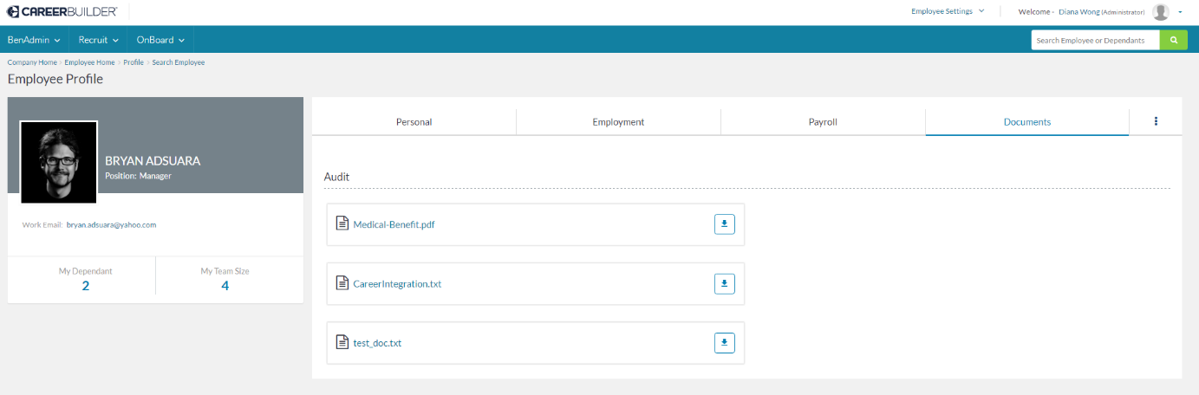
- Should we have a report for these uploaded documents (For analytics)?
For now, no. I can have that in the backlog once again but I will think the usage will be infrequent.
- Should employee be allowed to change the uploaded document under specific document type (List A or List B or List C) at any point of time?
Employee should submit another I9 if they need to update the uploaded document. In that way, we can log the reason and update, and can have both documents on hand.
- If we replace name of original documents, employee would be confused when he/she downloads the document and the name of uploaded is document is different from that of the downloaded document (For e.g. Employee uploads document with name P1.pdf. When he downloads, it will get download as “I9 Supporting Document – US passport”)
Good point team. Do we have some sort of a document category so we can retain the file name but still have some indexing of the supporting document. I have attached Workday’s uploaded document page here for reference. We can then consider how we can reflect category on the new profile page.
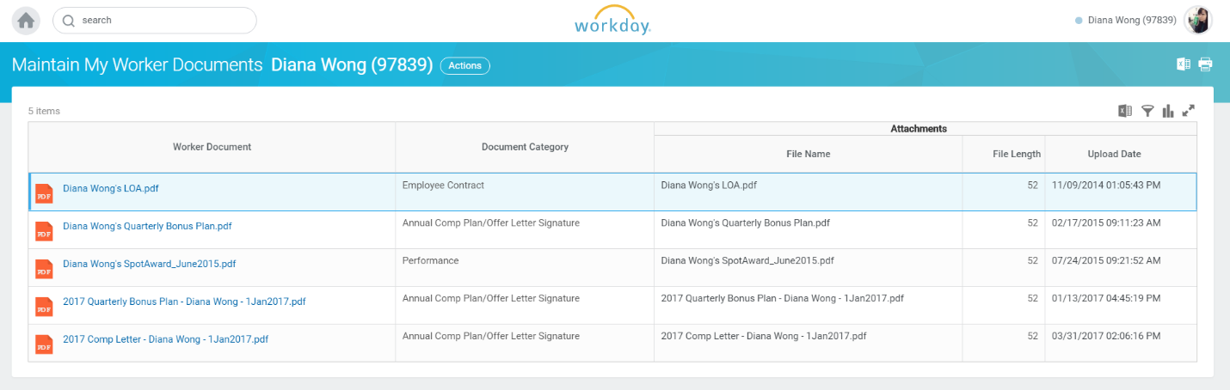
- What information should be included in the view history?
I am checking existing View History page and the information shown here should suffice.
