Table of Contents
1 Account setup in WORKTERRA 3
1.1 Account Setup on Stage 3
1.1.1 Create company on Stage 3
1.1.2 Create User Access Policy for Admin 3
1.1.3 Create Admin Account 3
1.1.4 Create Payroll Schedule 3
1.1.5 Review Email Messages Status and Format 3
1.1.6 Set New Hire /Rehire Rule 4
1.1.7 Setup User id and Password Generation for Employees (New Hires) 5
1.1.8 Tour Setup 6
1.1.9 Configurations 6
1.2 Moving Account to Production 6
1.3 Account Setup on Production 6
1.3.1 Create User Access Policy for Admin 6
1.3.2 Create Admin Account 6
2 TSR – OnBoard Flow 8
3 Setting up the Onboarding tour in WORKTERRA: 8
4 Sending the Onboarding tour to the candidate from TSR 9
5 For the Admin, in WT: 11
6 For the admin, in TSR: 12
7 For the employees: 13
8 TSR + OnBoard 14
8.1 Tour (PreBoard) Availability 14
8.2 Employee Experience while in Tunnel 14
8.2.1 Employee Login in Before Tour Available Date 14
8.2.2 Employee Login in After Tour Available Date but Before Start date 14
8.2.3 Employee Login in after Start date but before New Hire End Date 15
8.2.4 Employee Login in After New Hire End Date 15
8.3 Post Tunnel Experience 15
9 TSR + OnBoard + BenAdmin (No Waiting Period) 16
9.1 Tour (PreBoard) Availability 16
9.2 Employee Experience while in Tunnel 16
9.2.1 Employee Logs In Before Tour (PreBoard) Available Date 16
9.2.2 Employee Logs In After Tour Available Date but before Start Date 16
9.2.3 Employee Logs In After Start Date but Before New Hire Enrollment Window Ends 17
9.2.4 Employee Logs In After New Hire Enrollment Window Ends 17
9.3 Post Tunnel Experience 18
10 Checklist 18
11 Appendix 18
11.1 List of Tour Status 18
11.2 List of I-9 Status 19

Account setup in WORKTERRA

In account setup process of WORKTERRA, the account is first setup on stage environment and once UAT is done the setup is moved to the production environment. Please note the following points about this movement.

- The data created during UAT can be removed during move to production if needed.
- The admin accounts created on stage will not be moved to production.
- Any user access policy is not moved to production during this process.

Account Setup on Stage

Create company on Stage

The company should be created on stage environment. The module ‘OnBoard’ should be selected for “TSR + OnBoard” and the modules ‘OnBoard’ and ‘BenAdmin’ for “TSR + OnBoard + BenAdmin”
- Please note it is mandatory to create at least one class while creating a company. This can be any dummy class value which can be updated at a later stage.

Create User Access Policy for Admin

If a user access policy is not in place, a new policy should be created to define the actions the admin can perform. The policy should also be mapped to companies for which it will be used.

Create Admin Account

An admin account should be created and the appropriate user access policy should be assigned to it.

Create Payroll Schedule

At least one payroll schedule should be created in the company.

Review Email Messages Status and Format

The notifications to be delivered as email messages are available on the page: Communication >> Email Message Format. A default subject line, and email body is provided for each such email. For each email there is a flag ‘Email Message Format’ that should be in the state ‘Enabled’ for the emails to go out. By default this is disabled.

- For “TSR + OnBoard”

  - Following email messages are to be reviewed:

    - Change Password
    - Forgot Password
    - Add Employee
    - Tour assignment notification
    - Tour reminder notification
    - Tour completion notification
    - Tour cancellation notification

  - Review should include the following

    - The ‘Email Message Format’ flag should be enabled.
    - Any changes if required in default subject line and body of the email should be done.
    - If anyone needs to be in CC or BCC list of email notification add those in the respective fields.

  - For “TSR + OnBoard +BenAdmin”
    - In addition to above emails, there are multiple emails available for BenAdmin they should be enabled or disabled as per the requirements.

Set New Hire /Rehire Rule

The new hire/rehire rules should be setup using the settings available on the page “Employer Administrator >> Company Information >> New Hire/Rehire Rule”.

Settings for TSR + OnBoard

- Creating a new/rehire by using following settings

- Rule Name: A name for the new hire/rehire rule should be provided.

- New Hire Waiting Period: This should be set as 0.

- New Hire Enrollment Window Rule: In this dropdown multiple rules are listed to determine the date till which new hire enrollment window (also called new hire window) will be available.

  - Select the rule ‘XX’ day(s) from Date of Hire’ and in the adjacent field enter the number days. For example if the value 30 is entered the new hire window would be till 30 days from date of hire.

- For the other configurations on the page below are the recommended settings:
  - Ignore New Hire Period During Open Enrollment: Set this to ‘No’
  - Ignore Open Enrollment During New Hire: Set this to ‘Yes’
  - New Hire Effective Date Rule: In this dropdown various rule to list down effective date of new hire is listed.
    - Select the rule ‘Effective from Date of Hire’.
  - Requires verification for New Hires: Set this to ‘No’
  - Ignore Retroactive Effective Date: Set this to ‘No’
  - Use Alternate Waiting Period for Rehires: Set this to 0
  - Use Rehire Date as Election Effective Date: Set this to No
  - Rehire Waiting Period: Set this to 0
  - Rehire Enrollment Window Rule: XX day(s) from Rehire Date
  - Rehire Effective Date Rule: Effective from Date of Rehire
  - Requires verification for Rehires: No
  - Rule: In this field the eligibility rule ‘All Status Rule’ should be used.
  - Allow Employee to Upload Document: No

Settings for TSR + OnBoard + BenAdmin

- Create new hire/rehire rules as per BenAdmin requirements. The rule(s) may or may not be defined using classes.

- In case if at least one new hire/rehire rule is based on classes, then

  - Create another rule new hire /rehire rule. The eligibility rule applied to this new hire/rehire rule should have all class value selected as ‘NULL’. This is for employees not having any classes (coming from TSR).

Setup User id and Password Generation for Employees (New Hires)

- In WORKTERA, the customization for generating user id and password for new hires should be done. It is mandatory to configure this as per the instructions given below.

  - These customization can be done on the page: Customizer >> Security
  - User id customization: Setting for this are available under the heading ‘User ID Credentials’

    - For generating user id only First Name and Last Name should be used.

      - In case user id generated using the above parameters already exists, a random number is appended to the generated user id to make it unique. This information (random number) is provided in the email having login details.

    - Other available parameters (Date of Birth, Employee ID and SSN) should not be used as they are not provided by TSR while sending new hire information.

  - Password customization: Setting for this are available under the heading ‘Password Credentials’

    - For generating password only First Name, Last Name should be used.
    - Other available parameters (Date of Birth, Employee ID and SSN) should not be used as they are not provided by TSR while sending new hire information.

Tour Setup

- While defining tour eligibility, the “Is New Hire” macro should be set to Yes. This can be set using additional eligibility criteria.

- It is recommended that ‘Change Password’ page is added as the first page in the tour. This is to maintain the security of the employee accounts.

- Demographics page must be included in the tour. This is required as minimal information is provided while new hire is sent over by TSR. All other information can be collected here.

  - Emp ID field on demographics page should be configured as read-only.

- Forms having eligibility based on classes will not be available to employees (who do not have any classes) in tour until admin review is done.

Configurations

- On the page Company Information >> System Setting the flag Require Unique Email should be set as Yes.

Moving Account to Production

Once UAT is done the account will to production by Harbinger team.

Account Setup on Production

The company, modules and the customization done will be available on the production after the account is moved from stage to production. The following actions would still be required on the production environment.

Create User Access Policy for Admin

If a policy is not in place, a new user access policy should be created to define the actions the admin can perform. The policy should also be mapped to companies for which it will be used.

Create Admin Account

An admin account should be created and the appropriate user access policy should be assigned to it.

TSR – OnBoard Flow

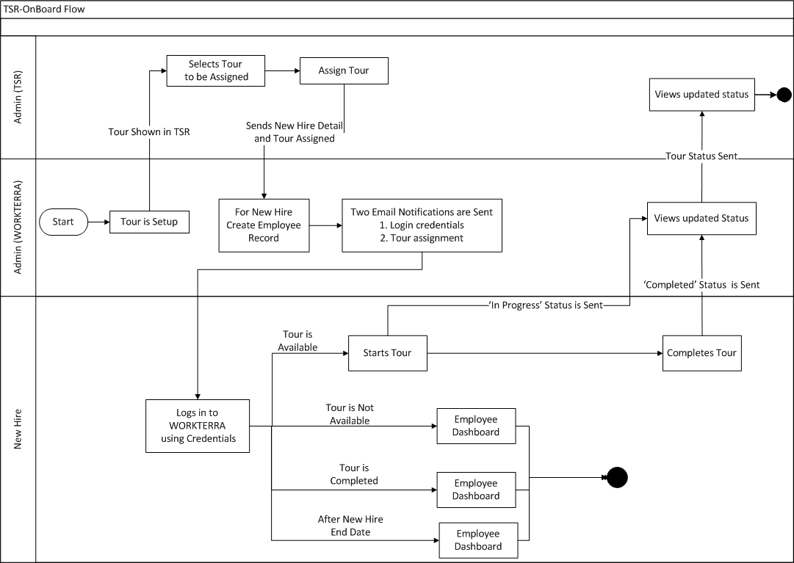

Setting up the Onboarding tour in WORKTERRA:
- The Onboarding tours are set up in WORKTERRA, not in TSR.
- Because the employer chooses in TSR which tour they want to send to the new employee (see figure 2), the assignment of classes will not impact which employee receives which tour.
- To use the naming convention familiar to most companies, we are calling the tours available in TSR Onboarding. However, in the technical setup of WT these are PreBoarding tours.
  - The decision to call the technically “PreBoarding” tour as “Onboarding” was made because a candidate can receive the PreBoarding tour before employment and complete it after employment, allowing more flexibility on when the tour is completed. Onboarding tours are only available on Day 1 on the job or after. In the future we may offer both PreBoarding and Onboarding as different tours, but at this time we are offering only “PreBoarding” and using “Onboarding” as the naming convention.
- In the tour setup, the client can choose how many days before employee start date (for Preboard tour) or after employee start date (for Onboard tour) they want the tour.
- System will not allow OnBoard or PreBoard to continue beyond new hire end date.
- The naming convention used to set up each tour in WT will appear in the drop down of TSR. Therefore, clear and illustrative naming conventions should be used so the TSR user knows easily which tour to choose for which new hire.

Sending the Onboarding tour to the candidate from TSR
- Requisition is opened in TSR
- Candidate applies to the requisition
  - For testing we need to create unique candidates with unique email addresses to effectively go into WORKTERRA. The TSR team knows how to do this. If at some point we change the testing process and WT also tests end-to-end, we can walk them through candidate creating in TSR in more detail.
- Candidate goes through the client’s set applicant workflow steps
- Candidate passes all the steps and is put in the “hire” stage (Figure 1)

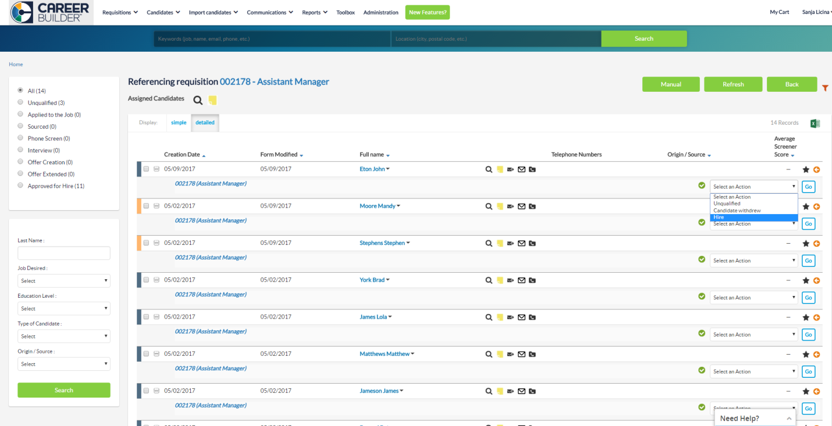
Figure 1: Candidate being hired in TSR

- Onboarding can be assigned only when a candidate has been updated to the “hire” step
  - Onboarding cannot be triggered before a candidate is put in the “hire” step. This is the only place in the workflow where the candidate can be sent to onboarding.
After a candidate is marked as a “hire” the recruiter is directed to the following page in TSR (Figure 2)
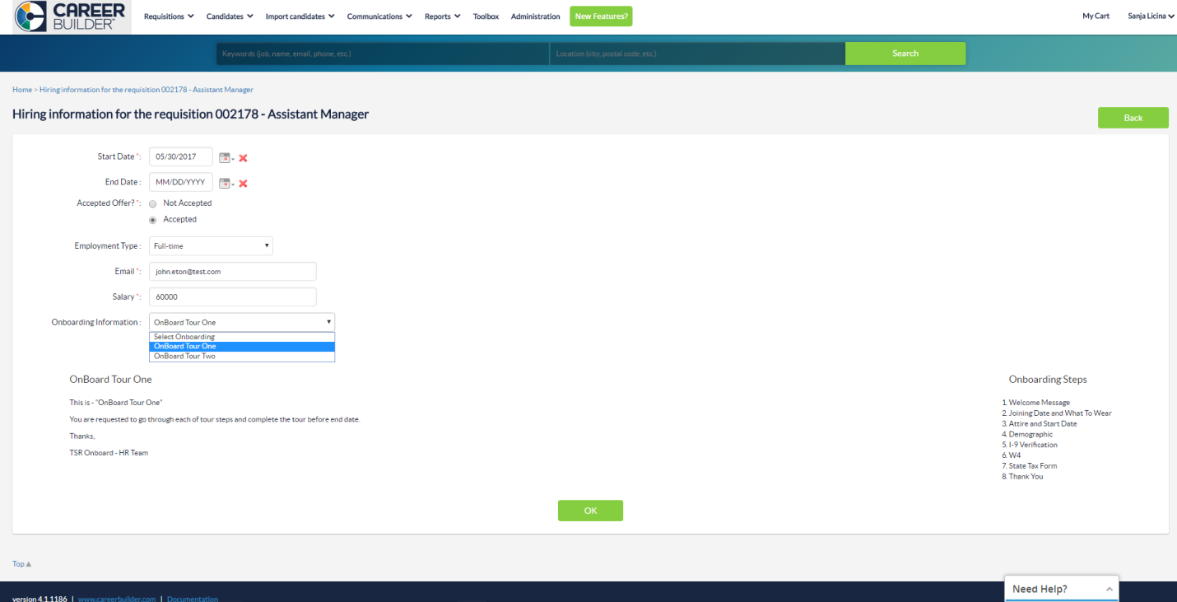
Figure 2: Assigning Tour in TSR
- There are no variations to the way that the fields on this page are set up – the same fields are always shown and the same fields are always required
- The following information is mandatory and passed from TSR to WORKTERRA
  - Candidate ID
  - Job ID
  - Tour ID
  - Job position (Title/requisition)
  - First name
  - Last name
  - Email ID
  - Annual Salary*
  - Start date*
  - Select a tour*
* These fields need to be entered on the hire page. The other fields can be pulled in from earlier in the recruitment process.
- The following is information is optional and can be passed from TSR to WORKTERRA
  - Candidate
    - Street address
    - County
    - City
    - State
    - Country
    - Postal code
- For the MVP, no additional information can be passed from TSR to WT
- The recruiter can’t proceed without the required information being completed
- After the tour is triggered a candidate record is created in WT. The required information is populated in WT from TSR for the employee record. This population is a one-time thing and subsequent update from TSR will not be reflected within WT.
- Employee email – for one login credential (rules for userid and password) and other for tour assignment

For the Admin, in WT:
- On the “Manage OnBoard Status” page the name of the employee appears after the tour is triggered (Figure 3)
  - Status is % completion, reflective of how far they got through in the onboarding process
  - The employer can send reminders to the employees to complete the tour from this page

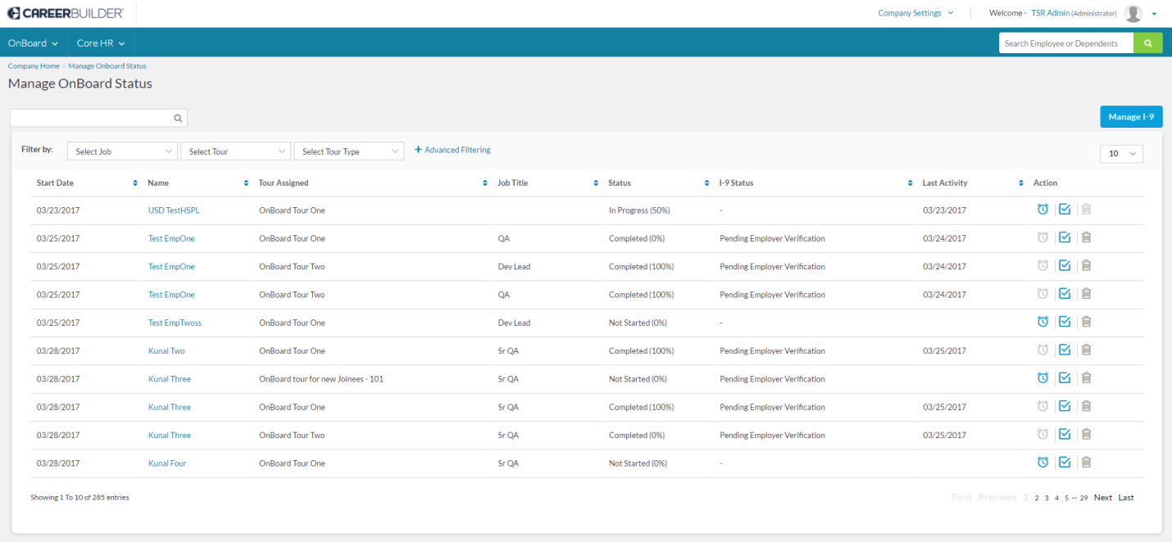
Figure 3: Manage OnBoard Status

- The employee appears on the “Manage I-9” page when I-9 form is attached and filled in the tour.
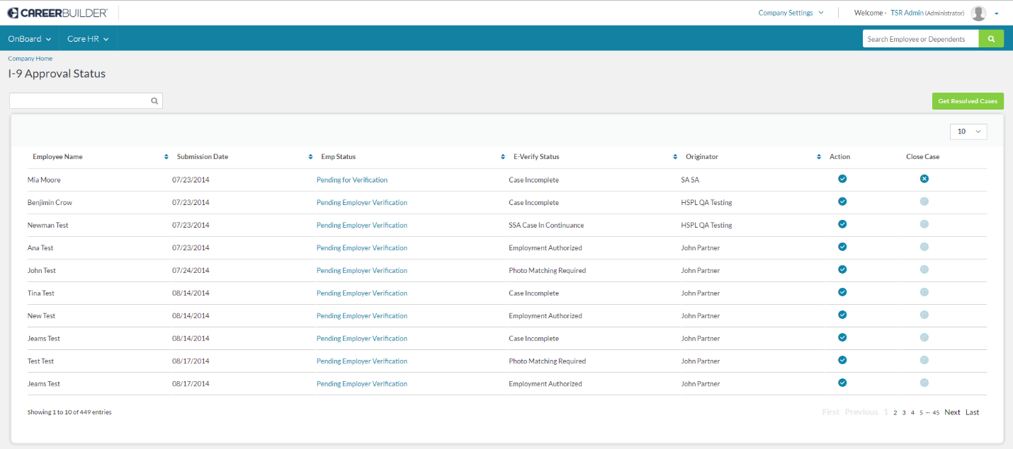
Figure 4: Manage I-9 Page
- The first icon in the Action column is to review Section 1 of I-9 submitted by the employee and then complete Section 2 of I-9
- For the accounts that have EVerify set up, they can also review the status of the case and take any action from this page.
- On the “Admin Review” page (will be rolled out to production on June 8)
  - You can assign classes
  - You can assign payroll schedule

For the admin, in TSR:
- “Manage Onboard Status” and “Manage I-9” links are available from the top curtain under the “Onboard” dropdown (Figure 5)
  - The employer will need to log into WT to access these pages after clicking the link, but will be re-directed to the correct page in WT after signing in
  - WT will send the tour status back to TSR. The three statuses are sent, in progress, and complete. (Figure 6)
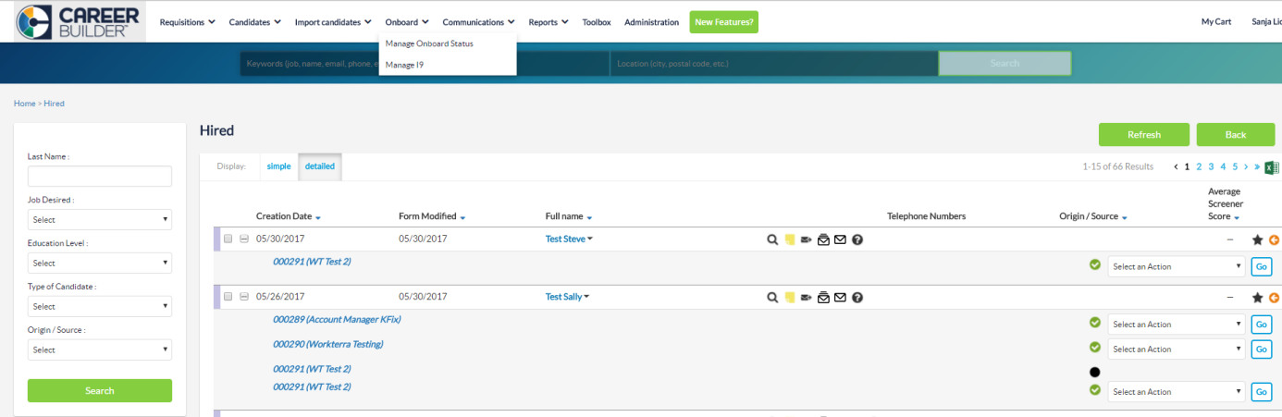
Figure 5

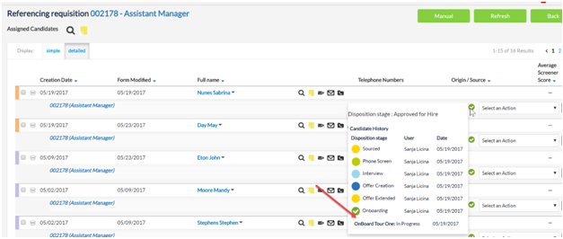
Figure 6

For the employees:
- As mentioned above, the client will specify the window before (for Preboard tour) or after (for Onboard tour) the start date they want the tour to become available for the employee.
- When the tour is triggered, the employee will receive 2 emails about the tour:
- Online Enrollment System - Login Credentials
- Tour Assignment Notification
- If the employee is send the emails within the window where the tour is available, after the sign into WT they will be able to immediately complete onboarding
- If the tour window is not yet open when they receive the emails, the employee will still be able to sign into WT, but will see a message there that the tour window is not open yet and to come back when it opens.
  - If the client never wants their employees to see this message, they can set a tour window that opens really early (e.g., 100 days before start date)
  - For employees whose tour is not open when they sign in, they will receive a reminder email the day the tour become available, letting them know that it is available.

TSR + OnBoard

Tour (PreBoard) Availability
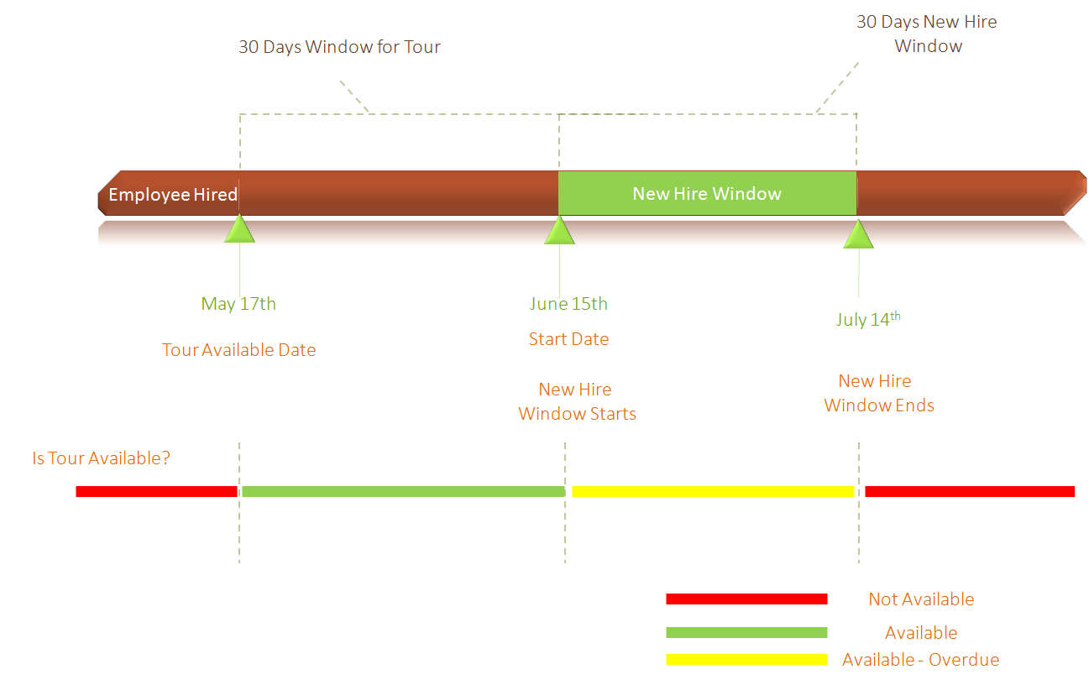

Employee Experience while in Tunnel

Employee Login in Before Tour Available Date

Employee Login in After Tour Available Date but Before Start date

Employee Login in after Start date but before New Hire End Date

Employee Login in After New Hire End Date

Post Tunnel Experience

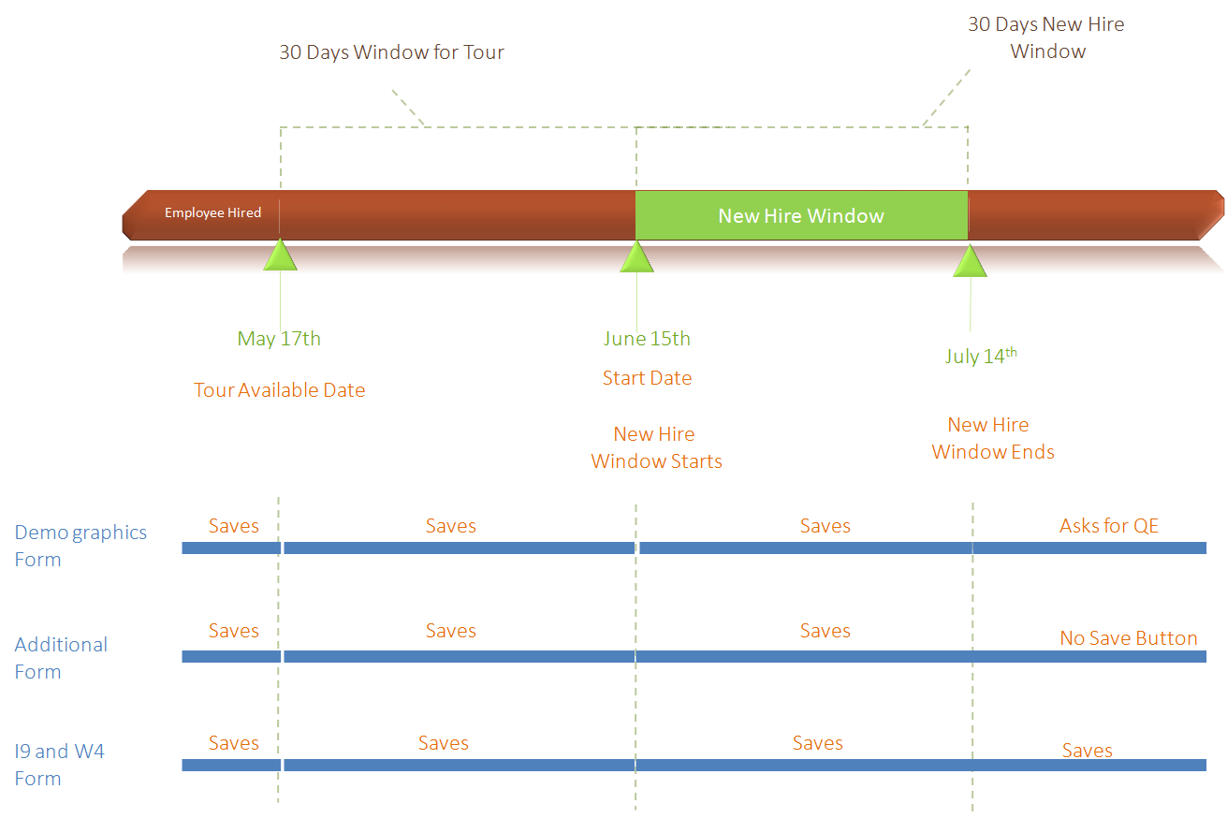

TSR + OnBoard + BenAdmin (No Waiting Period)

Tour (PreBoard) Availability
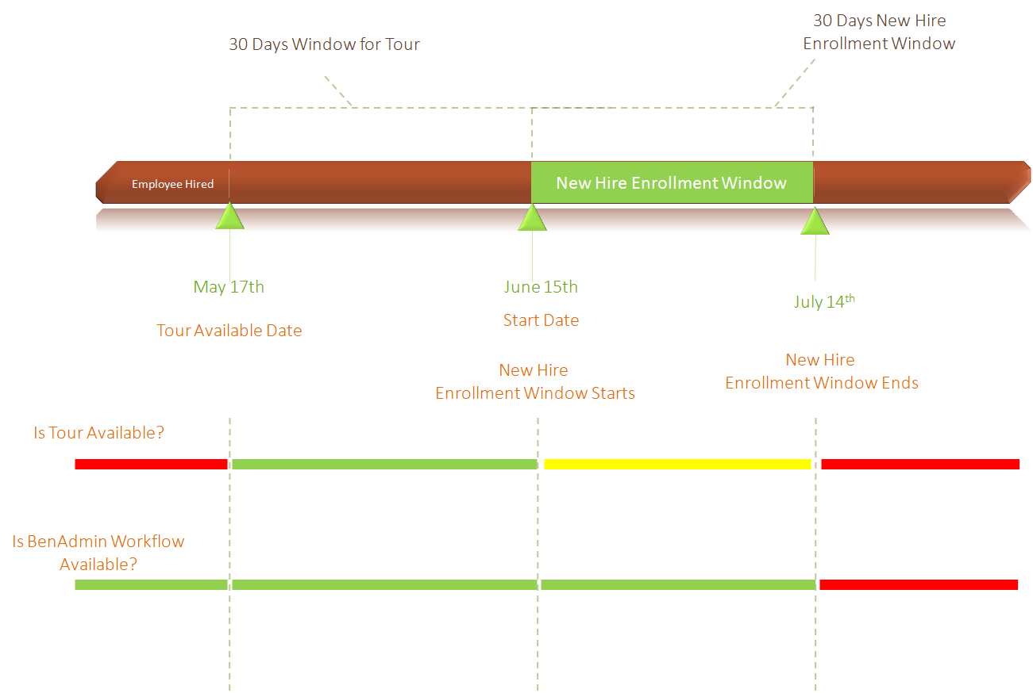

Employee Experience while in Tunnel

Employee Logs In Before Tour (PreBoard) Available Date

Employee Logs In After Tour Available Date but before Start Date

Employee Logs In After Start Date but Before New Hire Enrollment Window Ends

Employee Logs In After New Hire Enrollment Window Ends

Post Tunnel Experience
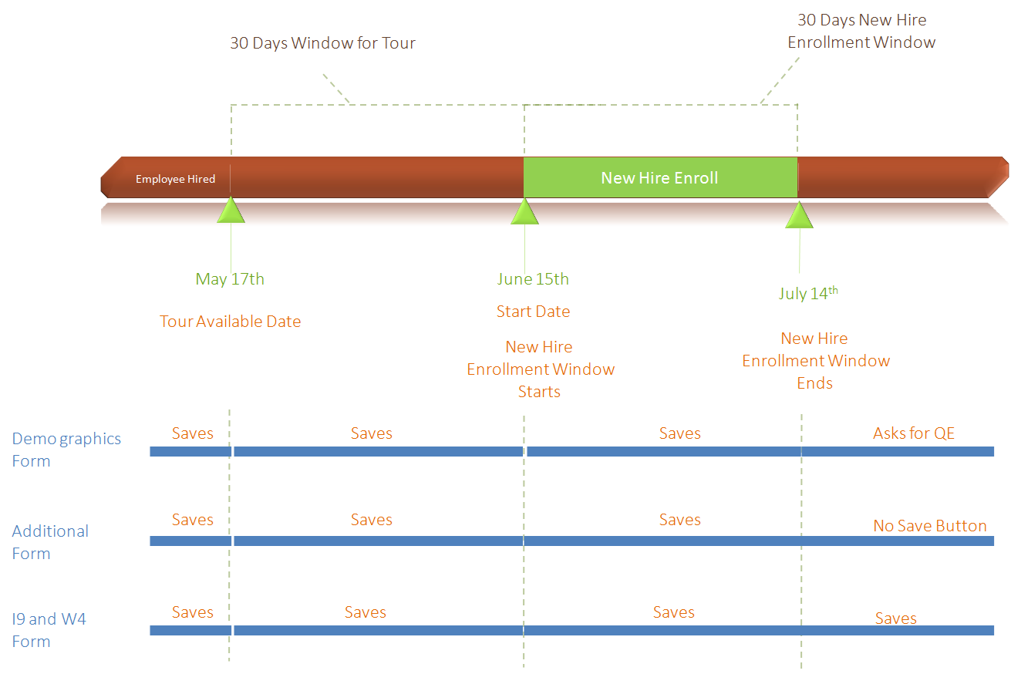

Checklist

- Enable email messages
- Review the subject line and email body of the email messages to be sent as notifications.
- Only First name and Last name should be used in user id
- Only First name, Last name should be used in password
- Demographics page should be included in tour
- EmplD should be marked as read-only in demographics page.
- ‘Is New Hire’ macro is enabled on tour eligibility.

Appendix

List of Tour Status
- Not Started
- In Progress
- Completed

List of I-9 Status

- Authorized
- Pending for Verification
- Incomplete
- Rejected
- Pending Employer Verification
- Case Closed
- Employer Verified

