1] Employee is not able to scroll down, buttons are clipped off.
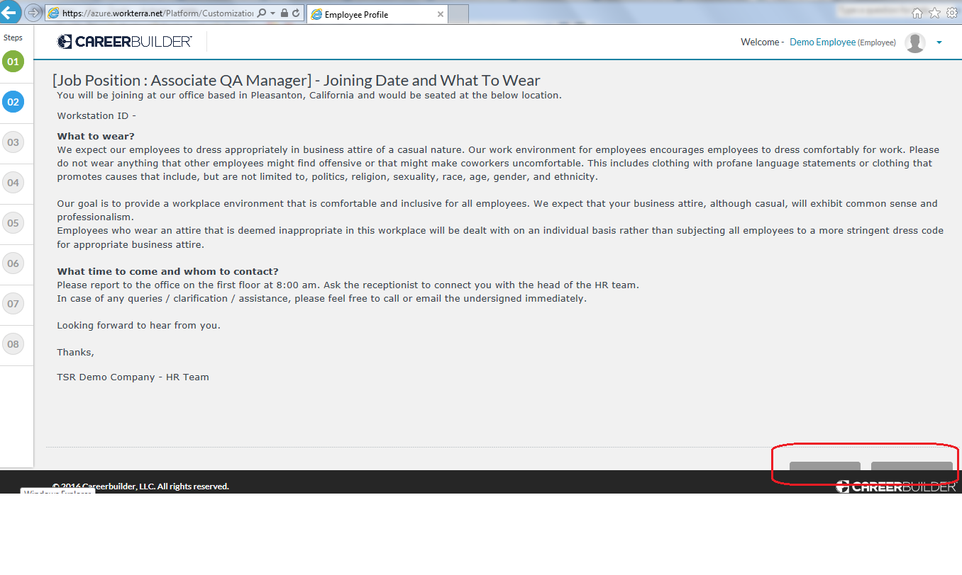
2] Employee is not able to scroll down, buttons are not displaying.
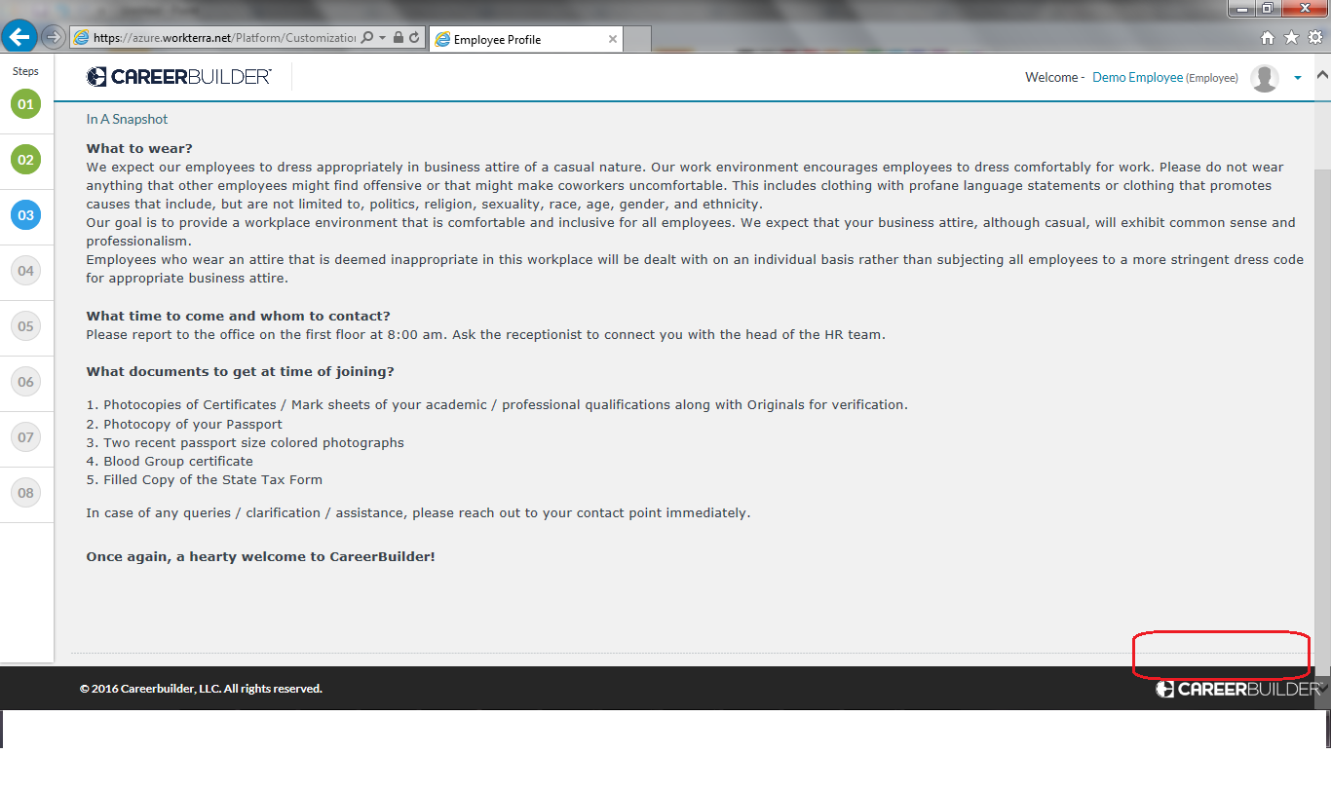

3] I-9 form, question mark is displaying two times.
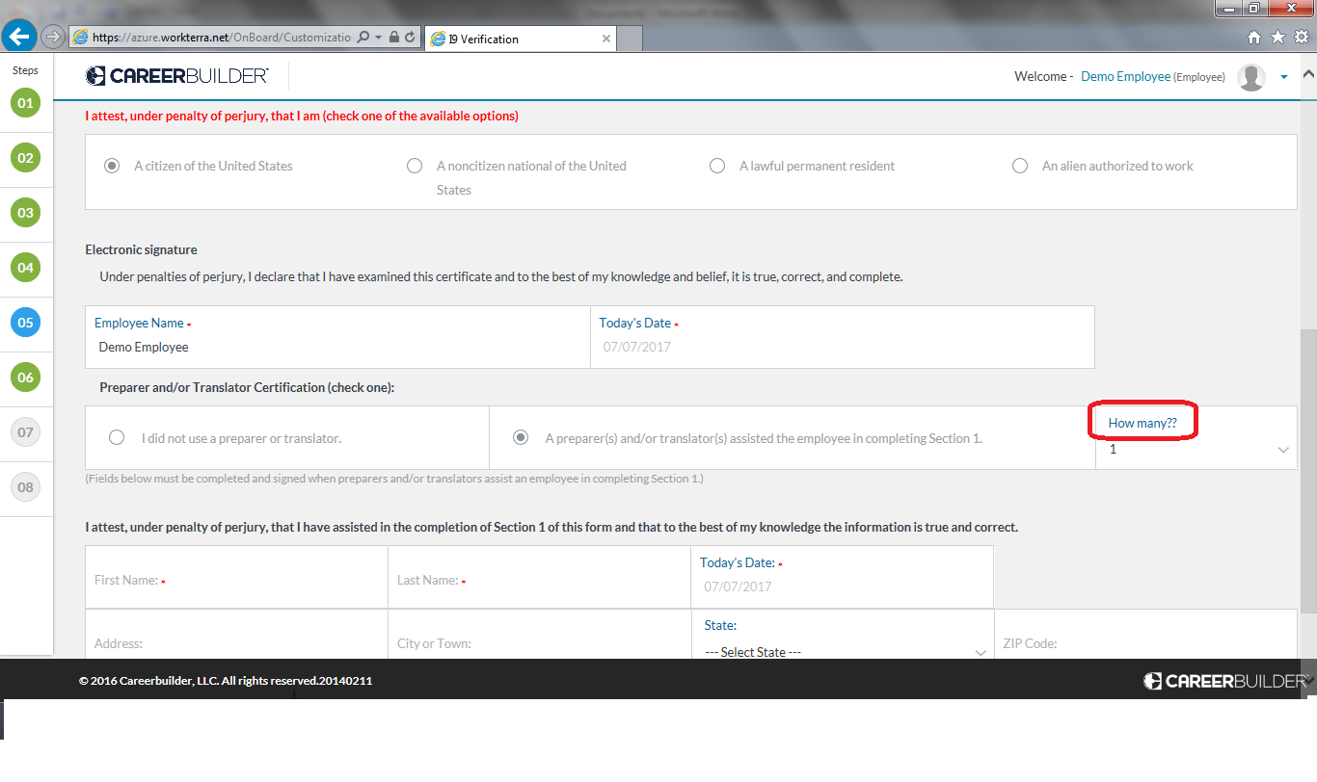

4] A] Need to change logo. B] Image is to blur. C] Need to change text as well, it is for DC Inc.
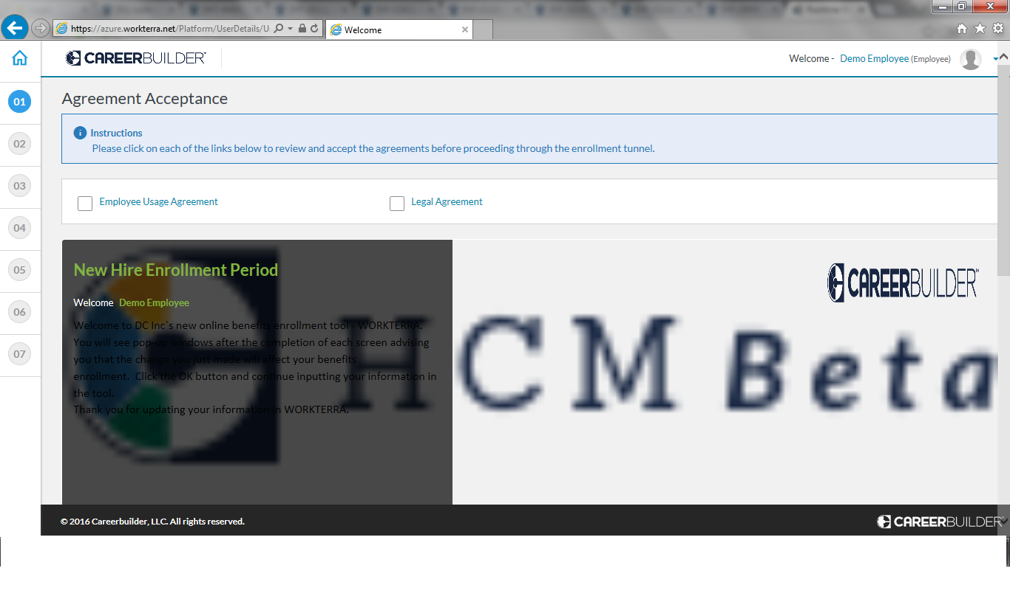
5] Images are not displaying.
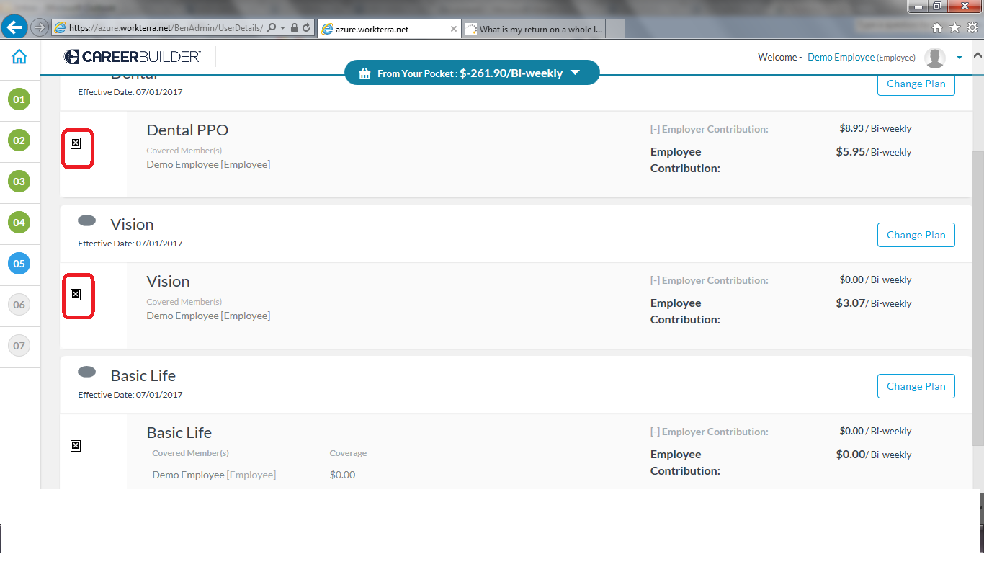

6] While navigating from one step to another of OnBoarding tour, employee can jump to next step by just clicking the link without completing in between steps. (e.g. Employee can jump to step 8 directly from step 2 without completing in between steps)

7] Copyright is displaying year as 2016, please let us know if we can change it to 2017.

