Beneficiaries at Selerix End – Lifetime Benefits Plan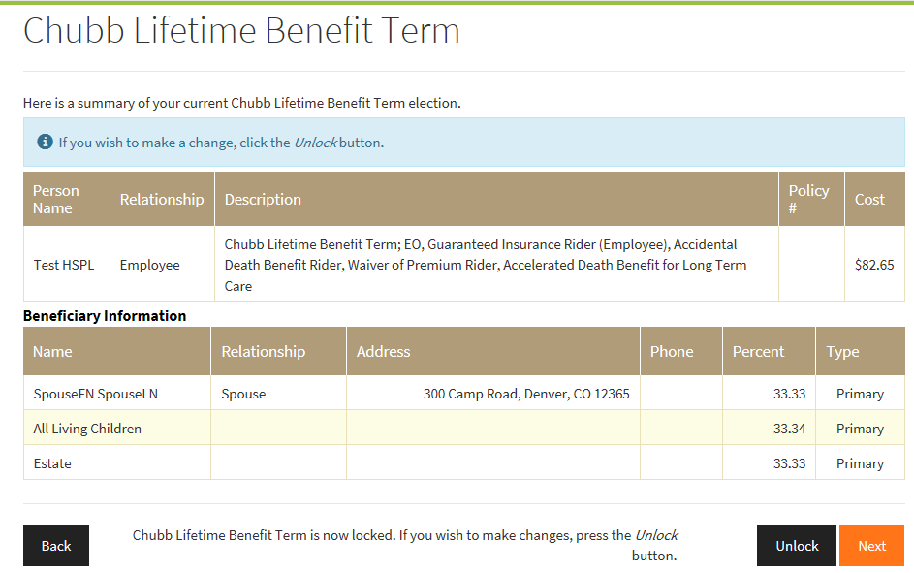

Beneficiaries at Selerix End – Accident Plan
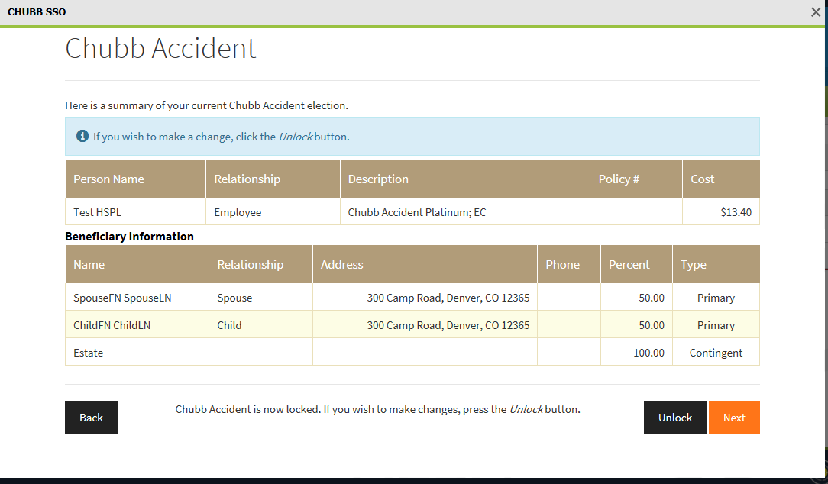
Beneficiaries information relected in WorkTerra – Lifetime Benefits Plan and Accident Plan

