2017

BioRad Boss Document : Queries

1. In life plans >> Plan 2 - Basic Life and AD&D>> here benefit type is given under “Basic Life and AD&D" as per the document; however there is no such benefit type provided in document.

As of now we have added the plan in the "Basic Employee life and AD & D" benefit type, Please confirm.

2. In FSA Plans >> Plan 2>> we have added new rule "Active Status No Casual Cobra (FSA)" as per the classes provided in the excel sheet. (Refer screen shot below)

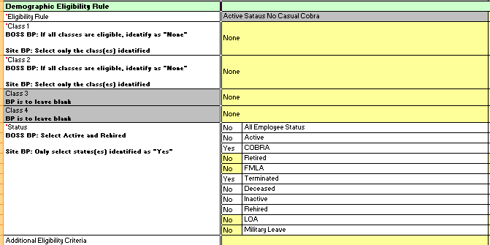
Figure 1: Demographic Eligibility Page

We have to add new rule "Active Status No Casual Cobra (FSA)" because there was existing rule name "Active Status No Casual Cobra" with “Class 2 : Full Time ".

Please check the classes for demographics eligibility rules are as expected or not.

3. In Health plans >>>Vision >> plans 12 and 25 , Provider given in the sheet is "Vision", however we do not have any such provider in the Provider List.

As of now, we have selected “VSP” as the Provider for Vision Plans. Please confirm the same.

4. Cost deduction schedule for "Delta Dental COBRA" plan is set to "Bi Weekly". In the Plan Design sheet it is mentioned as "Monthly", but we do not have “Monthly” payroll schedule in the company.

Could you please clarify on the same?

5. For plan #26 and #27, the Additional Eligibility criteria given as "X-Pat_equal to_Yes", but we cannot add field “X-Pat” in Workterra. Please let us know your thoughts on this.

6.For Health plans #26 and #27 benefit providers is given as "Group Health" in the sheet, however it is not provided in the providers list.

As of now we have selected provider as “Kaiser”. Please let us know your thoughts on this.

5. For Health plans #28, For the field "Active Plan for Cobra status" please let us know which active plan is to be selected, as it is mandatory field.(in the document it is left as blank)

Request you to please clarify

6. For all benefit types start date is given as "1/1/2018". However all the plan effective date is given in the document is in 2017. Please refer screen shot below

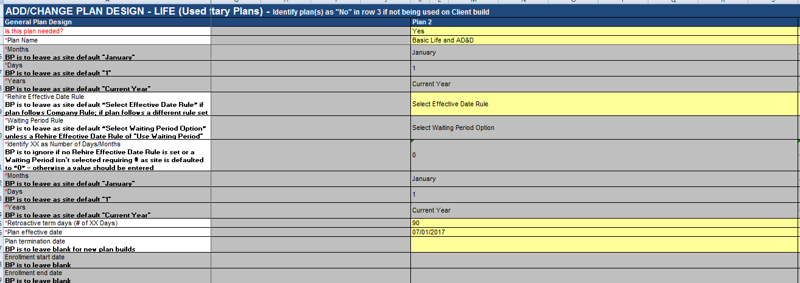
Figure 2

As were not able to add plans with date 2017, Therefore we have changed all benefit type date to 1/1/2017 let us know your views on this.

7. In Benefit Type Builder >> Type 2 Benefit Type Name (life section in the document) is Blank in the document. refer screen shot below

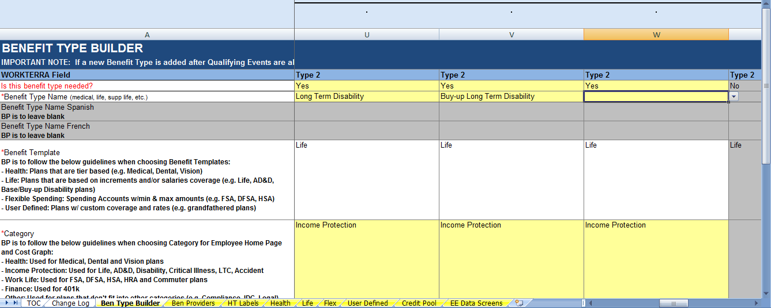
Figure 3: Benefit Type

We have added this blank benefit type as "Accidental insurance"

Additionally, in Life plans>> plan #14 "Business Travel Insurance" is added in "Accidental insurance"

Please let us know if our above mentioned understanding is correct.

8. In Benefit Type >> user defined >> type 4 the field name was blank.

(Refer screen shot)

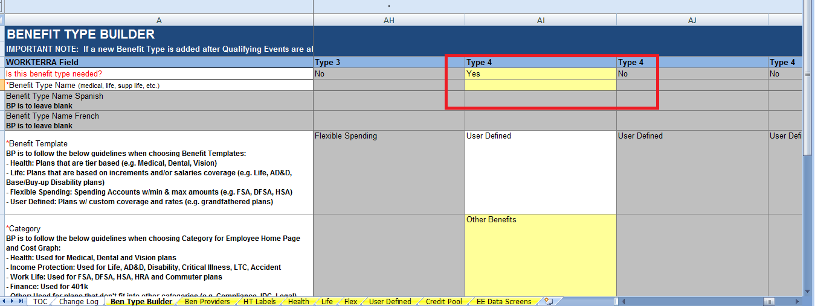
Figure 4: User Defined

We have named this benefit type as "E-Trade" and added user defined “E-Trade" plan into it.

Please let us know which name to be entered for this benefit type.

9. For User defined plan >>E-trade>> “Benefit Provider” name not provided, E-Trade Benefit provider is selected as of now.

Please let us know which benefit provider should be selected for the plan “E-trade”

10. E-Trade Plan “Eligibility Rules” page and “Cost and coverage” page data is not provided in per the sheet, hence left blank. Let us know your view on this.

11. Reduction Schedule query

For life plans>>

1. Supplemental Employee AD&D

2. Supplemental Family AD&D (No CH)

3. Supplemental Family AD&D (W/ CH)

On reduction schedule page>> the mandatory field “Base Age for Reduction schedule” is not provided for the above plans.

As of now we have selected the same values of reduction schedule page of the plan “Basic Life and AD&D”. refer screen shot below:

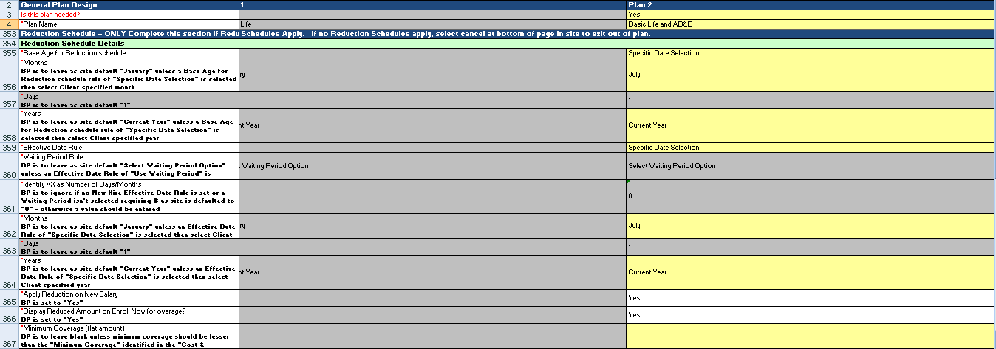
Figure 5: Reduction Schedule

Please let us know for any changes required.

12. In EDS>>custom form “Dependent Life Warning” not present in sheet. Hence, not added in EDS workflow.

13. For rate plan design mapping>> the plan “Anthem PPO Plan $750" is non cobra plan, and rate "Anthem $750 PPO" is cobra rate hence it cannot be mapped.

Additionally there are few more discrepancies for rates and plan mapping.

Request you to please check and verify all the rates and plans, and provide us the updated sheet.

