2017

BioRad Boss Document : Queries

1. In life plans >> Plan 2 - Basic Life and AD&D>> here benefit type is given under “Basic Life and AD&D" as per the document; however there is no such benefit type provided in document.

As of now we have added the plan in the "Basic Employee life and AD & D" benefit type, Please confirm.

GC – Confirmed (Amannda this is a Locked field in the Boss)

AJ – updated the BOSS to match the site

NOTE for Dev: no action needed from development

2. In FSA Plans >> Plan 2>> we have added new rule "Active Status No Casual Cobra (FSA)" as per the classes provided in the excel sheet. (Refer screen shot below)

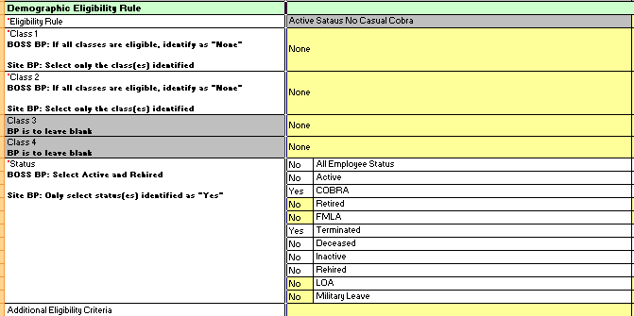
Figure 1: Demographic Eligibility Page

We have to add new rule "Active Status No Casual Cobra (FSA)" because there was existing rule name "Active Status No Casual Cobra" with “Class 2 : Full Time ".

Please check the classes for demographics eligibility rules are as expected or not.

GC – Confirmed

AJ – I see the eligibility rule was updated in the BOSS on Flex tab. We have now have both site and BOSS matching.

NOTE for Dev: no action needed from development

3. In Health plans >>>Vision >> plans 12 and 25 , Provider given in the sheet is "Vision", however we do not have any such provider in the Provider List.

As of now, we have selected “VSP” as the Provider for Vision Plans. Please confirm the same.

GC - Confirmed

AJ – I see the Provider on the Health tab has been updated for both plan 12 and 25 to VSP. We have now have both site and BOSS matching.

NOTE for Dev: no action needed from development

4. Cost deduction schedule for "Delta Dental COBRA" plan is set to "Bi Weekly". In the Plan Design sheet it is mentioned as "Monthly", but we do not have “Monthly” payroll schedule in the company.

Could you please clarify on the same?

GC - Will need to add to the site and assign to those plans.

AJ – I see Monthly payroll schedule in stage now. Monthly payroll schedule can now be tied to the COBRA plans. Plans have been updated in the site by implementation team. Gary please update the Company Info BOSS to help make sure this matches.

NOTE for Dev: no action needed from development

5. For plan #26 and #27, the Additional Eligibility criteria given as "X-Pat_equal to_Yes", but we cannot add field “X-Pat” in Workterra. Please let us know your thoughts on this.

GC – Will be added to the Demographics page and we will assign to the plan

AJ – agree with GC notes.

NOTE for Dev: See GC note above for this one. Implementation team will update plans once field is added.

6.For Health plans #26 and #27 benefit providers is given as "Group Health" in the sheet, however it is not provided in the providers list.

As of now we have selected provider as “Kaiser”. Please let us know your thoughts on this.

GC – Added Group Health Cooperative to the Boss on Benefit Providers.

AJ – I can confirm BOSS doc is updated. Site is now updated as well.

NOTE for Dev: no action needed from development

5. For Health plans #28, For the field "Active Plan for Cobra status" please let us know which active plan is to be selected, as it is mandatory field.(in the document it is left as blank)

Request you to please clarify

GC - This is an Active Plan and not a COBRA plan. Selection is OK

AJ - GC is correct. Plan #28 on the Health tab in BOSS is an active plan “EAP Plan” therefore no “Active Plan for COBRA status” needs to be selected.

NOTE for Dev: see feedback above. Plan #28 is an Active plan. Were you asking about a different plan?

6. For all benefit types start date is given as "1/1/2018". However all the plan effective date is given in the document is in 2017. Please refer screen shot below

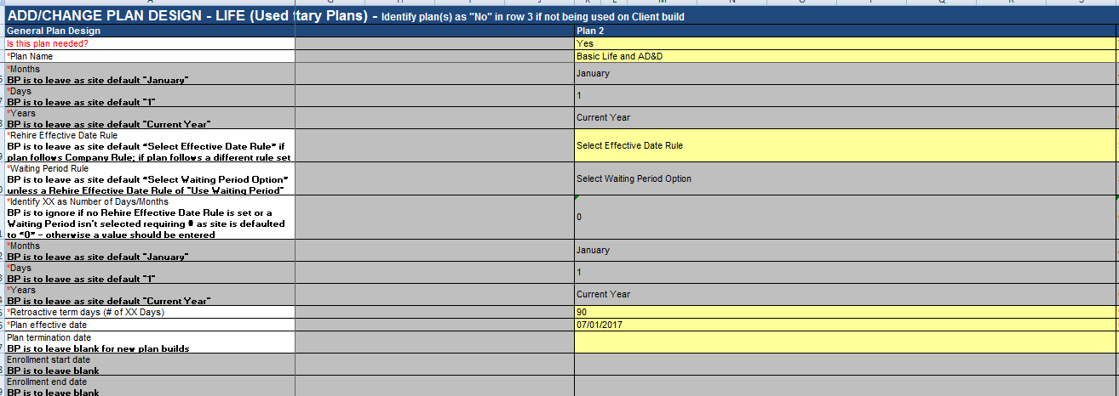
Figure 2

As were not able to add plans with date 2017, Therefore we have changed all benefit type date to 1/1/2017 let us know your views on this.

GC - Confirmed

AJ – Confirmed. BOSS now shows 1/1/2017 for the benefit types this way site and BOSS match.

NOTE for Dev: no further action needed from dev on this item.

7. In Benefit Type Builder >> Type 2 Benefit Type Name (life section in the document) is Blank in the document. refer screen shot below

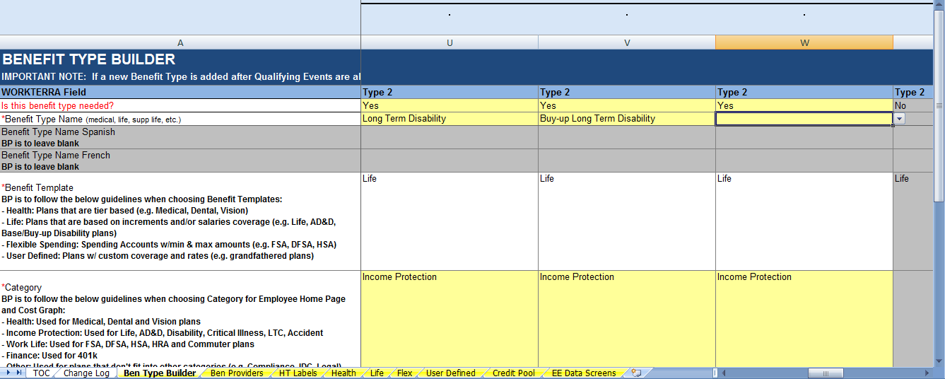
Figure 3: Benefit Type

We have added this blank benefit type as "Accidental insurance"

Additionally, in Life plans>> plan #14 "Business Travel Insurance" is added in "Accidental insurance"

Please let us know if our above mentioned understanding is correct.

GC - Need to unlock Boss and Update to Accidental Insurance

AJ – Robyn updated BOSS and I updated the site.

NOTE for Dev: no further action needed from dev on this item.

8. In Benefit Type >> user defined >> type 4 the field name was blank.

(Refer screen shot)

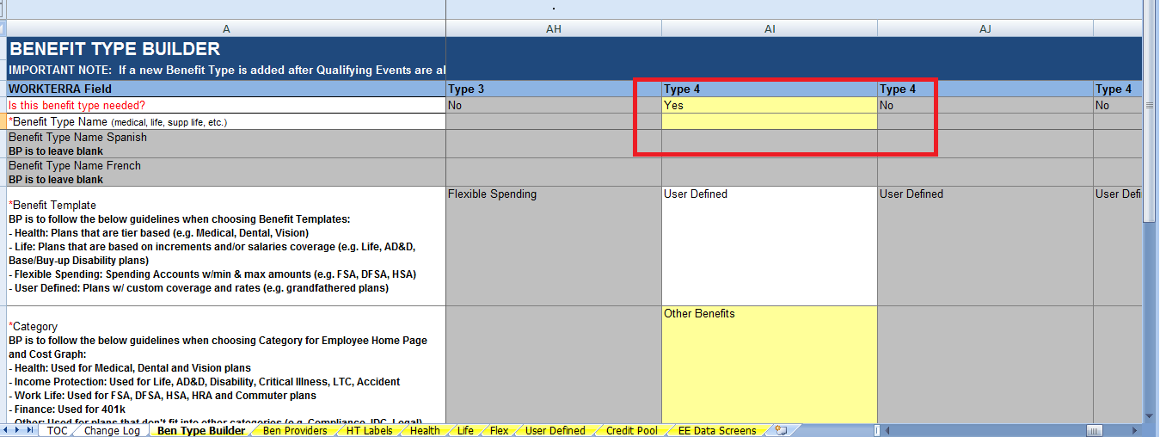
Figure 4: User Defined

We have named this benefit type as "E-Trade" and added user defined “E-Trade" plan into it.

Please let us know which name to be entered for this benefit type. .

GC - Need to unlock Boss and Update to Accidental Insurance

AJ – Robyn updated BOSS and I updated the site.

NOTE for Dev: no further action needed from dev on this item.

9. For User defined plan >>E-trade>> “Benefit Provider” name not provided, E-Trade Benefit provider is selected as of now.

Please let us know which benefit provider should be selected for the plan “E-trade” .

GC - User defined plan to be added after client confirmation.

AJ – AIG is the provider. Updated the Site and the BOSS. Gary will update both site and BOSS once client confirms on plan or form setup.

NOTE for Dev: no further action needed from dev on this item.

10. E-Trade Plan “Eligibility Rules” page and “Cost and coverage” page data is not provided in per the sheet, hence left blank. Let us know your view on this.

GC - User defined plan to be added after client confirmation.

AJ –Gary will update both site and BOSS once client confirms on plan or form setup.

NOTE for Dev: no further action needed from dev on this item.

11. Reduction Schedule query

For life plans>>

1. Supplemental Employee AD&D

2. Supplemental Family AD&D (No CH)

3. Supplemental Family AD&D (W/ CH)

On reduction schedule page>> the mandatory field “Base Age for Reduction schedule” is not provided for the above plans.

As of now we have selected the same values of reduction schedule page of the plan “Basic Life and AD&D”. refer screen shot below:

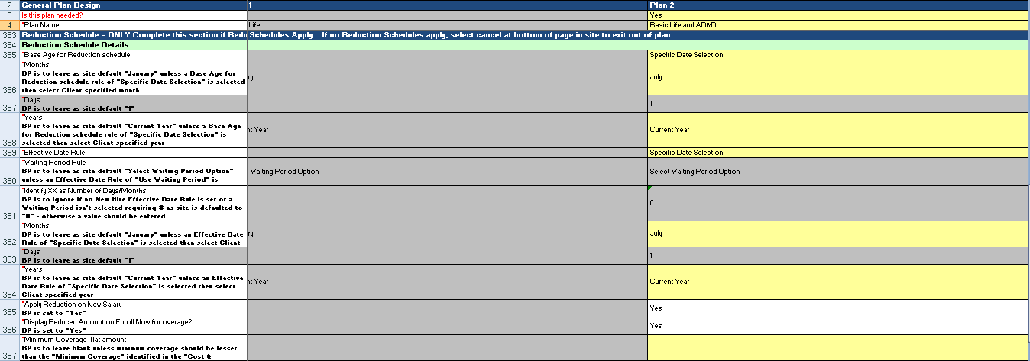
Figure 5: Reduction Schedule

Please let us know for any changes required.

GC - Updated Boss to match.

AJ – Confirmed.

NOTE for Dev: no further action needed from dev on this item.

12. In EDS>>custom form “Dependent Life Warning” not present in sheet. Hence, not added in EDS workflow.

GC - I will add to site

AJ – Confirmed.

NOTE for Dev: no further action needed from dev on this item.

13. For rate plan design mapping>> the plan “Anthem PPO Plan $750" is non cobra plan, and rate "Anthem $750 PPO" is cobra rate hence it cannot be mapped.

Additionally there are few more discrepancies for rates and plan mapping.

Request you to please check and verify all the rates and plans, and provide us the updated sheet.

GC - Amannda pls assist as is this to be NO as it is Not a COBRA Rate but as Active Rate?? Or this should be yes as a Cobra plan is built and this will be mapped to that plan and adjusted for rate.

AJ – There are no COBRA rates on the Rates Tool. All ‘COBRA Rate’ fields on the Health Rates have been updated to be No and updated Rate Tool BOSS doc was uploaded to JIRA. Gary lets create a setup Rate Tool for the COBRA rates and then we can add the COBRA rates on our own and it can then be used to send to COBRA EBS team as well.

NOTE for Dev: please use latest Rate Tool that is uploaded in JIRA to updated the rates.

