What is Selerix (https://www.selerix.com/)?
Answer: Selerix is a system like Workterra which offers a platform for employee benefit enrollment for multiple carriers through a single place.
Why we need to have these integrations in Workterra?
Answer: The clients belonging to HUB group already have ‘CHUBB’, ‘Trustmark’ benefits available for their employees, who are now a part of Workterra application for benefit enrollment. The benefit providers ‘CHUBB’, ‘Trustmark’ already have their benefits enrollment compatible with Selerix highly configurable platform, so they prefer to have enrollment into their benefits through Selerix System Only. Selerix is so configurable, using their SSO endpoints any System can connect to Selerix and as per the access level they provide, employee can traverse the enrollment Workflow for different benefit providers they have setup.

Below is the workflow between Workterra and Selerix system.
Enroll in Plan on Selerix Portal
Workterra
Selerix/Carrier (CHUBB/Trustmark) Setup
Process the encrypted response
Return enrollment data to Workterra in response
Enroll in Workterra Plan
Login Workterra
Employee
Workterra BenAdmin DB
Decrypted Selerix Response through Workterra SSL cert.
Encrypted Selerix Response (Enrollment data, beneficiary data, etc)
SAML Request (SSL Cert, Emp demographic,etc)

Process enrollment and beneficiary data as per Workterra compatibility

- Employee will login to Workterra System and traverse the enrollment workflow, when click on Enroll button of Trustmark/CHUBB benefits configured in Workterra.
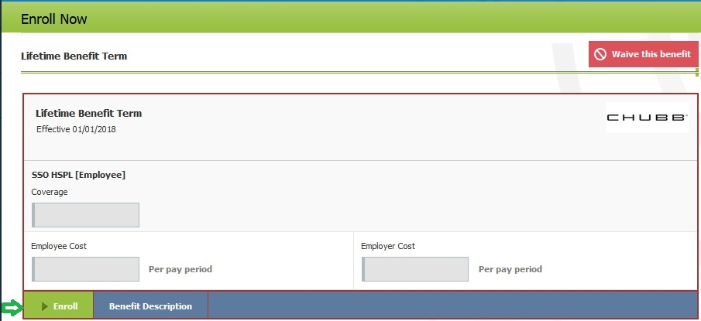

- On click of ‘Enroll’ button above, employee will get login to Selerix Portal in Popup.
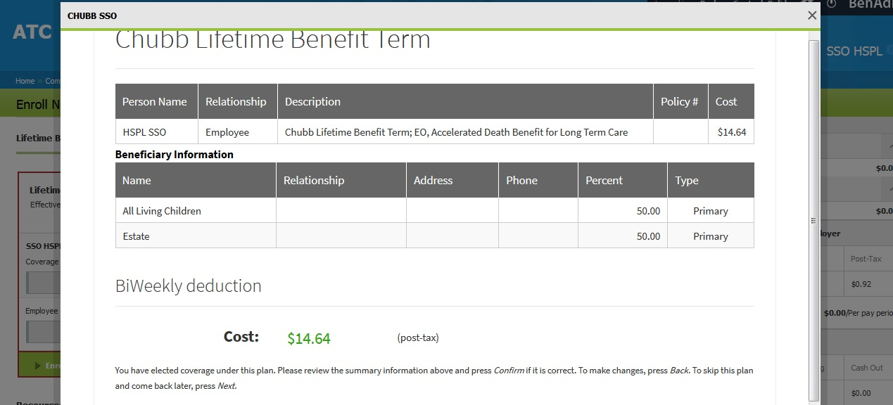

3) In background the above login will happen due to the SAML request we pass to Selerix System as per SSO setup done between Workterra and Selerix.
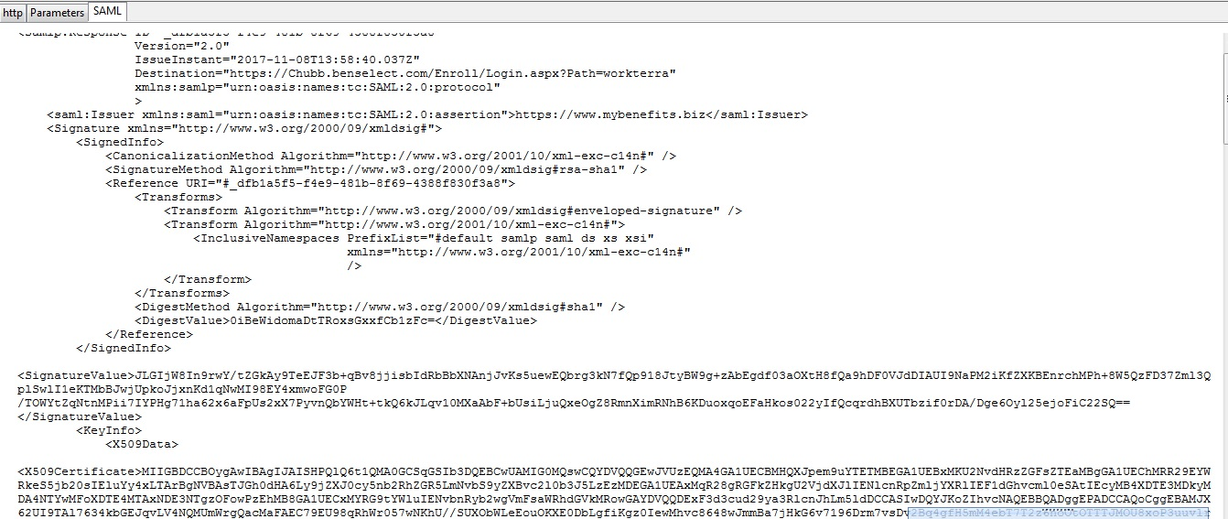

The above SAML request contains Selerix connection endpoints, employee/Spouse/Child demographic information, Workterra Public SSL certificate, the Signed request by Workterra Private Key, Encrypted request through Selerix public key, etc.

4)Once employee completed enrollment Workflow at Selerix end , in acknowledgement Selerix sends us encrypted SAM response which contains employee/spouse/child demographic, enrollment data, beneficiary data, etc. We decrypt that using Workterra’s private key and process the decrypted response as per Workterra enrollment structure. Once data get compatible to Workterra System, We store it in Workterra database, so that both Workterra and Selerix have enrollment data in Synch. Also now employee is now using Workterra System as a primary enrollment media, so s/he should refer Workterra for reference rather than Selerix.

