CIGNA EOI integration through SSO:
What is the process for Evidence of Insurability (EOI)?
Answer: When employee would like to have benefit coverage beyond the limit (GI amount as per Workterra System eligibility criteria), then s/he need to apply for the same with the benefit provider itself.
CIGNA is the provider for Life and Disability benefits for Austin and Symphony Client, and CIGNA provides SSO connection to their portal, so that the enrollment system like Workterra can directly connect to CIGNA portal through SSO in case of EOI. Instead of processing offline EOI application, CIGNA recommends that directly connect employee from Workterra portal to CIGNA portal for EOI processing, so that employee can himself/herself complete the EOI workflow.
Currently Austin and Symphony are the clients who use CIGNA plans enrolled for EOI through SSO connection established between Workterra and CIGNA portal.
In background pass employee demographic to CIGNA web service
Below is the process flow for EOI enrollment trough SSO for CIGNA plans.
Login Workterra
Web Serivice Call (Emp demographic)
Workterra
Enroll to CIGNA plan for EOI

Store employee record In CIGNA storage
Employee

Acknowledgement
Success/Fail
Fail
Employee DB
CIGNA
No employee record present/Respective Error
Success

CIGNA Portal for EOI enrollment

Employee Flow:
- Employee login to Workterra application, select coverage which is applicable for EOI and click Enroll button, enrollment get saved into Workterra only and employee can start enrolling other CIGNA plans.
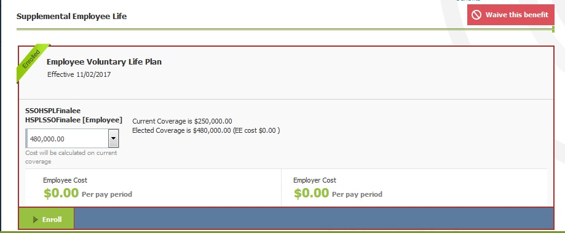

- Once employee did enrollment in all the CIGNA life and disability plans for which s/he would like to enroll, at the end of Workflow s/he can able to view below summary report of his/her CIGNA benefit eligible for EOI.
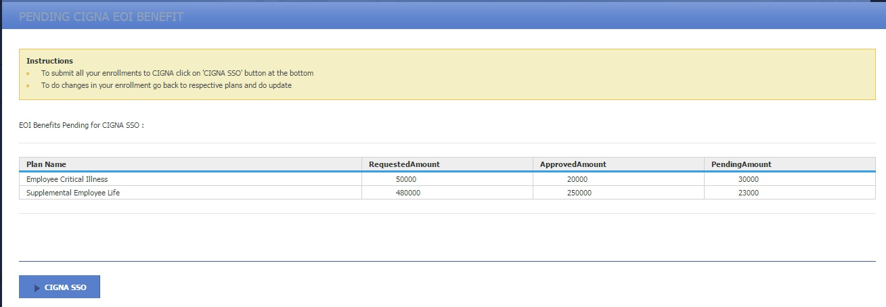

- Employee needs to click on ‘CIGNA SSO’ button forcefully to continue workflow and submit all CIGNA enrollments for EOI approval to CIGNA in single request. in case of failure with webservice call s/he gets below alert message

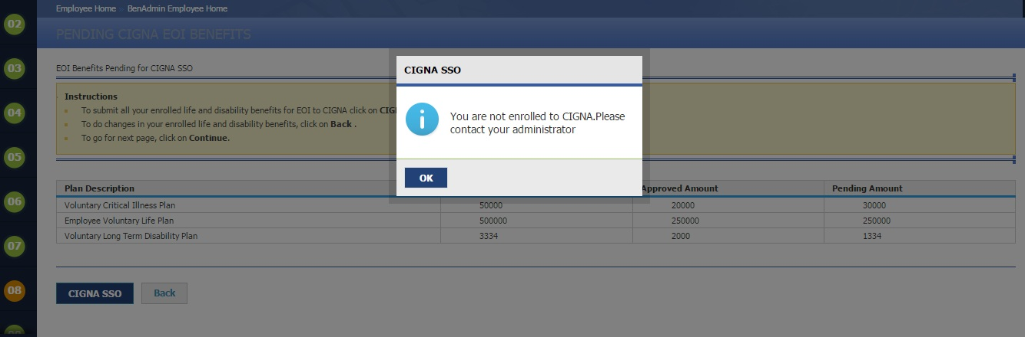

In case of successful webservice call s/he gets below alert message.

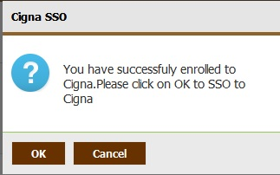

4) On Click of ‘OK’, employee get log in to CIGNA portal and can traverse EOI workflow.
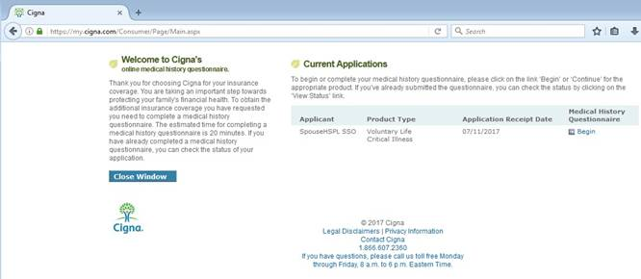

Admin Flow:
- Admin enrolls on behalf of employee outside workflow, by selecting plan click on Enroll button.
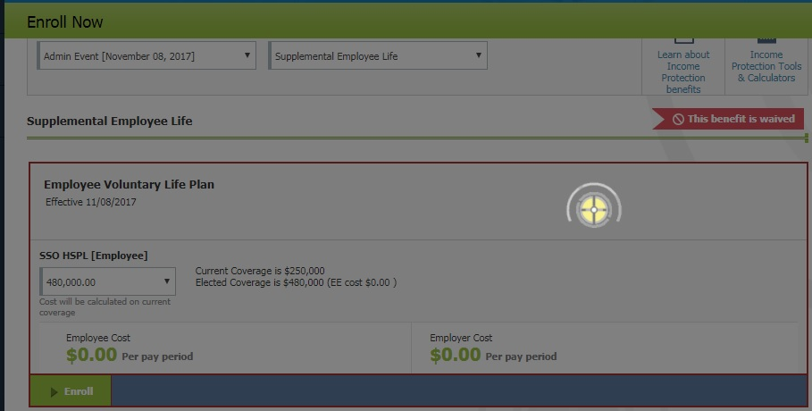

- Below alert message get displayed which says that – If you would like to enroll into multiple other CIGNA plans and would like to process all CIGNA plans in one go then click cancel and continue enrolling and while enrolling to final CIGNA plan click ‘OK’ so all plans enrolled get submitted to CIGNA for EOI approval. But in case if you would like to enroll for only this plan then click ‘OK’ which will submit below plan to CIGNA for EOI processing.
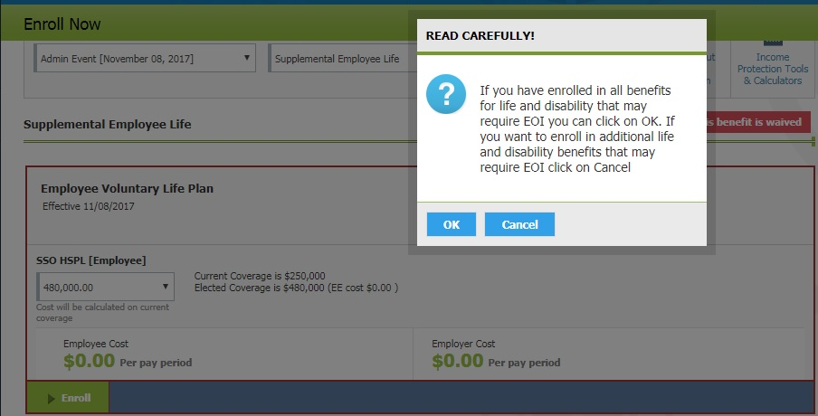

- On Click of ‘Ok’ button above, employee demographic information and plan enrollment data get submitted to CIGNA through Webservice. In case of successful webservice call below will be the acknowledgement from CIGNA webservice.

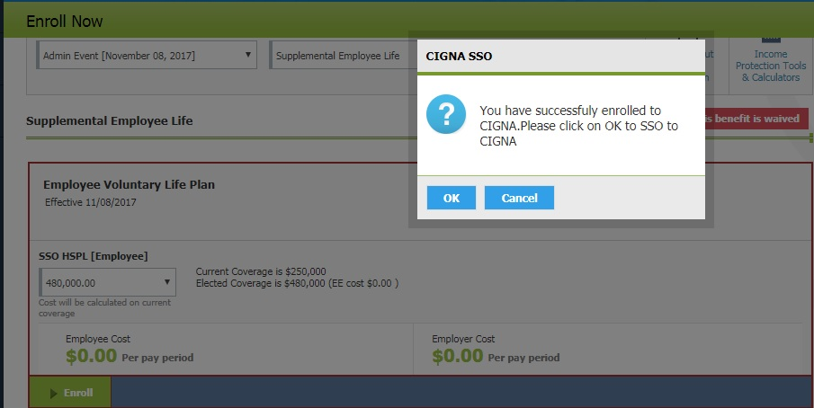

- On click of ‘OK’ button above employee redirected to CIGNA portal and get log in to CIGNA portal automatically using background SAML request and can traverse EOI workflow on CIGNA portal.

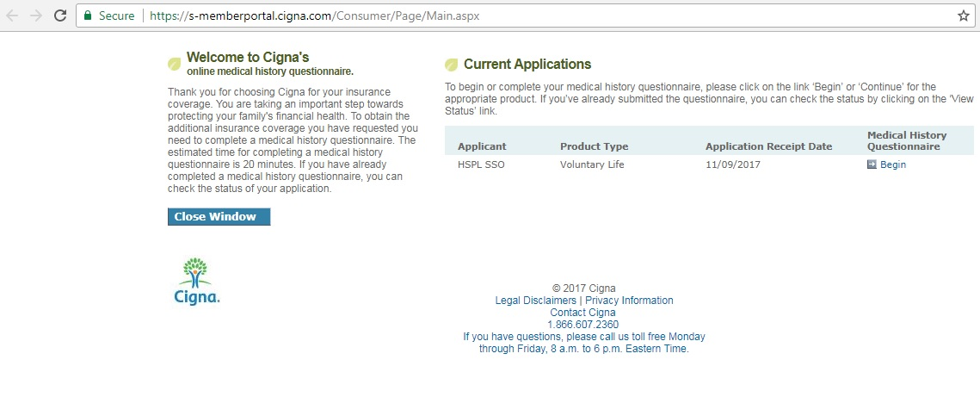

- Also in parallel enrollment get saved in Workterra.

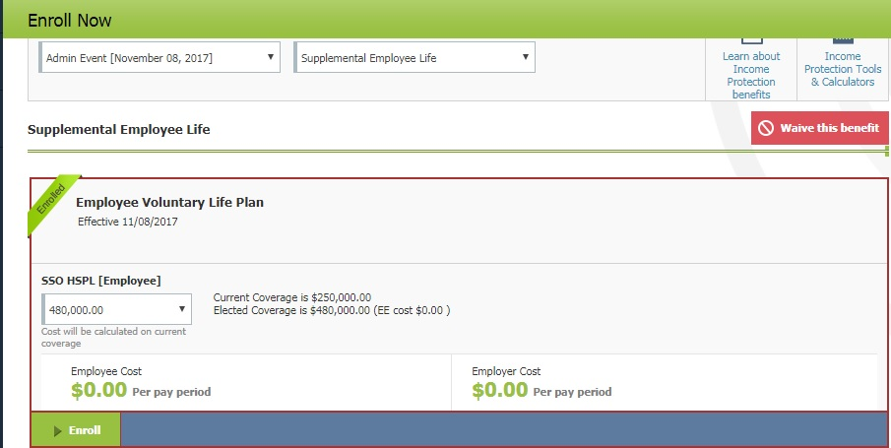

- In case of webservice call failure in step 2 below will be the output.
