2017

Email Functionality Guide

Table of Contents
1 Introduction 3
2 E-mail Broadcast 3
2.1 Purpose 3
2.2 Customization 3
2.3 Sending Email broadcast 5
3 Incomplete Enrollment Notification 6
3.1 Purpose 6
3.2 Customization 6
3.3 Sending incomplete enrollment notification mail 8
4 Incomplete enrollment notification – Benefit wise 9
4.1 Purpose 9
4.2 Customization 9
4.3 Sending incomplete enrollment notification mail – Benefit wise 11

Introduction
This document will serve as guide for email functionality in the WORKTERRA Application for the following areas:
- Email Broadcast
- Incomplete Enrollment Notification
- Incomplete Enrollment Notification – Benefit Wise

Screen shorts and textual description have been used to describe the process.

E-mail Broadcast

Purpose
Here we can send an email to the selected employees. This mail can also have file attachments (attachments such as exe, cmd, bat are not allowed).

Customization
- Customization on System Settings
Steps:
- Navigate to System Settings (Employer Administration ->Company Information->System Settings)
- Set Receive Email Notification to Yes.(Figure 1)
`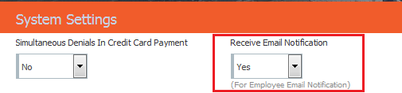
Figure 1: Receive Email Notification flag on System Settings
- Employee level settings
  - The employee should have a valid email address
  - Receive email setting should be set to Yes (Figure 2) (Select employee Employee->Demographics)

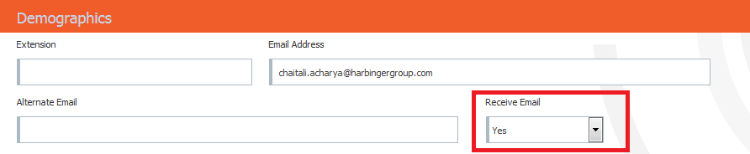
Figure 2: Setting Receive Email for Employee

- Customization on Send Email broadcast screen

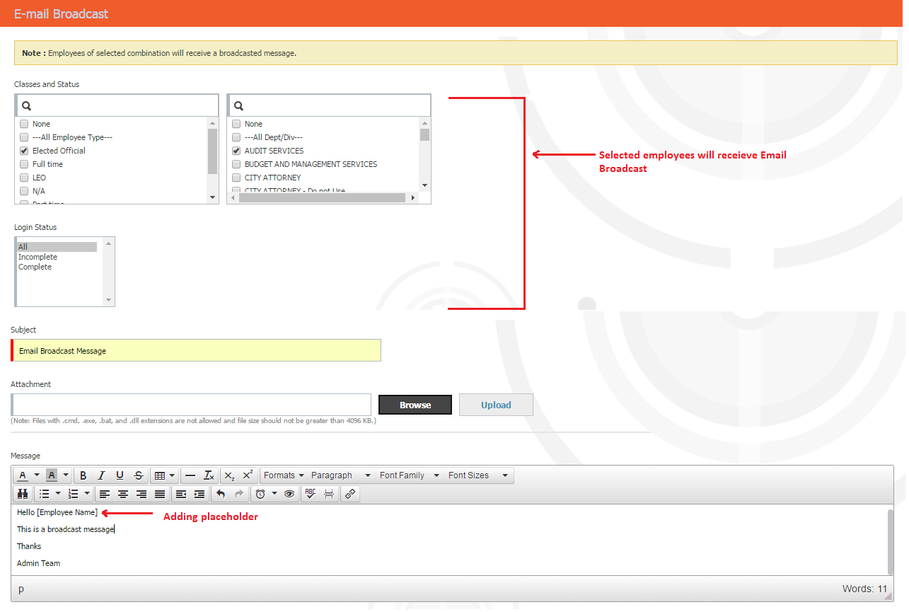
Figure 3: Email Broadcast screen

- Classes and Status, Login Status: The employees of selected classes, status and Login status will receive the Broadcast email.
(Here it is important to consider that the selected set of employees should have a valid email address and should have Receive email set to yes)
- Subject: The subject of the email broadcast
- Attachment: The attachment to be added in the email broadcast. Files with .bat, .exe, .dll, .cmd extensions are not allowed.
- Message: The message to be sent to the employees is set here.

NOTE: If any of the above customization settings are missed done then the broadcast emails are not sent .

Sending Email broadcast
After the customizations are done we can click on the Send button and we get the following pop up message.
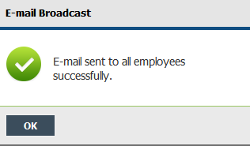
Figure 4: Email sent successfully pop up message
The emails once sent to the employees they appear as below (Figure 5).
- Single email is sent to all selected employees with their email ids in Bcc.
- The mails are sent in batches. A batch would send 80 mails.

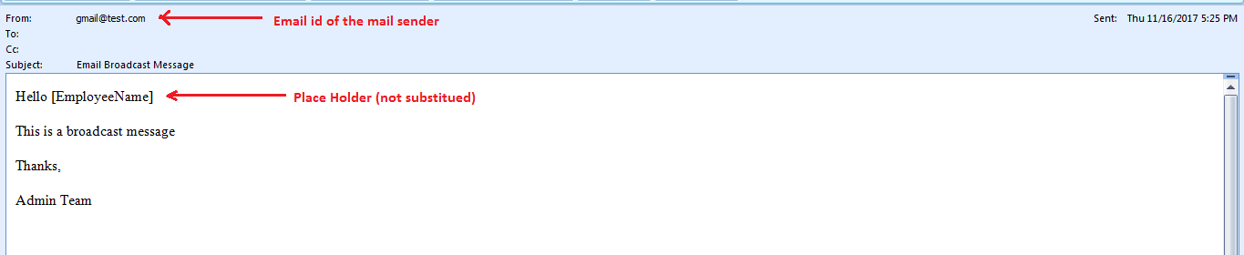
Figure 5: Email Broadcast message

- From: Here we get the email id of the logged in user who sent the broadcast message to the employees. (The user logged user who was sending the email broadcast had email id as gmail@test.com, so that appears in the From section)

- To and Cc: They do not appear as all selected employee email ids are in Bcc.

- Here the Place holder that we added (as seen in Figure 3) did not get substituted. Hence the place holder [EmployeeName] is seen as it is in Figure 5.

- Currently the system does not have place holders for Email Broadcast, so the added placeholders will not get substituted with values in the email message. They will appear as they are added in the email message.

Incomplete Enrollment Notification

Purpose
Here we can select employee(s) and send an email to them reminding them to complete the enrollment.

Customization
- Customizations on System Settings
Steps:
- Navigate to System Settings (Employer Administration ->Company Information->System Settings)
- Set Receive Email Notification to Yes.(Figure 1)
- Customization on Email Message Format
- Navigate to Email Message Format (Communication->Email Message Format)
- Select Incomplete Enrollment Notification in message category.
- Check if Email Message Format Status is Enabled, if not select Enabled and save.(Figure 6)

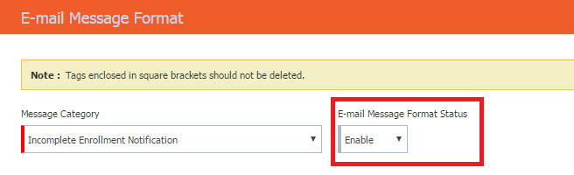
Figure 6: Customization on Email Message Format
- Employee level settings
  - The employee should have a valid email address
  - Receive email setting should be set to Yes (Figure 2) (Select employee Employee->Demographics).

- Incomplete Enrollment Notification settings
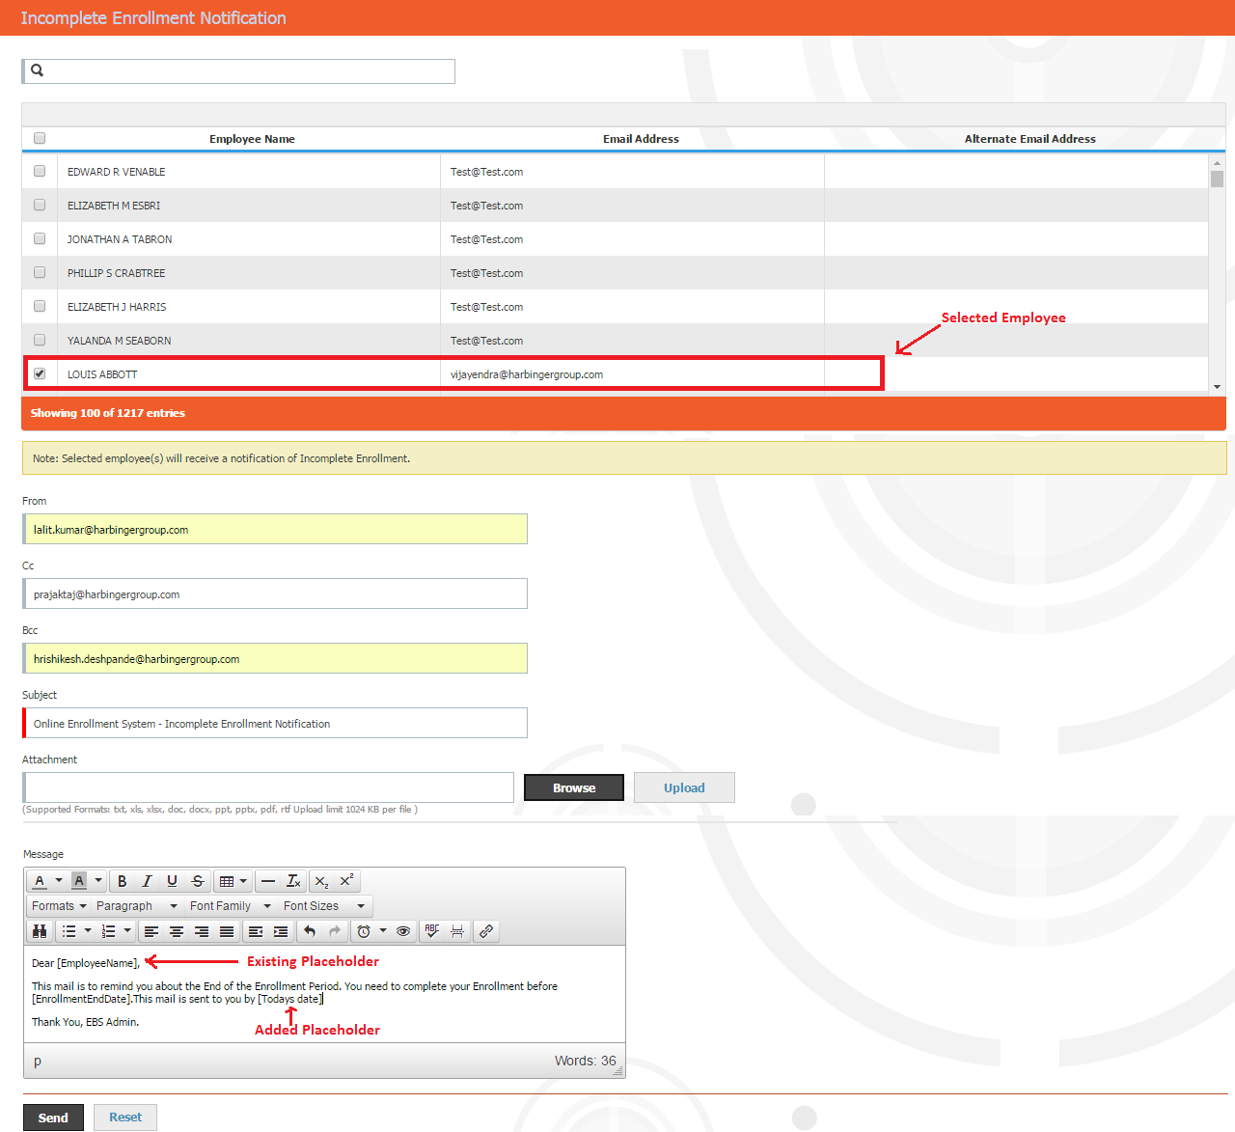
Figure 7: Customizations on Incomplete Enrollment Notification
Here the selected employee (s) will receive the mail that is configured.
- From: The email id is of the sender of the mail. If this section is left blank then the From email id is taken from the config files or backend database.(Here valid email id should be provided)
- Cc, Bcc: The email id of the person(s) to be given in Cc and Bcc. If these sections are left blank they appear blank on the email (Here valid email ids should be provided)
- Subject: The subject of the email
- Attachment: The attachment to be added in the email. Files with .bat, .exe, .dll, .cmd extensions are not allowed.

In this email message there are two Place holders (Figure 7)
- [EmployeeName] : The existing placeholder in the message
- [Todays date]:Place holder added by user manually.

NOTE: If any of the above customization settings are missed done then the email notification is not sent.

Sending incomplete enrollment notification mail

Once all the customizations are and the send button is clicked (Figure 7) we get the following pop up
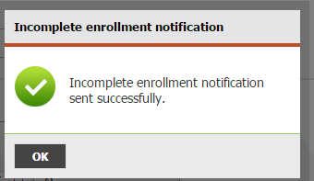
Figure 8 : Incomplete enrollment notification sent successfully pop up
Based on the customizations on Figure 7 the sent email appears as below Figure 9
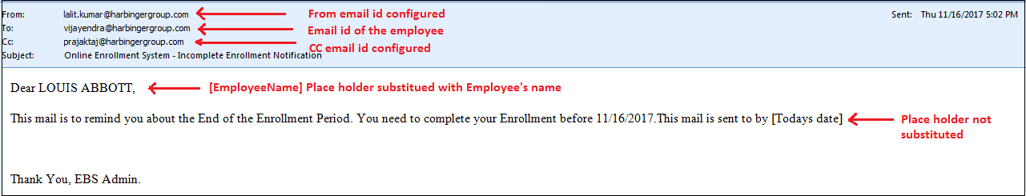
Figure 9: Incomplete enrollment notification mail
Here the Place holder [EmployeeName] got substituted with employee’s name. So the Place holders which are configured in the system are substituted with values. Since the place holder [Todays date] is not configured in the system it did not get substituted.
The number of employees selected here, receive the mail.
- The mails are sent to individual employees, one after the other, and not in batches.

If the From Bcc and Cc fields (in Figure 7) are left blank the mail sent to the employee appears as follows in (Figure 10)
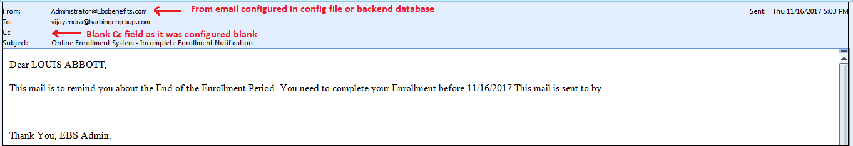
Figure 10: Incomplete Enrollment Notification mail if From, Bcc, Cc is set empty

Incomplete enrollment notification – Benefit wise

Purpose
Here we can select employee(s) and send an email to them reminding them to complete the enrollment. The employee selection can be based on Benefit Type and Plan Design.

Customization
- Customizations on System Settings
Steps:
- Navigate to System Settings (Employer Administration ->Company Information->System Settings)
- Set Receive Email Notification to Yes.(Figure 1)

- Customization on Email Message Format
- Navigate to Email Message Format (Communication->Email Message Format)
- Select Incomplete Enrollment Notification in message category.
- Check if Email Message Format Status is Enabled, if not select Enabled and save.(Figure 6)

- Employee level settings
  - The employee should have a valid email address
  - Receive email setting should be set to Yes (Figure 2) (Select employee Employee->Demographics).

- Incomplete Enrollment Notification – Benefit wise settings

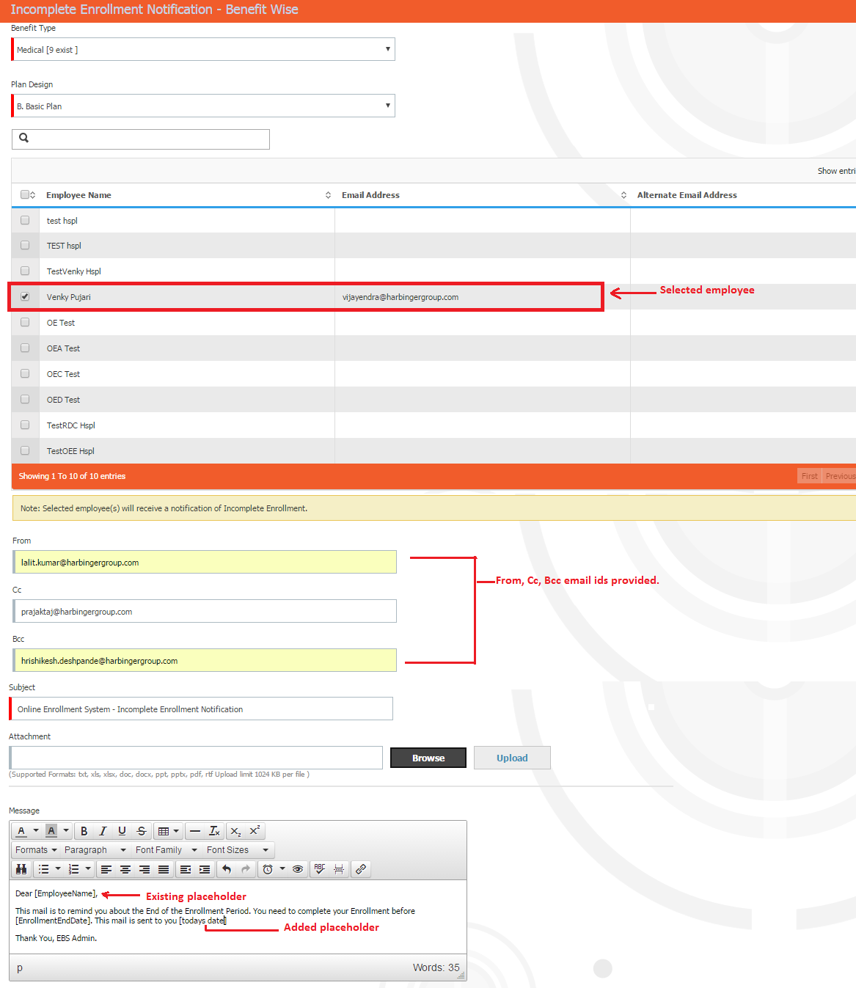
Figure 11: Customization on Incomplete enrollment notification - Benefit wise screen

- Benefit type: Selection of the benefit type for the incomplete enrollment notification
- Plan Design: Selection of plan belonging to the Benefit Type for the incomplete enrollment notification
- From: The email id is of the sender of the mail. If this section is left blank then the From email id is taken from the config files or backend database.(Here valid email id should be provided)
- Cc, Bcc: The email id of the person(s) to be given in Cc and Bcc. If these sections are left blank they appear blank on the email (Here valid email ids should be provided)
- Subject: The subject of the email
- Attachment: The attachment to be added in the email. Files with .bat, .exe, .dll, .cmd extensions are not allowed.
In this email message there are two Place holders (Figure 11)
- [EmployeeName] : The existing placeholder in the message
- [todays date]:Place holder added for by the user manually.

NOTE: If any of the above customization settings are missed done then the email notification is not sent.

Sending incomplete enrollment notification mail – Benefit wise
Once all the customizations are done and we send the mail, the following pop up appears. (Figure 12)
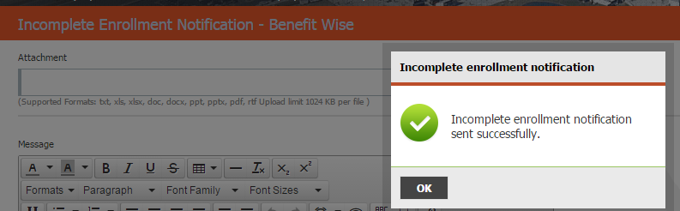
Figure 12: Incomplete enrollment notification - Benefit wise, email successfully sent pop up
Based on the customizations on Figure 11 the mail sent is as follows in Figure 13
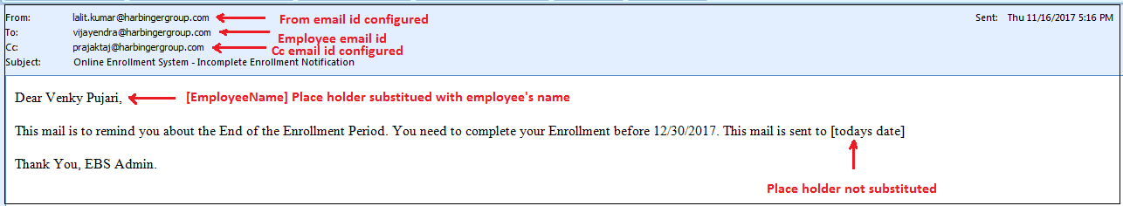
Figure 13: Incomplete Enrollment notification - Benefit wise email received
If the From Bcc and Cc fields (in Figure 11) are left blank the mail sent to the employee appears as follows in (Figure 14)
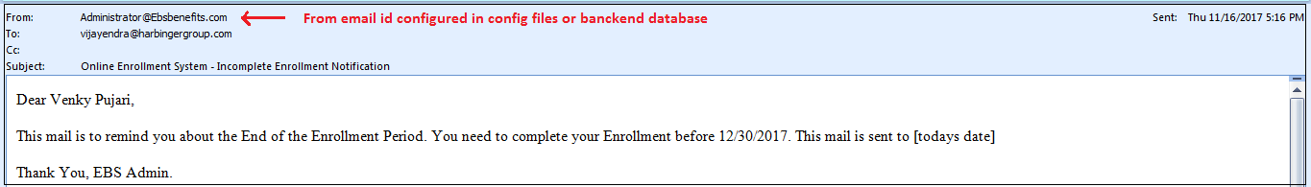
Figure 14: Incomplete Enrollment Notification - Benefit wise email, without From, Cc, Bcc email ids configured.
Here the Place holder [EmployeeName] got substituted with employee’s name. So the Place holders which are configured in the system are substituted with values. Since the place holder [todays date] is not configured in the system it did not get substituted.
The number of employees selected here, receive the mail.
- The mails are sent to individual employees, one after the other, and not in batches.

